[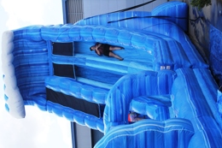](http://www.google.com.au/url?sa=i&rct=j&q=&esrc=s&source=images&cd=&cad=rja&uact=8&ved=0CAcQjRxqFQoTCK_hraLNh8kCFUG3pgodksQMWA&url=http%3A%2F%2Fwww.bubblingwithenergy.info%2FMega-Water-Slides%2F&bvm=bv.106923889,d.dGY&psig=AFQjCNFw-8r24fiR3y8qutI9FIgRTbog0w&ust=1447304906900662)