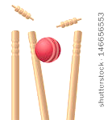

**BATTING**

* **Place your ball onto your tee**
* **Hold the cricket bat with both hands – put your favourite hand down low and your other hand up high**
* **Rest the end of the bat on the ground, just to the side of your toes – make sure the flat side is looking at the ball**
* **Swing the back backwards just a little bit, and then swing through**

**FIELDING**

* **Make sure that you are ready when your partner hits their ball – facing and  
  watching the ball**
* **Once the ball has been hit,  
  chase after it as quick as you  
  can**
* **Trap the ball to stop it from  
  getting any further, they scoop  
  it up and run it back to the tee**



CRICKET: BATTING AND FIELDING