O:\Designer\IN PROGRESS\KELLY SPORTS\KS_10_A4 flyer_3_program\IMAGES\pin.png 8 Knightsbridge Place, Diamond Creek, 3089

$20.00 OFF FOR

PREVIOUS DANCE

STUDENTS. COME AND

HAVE A TRY.

**T** (03) 9438 2469

**M** 0403 121 289

**E** [michaelhogg@kellysports.com.au](mailto:michaelhogg@kellysports.com.au)

**WATTLE GLEN PRIMARY SCHOOL**

****

**DYNAMIC DANCE**

**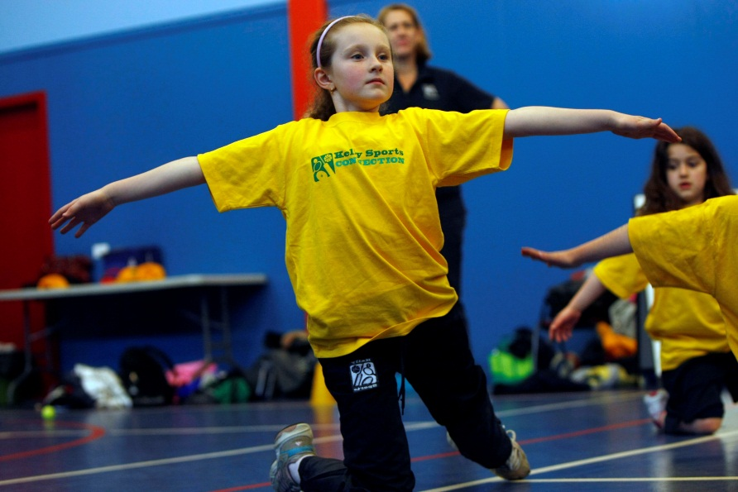**

LET THE BEAT ENTER YOU FEET! Our specialized Dance coaches can get your child’s hips swinging, feet rocking and heads bumping to all of modern contemporary music’s classics. Sign up fast as places are limited and let our coaches beat; ignite your child’s feet!

**WHEN:** Friday

**COMMENCING:** 26/05/2017

**CONCLUDING:** 23/06/2017

**TIME:** 1.30pm – 2.25pm

**YEAR LEVELS:** P – 6



**COST: $50** (enrol online – go to [www.kellysports.com.au](http://www.kellysports.com.au) and search for your school)

**It’s here online enrolments !**

**To enrol**, please visit [www.kellysports.com.au](http://www.kellysports.com.au) or

fill out the enrolment form & **send** with a cheque or credit card details to:

Kelly Sports PO BOX 71, Moonee Vale, VIC, 3055.

Payment options available!

Do **not** leave enrolment forms at the school office

**VENUE: Wattle Glen Primary School**

**­**

To enrol, please visit [www.kellysports.com.au](http://www.kellysports.com.au)

or fill the below enrolment form & send credit card details to:   
**8 Knightsbridge Place, Diamond Creek, 3089**. Payment options available!   
**Do not** leave enrolment forms at the school office.

**It’s here online enrolments !**

**To enrol**, please visit [www.kellysports.com.au](http://www.kellysports.com.au) or

fill out the enrolment form & **send** with a cheque or credit card details to:

Kelly Sports PO BOX 71, Moonee Vale, VIC, 3055.

Payment options available!

Do **not** leave enrolment forms at the school office

**ONLINE ENROLMENT**

**www.kellysports.com.au/zone/plentyvalley**

**ENROLMENT FORM**

School: Year Level:

Name: Room No:

Address: Post Code:

Phone: Mobile/Work:

Email: Medical Conditions:

At the completion of after school clinics, does your child? □ Go to after care □ Get collected

**Parents’ consent I hereby authorise Kelly Sports to act on my behalf should my child require medical attention, and release Kelly Sports Plenty Valley from any liability for injury incurred by my child at Kelly Sports programmes.**

Parent/Caregiver name: Signature:

Amount Paid: $ Credit card payment: □ **Visa** □ **Mastercard**

Card Number: □□□□ □□□□ □□□□ □□□□ Expiry Date: □□/□□

CVV Number: □□□

**It’s here online enrolments !**

**To enrol**, please visit [www.kellysports.com.au](http://www.kellysports.com.au) or

fill out the enrolment form & **send** with a cheque or credit card details to:

Kelly Sports PO BOX 71, Moonee Vale, VIC, 3055.

Payment options available!

Do **not** leave enrolment forms at the school office

**It’s here online enrolments !**

**To enrol**, please visit [www.kellysports.com.au](http://www.kellysports.com.au) or

fill out the enrolment form & **send** with a cheque or credit card details to:

Kelly Sports PO BOX 71, Moonee Vale, VIC, 3055.

Payment options available!

Do **not** leave enrolment forms at the school office

**It’s here online enrolments !**

**To enrol**, please visit [www.kellysports.com.au](http://www.kellysports.com.au) or

fill out the enrolment form & **send** with a cheque or credit card details to:

Kelly Sports PO BOX 71, Moonee Vale, VIC, 3055.

Payment options available!

Do **not** leave enrolment forms at the school office