

**GREENHILLS**

**PRIMARY SCHOOL P** (03) 9384 2204

**M** 0403 149 391

** E** [mitch@kellysports.com.au](mailto:mitch@kellysports.com.au)

**NEW LUNCH TIME PROGRAM!**



**BASKETBALL CLUB**

**When: Tuesdays**  
**Starts: 19th February**  
**Finishes: 2nd April**  
**Time: 1:00pm – 2:00pm**  
**Year Levels: Prep – 4  
Cost: $92.40 (Inc GST)**

Come and join our first ever Basketball program at Greenhills PS. This Basketball Program includes all the skill and activities required to help enhance your child's skills, and get them on the way to being the next Basketball Superstar. Hop on board and shoot a goal this term.  
Only 14 spots available so sign up fast.



**How To Enrol?**Please visit [www.kellysports.com.au/events](http://www.kellysports.com.au/events) and search for your school.  
**Our new booking system requires upfront payments to secure your position. For more information, please call the head office.**



**"The Kelly Sports Programs offer our students opportunities for physical activities; including dance & multi-sports. Conveniently located on our school grounds, they are popular with students and their families. Staff are skilled in working with young people to love active participation.”**

Don't forgot about our **SIZZLING SUMMER SPORTS PROGRAM** currently running every Tuesday straight after school. This Multi Sport program includes sports such as Soccer, Cricket, Basketball & Tennis. Sign up anytime and only pay for how many weeks are remaining in the term.



***Amanda Hay, Principal – Newtown Primary School***

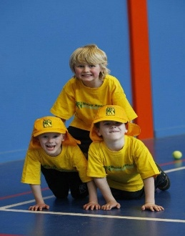

**When: Tuesdays**  
**Starts: Commenced**  
**Finishes: 2nd April**  
**Time: 3:40pm – 4:40pm**  
**Year Levels: Prep – 4  
Cost: $13.20(Inc GST) per week**

