

**ST JOSEPH’S MERNDA**

**P** (03) 9384 2204  
**M** 0403 149 391  
**E** [mitch@kellysports.com.au](mailto:mitch@kellysports.com.au)



**HIP HOP**

Kelly Sports welcomes HIP HOP back in Term 1! In this program Students will have the opportunity to move, groove, spin and bop to the sound of hip hop beats alongside our very experienced dance instructor. You will have a fantastic time learning the new moves in our high intensity, excitement-filled dance environment. At the end of the term the kids will have learnt a new performance to showcase to their parents.





**How To Enrol?**Please visit [www.kellysports.com.au/events](http://www.kellysports.com.au/events) and search for your school.  
Our new booking system requires upfront payments to secure your position. For more information, please call the head office.

**"The Kelly Sports Programs offer our students opportunities for physical activities; including dance & multi-sports. Conveniently located on our school grounds, they are popular with students and their families. Staff are skilled in working with young people to love active participation.”**



***Amanda Hay, Principal – Newtown Primary School***

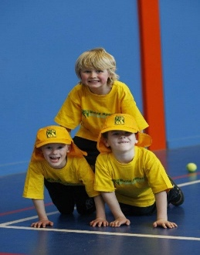

**CLASS INFORMATION**

Only 20 spots available so sign up fast to secure your position  
  
At the end of the term parents will be invited to an open class to watch the full dance routine.

Come and join us every Tuesday at Lunch time.

**When: Tuesdays**  
**Starts: 5th February**  
**Finishes: 2nd April**  
**Time: 11:00am – 12:00pm**  
**Year Levels: Prep – 4  
Cost: $118.80 (Inc GST)**

