

**GREENHILLS**

**PRIMARY SCHOOL P** (03) 9384 2204

**M** 0403 149 391

** E** [mitch@kellysports.com.au](mailto:mitch@kellysports.com.au)



**BASKETBALL CLUB – Lunch Time Tuesdays**Come and join us at lunch time for our 2nd term of Basketball Club. This Basketball Program includes all the skill and activities required to help enhance your child's skills, and get them on the way to being the next Basketball Superstar. Hop on board and shoot a goal this term.

**AWESOME AUTUMN SPORTS– After School Tuesdays**Kelly Sports is back in Term 2 for a **AWESOME AUTUMN OF SPORTS!!**   
Our Kelly Sports classes are all inclusive, fun & interactive with a key focus on maximum participation. Each week children will be introduced to new sports & activities in a positive environment. It’s a fantastic way to get your child active while having fun as well as building confidence and social skills!



**How To Enrol?**Please visit [www.kellysports.com.au/events](http://www.kellysports.com.au/events) and search for your school.  
**Our new booking system requires upfront payments to secure your position. For more information, please call the head office.**



**"The Kelly Sports Programs offer our students opportunities for physical activities; including dance & multi-sports. Conveniently located on our school grounds, they are popular with students and their families. Staff are skilled in working with young people to love active participation.”**



***Amanda Hay, Principal – Newtown Primary School***

**CLASS INFORMATION**

Only 15 spots available for each program so sign up fast to secure your position  
  
Multi Sports includes **Soccer, Basketball, AFL & Hockey,** plus we will incorporate our Kelly Sports Modified games children love.

Come and join us every Tuesday at lunch & straight after school.

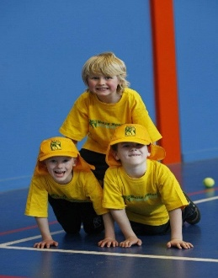

**When: Tuesdays**  
**Starts: 30th April**  
**Finishes: 25th June**   
**Sports: 3:40pm – 4:40pm  
Bball: 1:00pm – 2:00pm**  
**Year Levels: Prep – 4  
Cost: $118.80 (Inc GST)**

