  8 Knightsbridge Place, Diamond Creek, 3089

NEW DANCE

CLASS STARTING

THIS TERM

WEEK

**T** (03) 9438 2469

**M 0403 121 289**

**E** [michaelhogg@kellysports.com.au](mailto:michaelhogg@kellysports.com.au)

**ST JOSEPH’S PRIMARY SCHOOL**

**DYNAMIC DANCE**

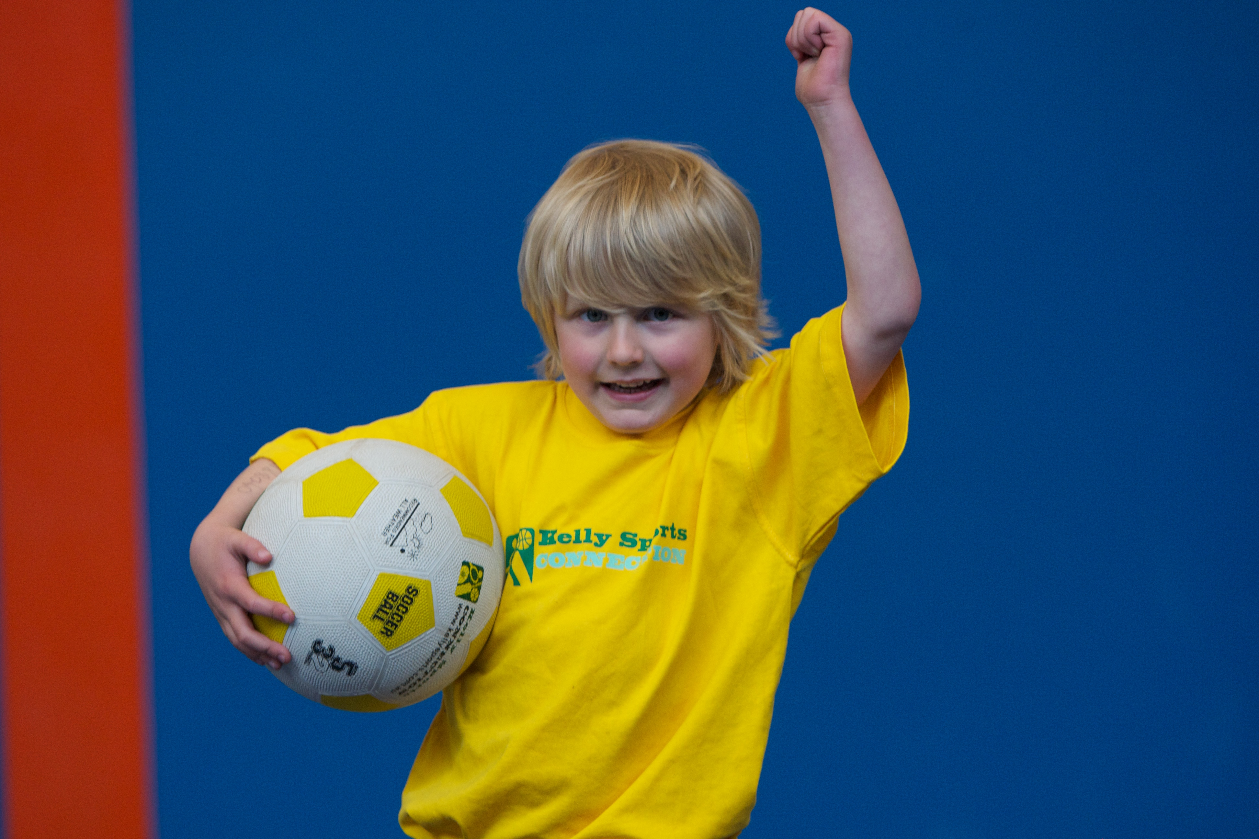

LET THE BEAT ENTER YOU FEET! Our specialized Dance coaches can get your child’s hips swinging, feet rocking and heads bumping to all of modern contemporary music’s classics. Sign up fast as places are limited and let our coaches beat; ignite your child’s feet!

**WHEN:** Tuesday

**COMMENCING:** 28/07/2015

**CONCLUDING:** 15/09/2015

**TIME:** 11am – 12.00pm

**YEAR LEVELS:** P – 4

**WHEN:** Thursday

**COMMENCING:** 23/07/2015

**CONCLUDING:** 17/09/2015

**TIME:** 11.00am – 12.00pm

**YEAR LEVELS:** P – 4



**GYM CRAZY**

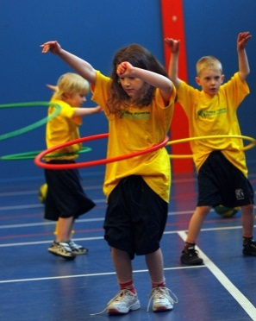

LEAP INTO GYM CRAZY THIS TERM. This fast paced, highly active non-stop program is an introduction into the world of gymnastics. Colourful Ribbons, Entertaining Hula Hoops, Fantastic Rhythmical Routines, Cartwheels and Group Dynamics allows your child to build up their thirst for energetic activities.



**COST: $90 (gym) $80 (dance)**(enrol – go to [www.kellysports.com.au](http://www.kellysports.com.au) and search for your school)

**It’s here online enrolments !**

**To enrol**, please visit [www.kellysports.com.au](http://www.kellysports.com.au) or

fill out the enrolment form & **send** with a cheque or credit card details to:

Kelly Sports PO BOX 71, Moonee Vale, VIC, 3055.

Payment options available!

Do **not** leave enrolment forms at the school office

**VENUE: St Joseph’s Primary School**

**­**

To enrol, please visit **w**ww.kellysports.com.auor fill out the below enrolment form & send credit card details to 8 Knightsbridge Place**,** Diamond Creek,3089.. Payment options available! **Do not** leave enrolment forms at the school office.

**ONLINE ENROLMENT**

**www.kellysports.com.au**

**It’s here online enrolments !**

**To enrol**, please visit [www.kellysports.com.au](http://www.kellysports.com.au) or

fill out the enrolment form & **send** with a cheque or credit card details to:

Kelly Sports PO BOX 71, Moonee Vale, VIC, 3055.

Payment options available!

Do **not** leave enrolment forms at the school office

**ENROLMENT FORM**

□ Dynamic Dance (Lunch time) □ Gym Crazy (Lunch time)

School: Year Level:

Name: Room No:

Address: Post Code:

Phone: Mobile/Work:

Email: Medical Conditions:

At the completion of after school clinics, does your child? □ Go to after care □ Get collected

**Parents’ consent: I hereby authorise Kelly Sports to act on my behalf should my child require medical attention, and release   
Kelly Sports Plenty Valley from any liability for injury incurred by my child at Kelly Sports programmes.**

Parent/Caregiver name: Signature:

Amount Paid: $ Credit card payment: □ **Visa** □ **Master card**

Card Number: □□□□ □□□□ □□□□ □□□□ Expiry Date: □□/□□

CVV Number: □□□

**It’s here online enrolments !**

**To enrol**, please visit [www.kellysports.com.au](http://www.kellysports.com.au) or

fill out the enrolment form & **send** with a cheque or credit card details to:

Kelly Sports PO BOX 71, Moonee Vale, VIC, 3055.

Payment options available!

Do **not** leave enrolment forms at the school office

**It’s here online enrolments !**

**To enrol**, please visit [www.kellysports.com.au](http://www.kellysports.com.au) or

fill out the enrolment form & **send** with a cheque or credit card details to:

Kelly Sports PO BOX 71, Moonee Vale, VIC, 3055.

Payment options available!

Do **not** leave enrolment forms at the school office

**It’s here online enrolments !**

**To enrol**, please visit [www.kellysports.com.au](http://www.kellysports.com.au) or

fill out the enrolment form & **send** with a cheque or credit card details to:

Kelly Sports PO BOX 71, Moonee Vale, VIC, 3055.

Payment options available!

Do **not** leave enrolment forms at the school office