  8 Knightsbridge Place, Diamond Creek, 3089

WEEK

**T** (03) 9438 2469

**M 0403 121 289**

**E** [michaelhogg@kellysports.com.au](mailto:michaelhogg@kellysports.com.au)

**ST JOSEPH’S PRIMARY SCHOOL**

**AMAZING AUTUMN SPORTS**

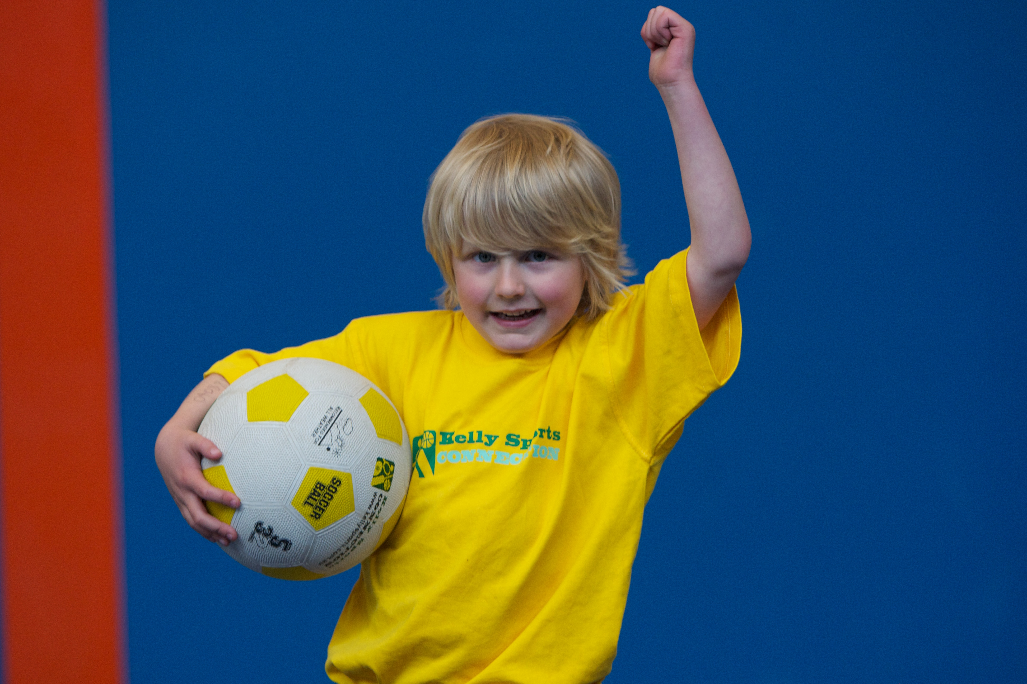

DON’T MISS OUT ON THIS HOT CATCH! AMAZING AUTUMN SPORTS allows your child to play a range of dynamic and active programs run over 9 **weeks**; these include: **Basketball, Tennis, Soccer, Hockey and Crazy Games!** This Program will not only provide an essential base for your child's motor skills and help build awareness, co-ordination and friendship all in an enjoyable environment

**WHEN:** Tuesday

**COMMENCING:** 21/04/2015

**CONCLUDING:** 16/06/2015

**TIME:** 11am – 12.00pm

**YEAR LEVELS:** P – 4

**WHEN:** Thursday

**COMMENCING:** 23/04/2015

**CONCLUDING:** 18/06/2015

**TIME:** 11.00am – 12.00pm

**YEAR LEVELS:** P – 4



**GYM CRAZY**

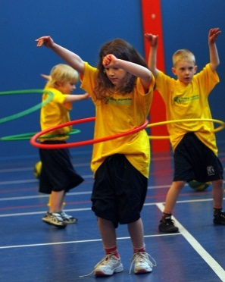

LEAP INTO GYM CRAZY THIS TERM. This fast paced, highly active non-stop program is an introduction into the world of gymnastics. Colourful Ribbons, Entertaining Hula Hoops, Fantastic Rhythmical Routines, Cartwheels and Group Dynamics allows your child to build up their thirst for energetic activities.



**COST: $90.00** (enrol – go to [www.kellysports.com.au](http://www.kellysports.com.au) and search for your school)

**It’s here online enrolments !**

**To enrol**, please visit [www.kellysports.com.au](http://www.kellysports.com.au) or

fill out the enrolment form & **send** with a cheque or credit card details to:

Kelly Sports PO BOX 71, Moonee Vale, VIC, 3055.

Payment options available!

Do **not** leave enrolment forms at the school office

**VENUE: St Joseph’s Primary School**

**­**

To enrol, please visit **w**ww.kellysports.com.auor fill out the below enrolment form & send credit card details to 8 Knightsbridge Place**,** Diamond Creek,3089.. Payment options available! **Do not** leave enrolment forms at the school office.

**ONLINE ENROLMENT**

**www.kellysports.com.au**

**It’s here online enrolments !**

**To enrol**, please visit [www.kellysports.com.au](http://www.kellysports.com.au) or

fill out the enrolment form & **send** with a cheque or credit card details to:

Kelly Sports PO BOX 71, Moonee Vale, VIC, 3055.

Payment options available!

Do **not** leave enrolment forms at the school office

**ENROLMENT FORM**

□ Amazing Autumn Sports (Lunch time) □ Gym Crazy (Lunch time)

School: Year Level:

Name: Room No:

Address: Post Code:

Phone: Mobile/Work:

Email: Medical Conditions:

At the completion of after school clinics, does your child? □ Go to after care □ Get collected

**Parents’ consent: I hereby authorise Kelly Sports to act on my behalf should my child require medical attention, and release   
Kelly Sports Plenty Valley from any liability for injury incurred by my child at Kelly Sports programmes.**

Parent/Caregiver name: Signature:

Amount Paid: $ Credit card payment: □ **Visa** □ **Master card**

Card Number: □□□□ □□□□ □□□□ □□□□ Expiry Date: □□/□□

CVV Number: □□□

**It’s here online enrolments !**

**To enrol**, please visit [www.kellysports.com.au](http://www.kellysports.com.au) or

fill out the enrolment form & **send** with a cheque or credit card details to:

Kelly Sports PO BOX 71, Moonee Vale, VIC, 3055.

Payment options available!

Do **not** leave enrolment forms at the school office

**It’s here online enrolments !**

**To enrol**, please visit [www.kellysports.com.au](http://www.kellysports.com.au) or

fill out the enrolment form & **send** with a cheque or credit card details to:

Kelly Sports PO BOX 71, Moonee Vale, VIC, 3055.

Payment options available!

Do **not** leave enrolment forms at the school office

**It’s here online enrolments !**

**To enrol**, please visit [www.kellysports.com.au](http://www.kellysports.com.au) or

fill out the enrolment form & **send** with a cheque or credit card details to:

Kelly Sports PO BOX 71, Moonee Vale, VIC, 3055.

Payment options available!

Do **not** leave enrolment forms at the school office