 8 Knightsbridge Place, Diamond Creek, 3089

Only

$90 for 10 weeks

**T** (03) 9438 2469

**M 0403 1212 89**

**E** michaelhogg@kellysports.com.au

**ST DAMIAN’S PRIMARY SCHOOL**

**SPRING INTO SPORTS**

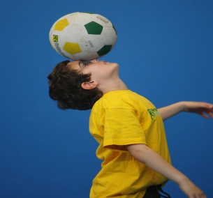

DON’T MISS OUT ON THIS GREAT CATCH! SPRING INTO SPORTS allows your child to play a range of dynamic and active programs run for only 10 **weeks**; these include: Lots of different community based Sports, Running games and ball based fun games**!** This Program will not only provide an essential base for your child's motor skills and help build awareness, co-ordination and friendship all in an enjoyable environment

**WHEN:** Wednesday

**COMMENCING:** 08/10/2014

**CONCLUDING:** 10/12/2014

**TIME:** 3.25pm – 4.25pm

**YEAR LEVELS:** P – 4

**WHEN:** Wednesday

**COMMENCING:** 08/10/2014

**CONCLUDING:** 10/12/2014

**TIME:** 1.30pm – 2.15pm

**YEAR LEVELS:** P – 4



**DYNAMIC DANCE**

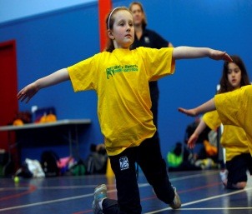

LET THE BEAT ENTER YOU FEET! Our specialized Dance coaches can get your child’s hips swinging, feet rocking and heads bumping to all of modern contemporary music’s classics. Sign up fast as places are limited and let our coaches beat; ignite your child’s feet!



**COST $90** enrol at **www.kellysports.com.au** & search for your school

**It’s here online enrolments !**

**To enrol**, please visit [www.kellysports.com.au](http://www.kellysports.com.au) or

fill out the enrolment form & **send** with a cheque or credit card details to:

Kelly Sports PO BOX 71, Moonee Vale, VIC, 3055.

Payment options available!

Do **not** leave enrolment forms at the school office

**VENUE St Damian’s Primary School**

**­**

To enrol, please visit **www.kellysports.com.au** or fill out the below enrolment form & sendwith a cheque or

credit card details to: **8 Knightsbridge Place, Diamond Creek, 3089**.   
**Do not** leave enrolment forms at the school office.

**It’s here online enrolments !**

**To enrol**, please visit [www.kellysports.com.au](http://www.kellysports.com.au) or

fill out the enrolment form & **send** with a cheque or credit card details to:

Kelly Sports PO BOX 71, Moonee Vale, VIC, 3055.

Payment options available!

Do **not** leave enrolment forms at the school office

**ENROLMENT FORM**

□ **Spring into Sports** (After School) □ **Dynamic Dance** (Lunch time)

School: Year Level:

Name: Room No:

Address: Post Code:

Phone: Mobile/Work:

Email: Medical Conditions:

At the completion of after school clinics, does your child? □ Go to after care □ Get collected

**Parents’ consent: I hereby authorise Kelly Sports to act on my behalf should my child require medical attention, and release   
Kelly Sports Plenty Valley from any liability for injury incurred by my child at Kelly Sports programmes.**

Parent/Caregiver name: Signature:

Amount Paid: $ Credit card payment: □ **Visa** □ **Mastercard**

Card Number: □□□□ □□□□ □□□□ □□□□ Expiry Date: □□/□□

CVV Number: □□□

**ONLINE ENROLMENT**

**www.kellysports.com.au**

**It’s here online enrolments !**

**To enrol**, please visit [www.kellysports.com.au](http://www.kellysports.com.au) or

fill out the enrolment form & **send** with a cheque or credit card details to:

Kelly Sports PO BOX 71, Moonee Vale, VIC, 3055.

Payment options available!

Do **not** leave enrolment forms at the school office

**It’s here online enrolments !**

**To enrol**, please visit [www.kellysports.com.au](http://www.kellysports.com.au) or

fill out the enrolment form & **send** with a cheque or credit card details to:

Kelly Sports PO BOX 71, Moonee Vale, VIC, 3055.

Payment options available!

Do **not** leave enrolment forms at the school office

**It’s here online enrolments !**

**To enrol**, please visit [www.kellysports.com.au](http://www.kellysports.com.au) or

fill out the enrolment form & **send** with a cheque or credit card details to:

Kelly Sports PO BOX 71, Moonee Vale, VIC, 3055.

Payment options available!

Do **not** leave enrolment forms at the school office