

NEW EXCITING

SPORTS FUN

PROGRAM

8 Knightsbridge Place, Diamond Creek, 3089.

**M** 0403 121 289

**E** [michaelhogg@kellysports.com.au](mailto:michaelhogg@kellysports.com.au)

**ELTHAM NORTH PRIMARY SCHOOL**

**SUPER SPRING MORNINGS**

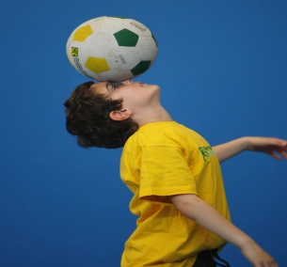

TIME TO GET INVOLVED! SUPER SPRING MORNINGS allows your child to play a range of dynamic and active programs run over 6 **Weeks** these include: **Basketball, Soccer, Cricket, Hockey and Fun Crazy Ball Games!** This Program will not only provide an essential base for your child's motor skills and help build awareness, co-ordination and friendship all in an enjoyable environment.

**WHEN:** Wednesday **COMMENCING:** 02/11/2016

**CONCLUDING:** 07/12/2016

**TIME:** 8.00 – 8.45am

**YEAR LEVELS:** P – 5



Can’t drop the kids off till 8:45am?? Kelly Sports would like to offer a before school program for all those sports nuts out there. Parents this gives you the opportunity to get to work in time as well as the kids getting active before they start the day. YOU WOULD BE CRAZY NOT TO TAKE THIS OFFER UP.

**VENUE Eltham North Primary School**

**WHO Grade Prep – Grade 6**

**COST $50**

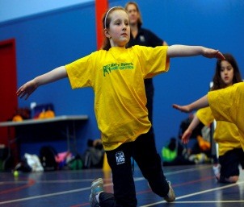

**­**

**It’s here online enrolments !**

**To enrol**, please visit [www.kellysports.com.au](http://www.kellysports.com.au) or

fill out the enrolment form & **send** with a cheque or credit card details to:

Kelly Sports PO BOX 71, Moonee Vale, VIC, 3055.

Payment options available!

Do **not** leave enrolment forms at the school office

**ONLINE ENROLMENT**

**www.kellysports.com.au**

To enrol, please visit **www.kellysports.com.au** or fill out the below enrolment form & sendwith a cheque or

credit card details to:8 Knightsbridge Pl, **Diamond Creek VIC 3089**   
**Do not** leave enrolment forms at the school office.

**ENROLMENT FORM**

□ **Super Spring Mornings (Before School)**

School: Year Level:

Name: Room No:

Address: Post Code:

Phone: Mobile/Work:

Email: Medical Conditions:

**Parents’ consent: I hereby authorise Kelly Sports to act on my behalf should my child require medical attention, and release   
Kelly Sports Plenty Valley from any liability for injury incurred by my child at Kelly Sports programmes.**

Parent/Caregiver name: Signature:

Amount Paid: $ Credit card payment: □ **Visa** □ **Mastercard**

Card Number: □□□□ □□□□ □□□□ □□□□ Expiry Date: □□/□□

CVV Number: □□□

**It’s here online enrolments !**

**To enrol**, please visit [www.kellysports.com.au](http://www.kellysports.com.au) or

fill out the enrolment form & **send** with a cheque or credit card details to:

Kelly Sports PO BOX 71, Moonee Vale, VIC, 3055.

Payment options available!

Do **not** leave enrolment forms at the school office

**It’s here online enrolments !**

**To enrol**, please visit [www.kellysports.com.au](http://www.kellysports.com.au) or

fill out the enrolment form & **send** with a cheque or credit card details to:

Kelly Sports PO BOX 71, Moonee Vale, VIC, 3055.

Payment options available!

Do **not** leave enrolment forms at the school office

**It’s here online enrolments !**

**To enrol**, please visit [www.kellysports.com.au](http://www.kellysports.com.au) or

fill out the enrolment form & **send** with a cheque or credit card details to:

Kelly Sports PO BOX 71, Moonee Vale, VIC, 3055.

Payment options available!

Do **not** leave enrolment forms at the school office