
8 Knightsbridge Place, Diamond Creek 3089
M 0403 121 289
Special O

E michaelhogg@kellysports.com.au


LITTLE LEARNER’S EARLY EDUCATION
FUNDAMENTAL
SKILLS PROGRAM

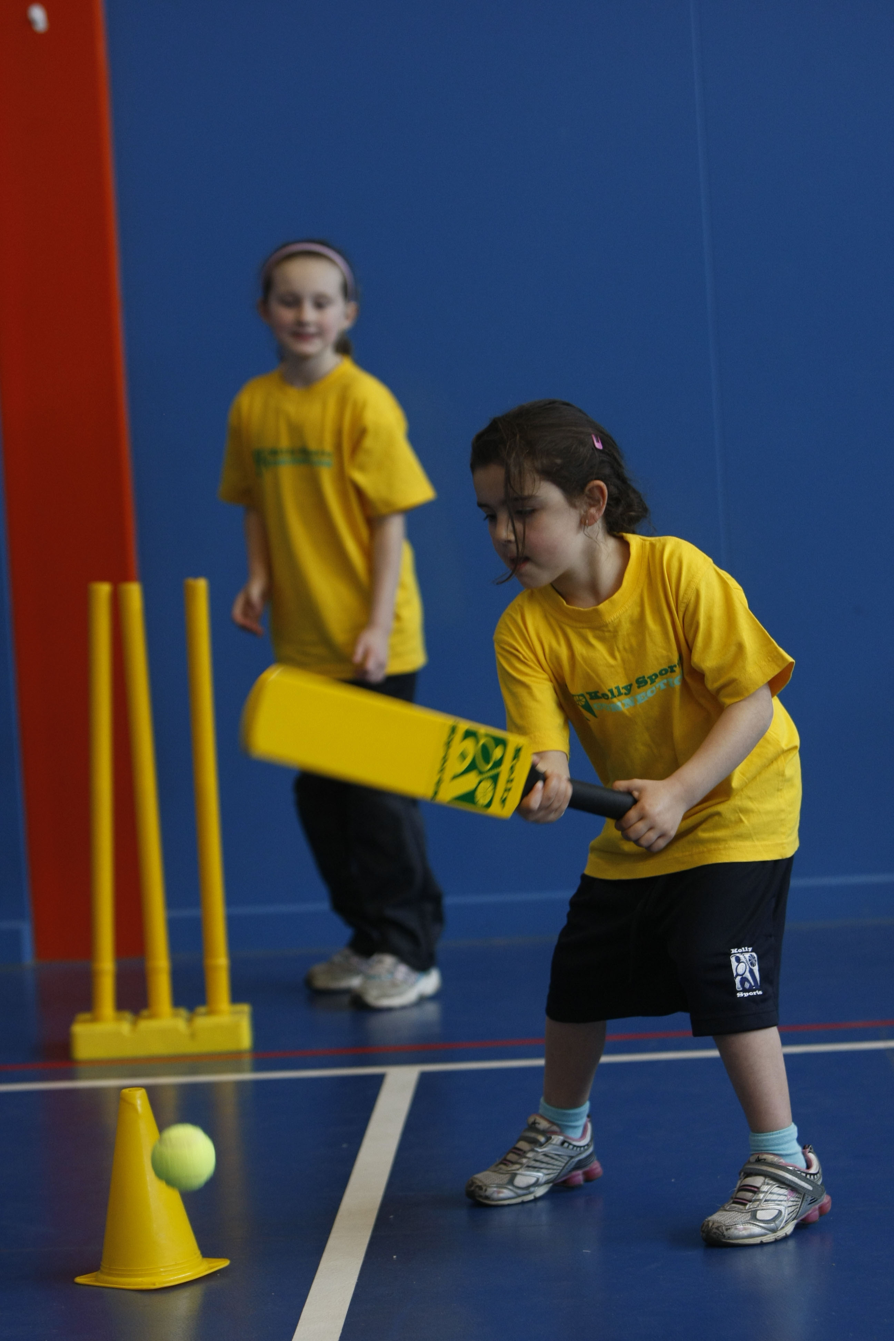

Kelly Sports runs programmes to teach children the fundamentals of sport. This 10 WEEK program is all inclusive with high participation. Our key aims are to develop and enhance the following skills – running, jumping, catching, throwing, passing, kicking and striking:
The Fundamental Skills Program includes:
- Motor Skill Development
- Balance and Hand- Eye Cordination
- Introduction to a variety of sports -Soccer, Basketball, Cricket, Hockey, Football and more.

WHEN: Friday
COMMENCING: 21/07/2017
CONCLUDING: 22/09/2017
TIME: 12:00pm – 12:35pm

COST: $70 (enrol online go to www.kellysports.com.au and search for your centre)
It’s here online enrolments !
To enrol, please visit www.kellysports.com.au or
fill out the enrolment form & send with a cheque or credit card details to:
Kelly Sports PO BOX 71, Moonee Vale, VIC, 3055.
Payment options available!
Do not leave enrolment forms at the school office

VENUE: Little Learner’s Early Education
It’s here online enrolments !
To enrol, please visit www.kellysports.com.au or
fill out the enrolment form & send with a cheque or credit card details to:
Kelly Sports PO BOX 71, Moonee Vale, VIC, 3055.
Payment options available!
Do not leave enrolment forms at the school office

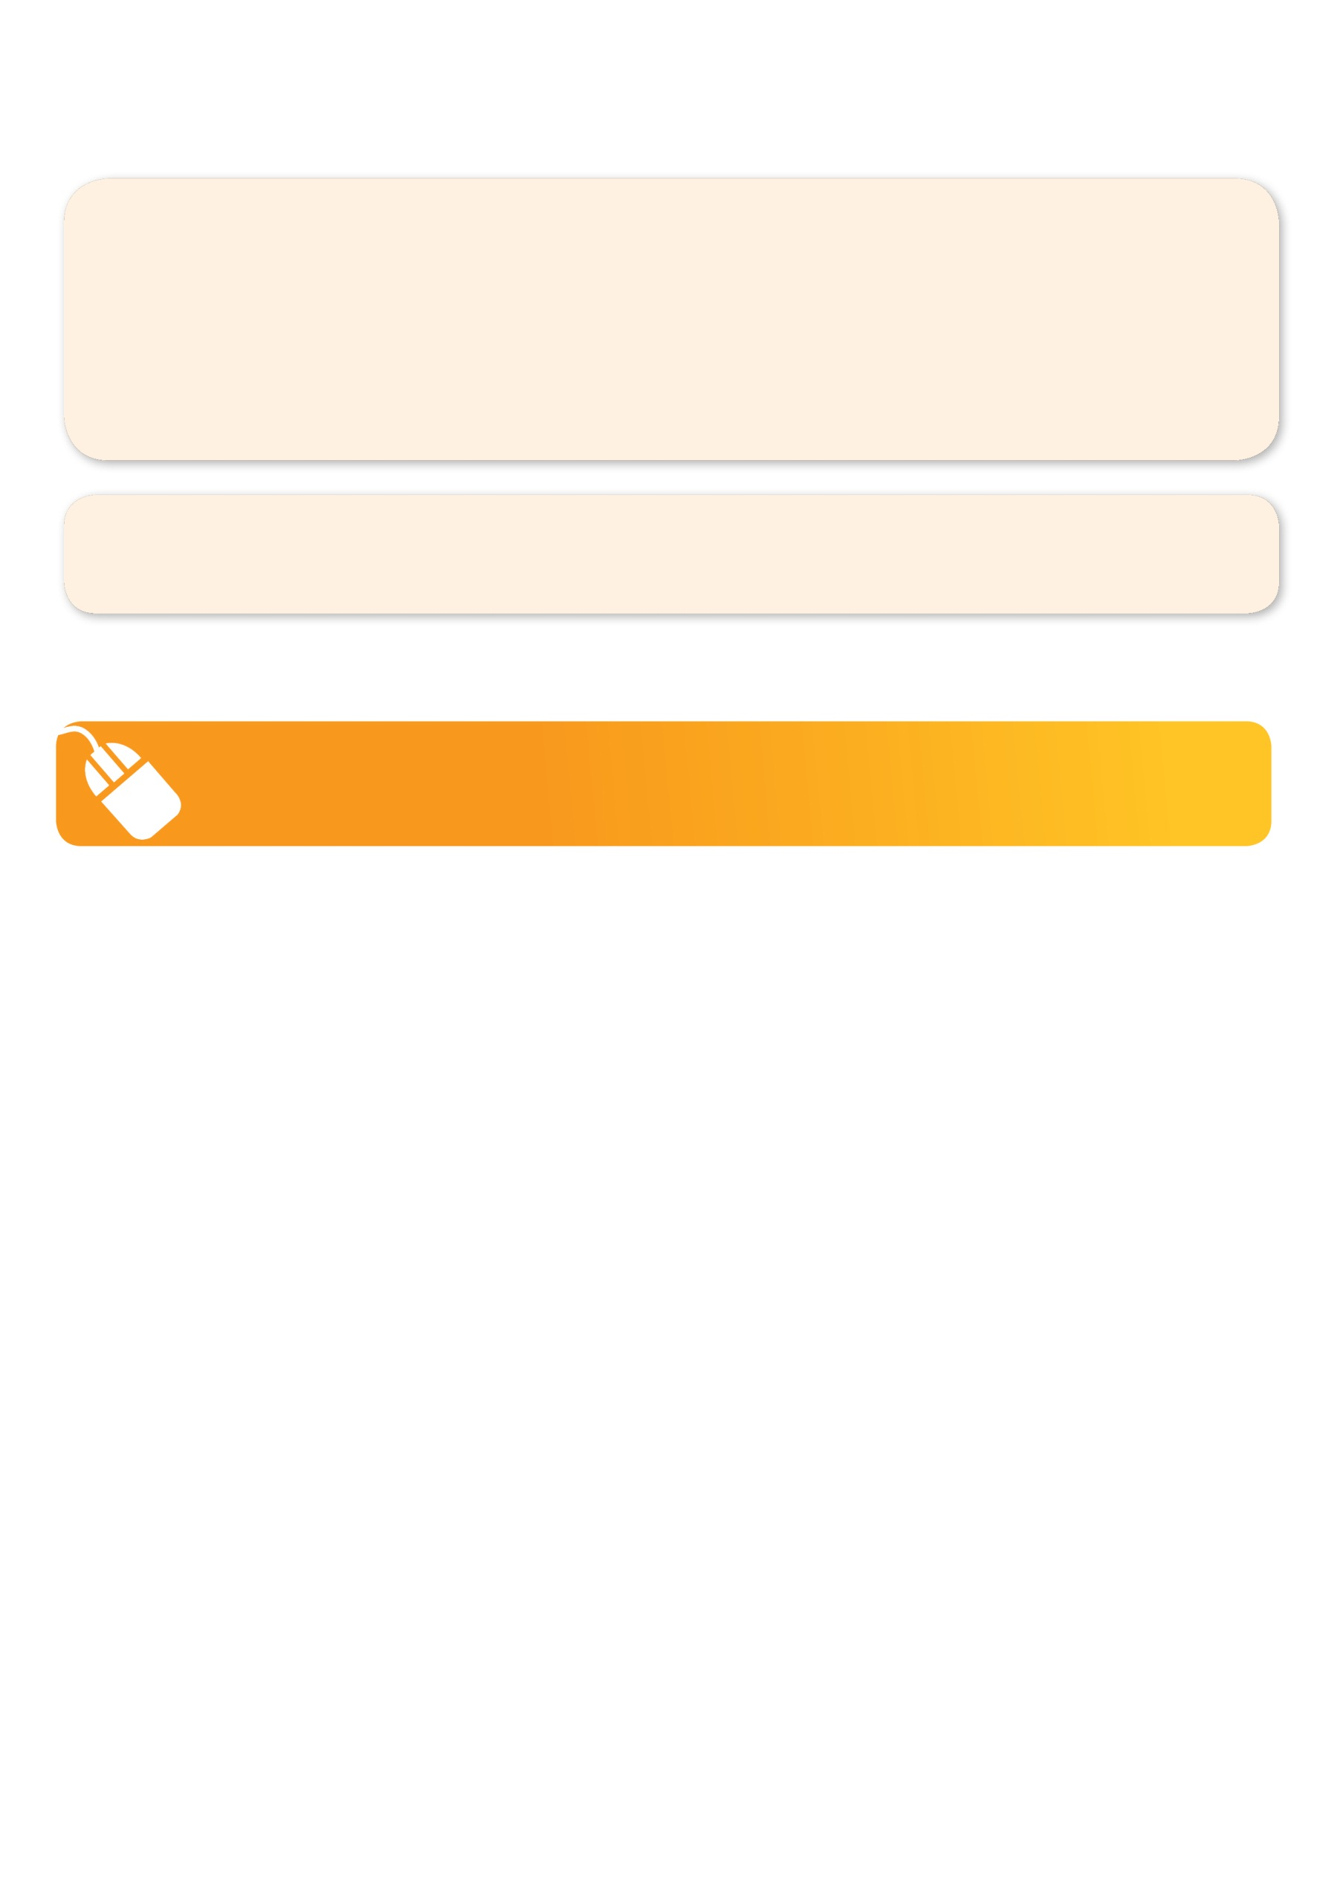
It’s here online enrolments !
To enrol, please visit www.kellysports.com.au or
fill out the enrolment form & send with a cheque or credit card details to:
Kelly Sports PO BOX 71, Moonee Vale, VIC, 3055.
Payment options available!
Do not leave enrolment forms at the school office

It’s here online enrolments !
To enrol, please visit www.kellysports.com.au or
fill out the enrolment form & send with a cheque or credit card details to:
Kelly Sports PO BOX 71, Moonee Vale, VIC, 3055.
Payment options available!
Do not leave enrolment forms at the school office

It’s here online enrolments !
To enrol, please visit www.kellysports.com.au or
fill out the enrolment form & send with a cheque or credit card details to:
Kelly Sports PO BOX 71, Moonee Vale, VIC, 3055.
Payment options available!
Do not leave enrolment forms at the school office

To enrol, please visit www.kellysports.com.au or
fill out the below enrolment form & send with a cheque or credit card details to:
8 Knightsbridge Place, Diamond Creek 3089. Payment options available!

ONLINE ENROLMENT
www.kellysports.com.au

ENROLMENT FORM

School: Year Level:
Name: Room No:
Address: Post Code:
Phone: Mobile/Work:
Email: Medical Conditions:

Parents’ consent: I hereby authorise Kelly Sports to act on my behalf should my child require medical attention, and release
Kelly Sports from any liability for injury incurred by my child at Kelly Sports programmes.
Parent/Caregiver name: Signature:
Amount paid: $ Credit card payment:  Visa  Mastercard
Card Number:     Expiry Date: /
CVV Number: : 

