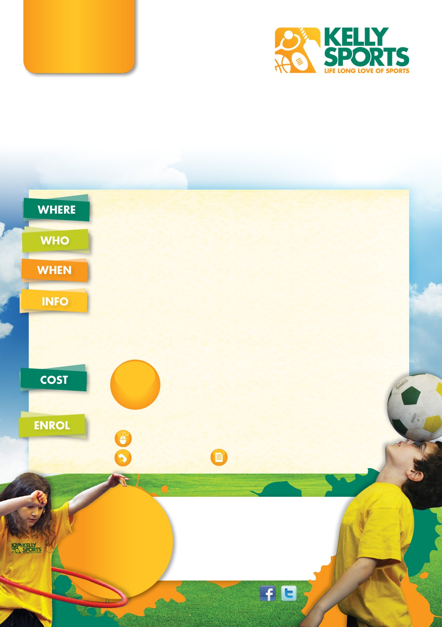
Call Dave on 0438833746
Dave White or Louise Hart
T 0438833746 or 0434860960
E davewhite@kellysports.com.au
PO Box 3180, Joondalup,WA ,6027

HOLIDAY PROGRAM
FUN FILLED ACTIVITIES …. ARTS & CRAFTS

Sports orientated holiday program designed for children to emphasise fun, enjoyment and maximum participation delivered by Kelly Sports a registered childcare provider.

YANCHEP DISTRICT HIGH SCHOOL
15 Primary Road, Yanchep
Ages 4-12 years

Tuesday, 7th April to Friday 17th April
8:00am-5:00pm Daily (excluding Saturday , Sunday & Public holidays)

Kelly Sports WA is offering an exciting holiday sports program
for kids this December/January School holiday period.
Enjoy daily schedule of modified games to keep your kids entertained. Programs are designed to help kids develop basic skills such as kicking, throwing, and catching as well as having fun.
Sports include Basketball, Netball, Cricket, Hockey, Soccer, AFL, Volleyball, Dancing, Gymnastics and creative craft activities.
Friendly and experienced coaches that enjoy teaching and delivering fun activities and developing kids skills

Children to bring a packed lunch, snacks and drinks to be enjoyed during breaks in between sessions.
All Children enrolled receive a small gift.

$35

PER DAY

THREE WAYS TO ENROLL

Online: www.kellysports.com.au awwwwwwwwww.kellysports.com.au/zone/plentyvalley

LOOK OUT!
SEE WHAT’S
COMING UP

KELLY SPORTS NOW
DOES BIRTHDAY PARTIES!
For more info, go to
www.kellysports.com.au
davewhite@kellysports.com.au

Call Dave on 0438833746

davewhite@kellysports.com.au

