 P.O. Box 3180, Joondalup, W.A. 6027

**T** 0438 833 746

**E** [davewhite@kellysports.com.au](mailto:davewhite@kellysports.com.au)

**GOODSTART EARLY LEARNING JOONDALUP**

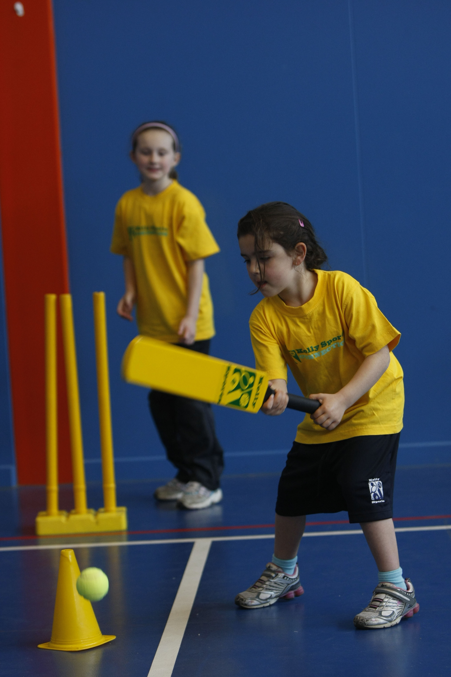

**FUNDAMENTAL**

**SKILLS PROGRAM**

Kelly Sports runs half hour programmes to teach children the fundamentals of sport. This 7 **WEEK** program is all inclusive with high participation. Our key aims are to develop and enhance the following skills – **running, jumping, catching, throwing, passing, kicking and striking:**

The Fundamental Skills Program includes:

**- Motor Skill Development  
- Balance and Hand- Eye Cordination  
- Introduction to a variety of sports -Soccer, Basketball, Football.**

**WHEN:** Wednesday

**COMMENCING:** 29/10/2014

**CONCLUDING:** 10/12/2014

**TIME:**  1:15pm – 1:45pm – Pre School (3 to 4 Yrs)

1:45pm – 2:15pm – Pre School (4 to 5 Yrs)

**WHEN:** Friday

**COMMENCING:** 31/10/2014

**CONCLUDING:** 12/12/2014

**TIME:**  9:30am – 10:00am – Pre School (3 to 4 Yrs)

10:00am – 10:30am – Pre School (4 to 5 Yrs)



**COST: $45** (enrol online go to [**www.kellysports.com.a**](http://www.kellysports.com.a)**u** and search for your school/centre)

**It’s here online enrolments !**

**To enrol**, please visit [www.kellysports.com.au](http://www.kellysports.com.au) or

fill out the enrolment form & **send** with a cheque or credit card details to:

Kelly Sports PO BOX 71, Moonee Vale, VIC, 3055.

Payment options available!

Do **not** leave enrolment forms at the school office

**VENUE: Goodstart Early Learning Joondalup**

**It’s here online enrolments !**

**To enrol**, please visit [www.kellysports.com.au](http://www.kellysports.com.au) or

fill out the enrolment form & **send** with a cheque or credit card details to:

Kelly Sports PO BOX 71, Moonee Vale, VIC, 3055.

Payment options available!

Do **not** leave enrolment forms at the school office

To enrol, please visit [**www.kellysports.com.au**](http://www.kellysports.com.au)and search for yourschool/centre or fill out the enrolment form below & sendwith a cheque or credit card details to: **PO BOX 3180 Joondalup W.A. 6027**. Payment options available! **Do not** leave enrolment forms at the school office.

**ONLINE ENROLMENT**

**www.kellysports.com.au**

**It’s here online enrolments !**

**To enrol**, please visit [www.kellysports.com.au](http://www.kellysports.com.au) or

fill out the enrolment form & **send** with a cheque or credit card details to:

Kelly Sports PO BOX 71, Moonee Vale, VIC, 3055.

Payment options available!

Do **not** leave enrolment forms at the school office

**It’s here online enrolments !**

**To enrol**, please visit [www.kellysports.com.au](http://www.kellysports.com.au) or

fill out the enrolment form & **send** with a cheque or credit card details to:

Kelly Sports PO BOX 71, Moonee Vale, VIC, 3055.

Payment options available!

Do **not** leave enrolment forms at the school office

**It’s here online enrolments !**

**To enrol**, please visit [www.kellysports.com.au](http://www.kellysports.com.au) or

fill out the enrolment form & **send** with a cheque or credit card details to:

Kelly Sports PO BOX 71, Moonee Vale, VIC, 3055.

Payment options available!

Do **not** leave enrolment forms at the school office