

**ST JOHNS**

**PRIMARY SCHOOL P** (03) 9384 2204

**E** [stephan@kellysports.com.au](mailto:stephan@kellysports.com.au)



**START OF YEAR HIP-HOP – Lunch Time Monday’s  
IT’S THE START OF THE YEAR AND IT’S TIME TO DANCE!**   
Join us in Term 1 for our HIP-HOP program for boys and girls. This program will combine both Hip Hop and Cheerleading to create a new and fresh routine. You will have a fantastic time learning the new moves in our high intensity, excitement-filled dance environment. Book early for this incredibly fun program!

**SUMMER MULTI SPORTS – After School Thursday’s**Come and experience all the fun in our 9 week Kelly Sports

Summer Multi Sport program.

Our Kelly Sports classes are all inclusive, fun & interactive with a key focus on maximum participation. Each week children will be introduced to new sports & activities in a positive environment. It’s a fantastic way to get your child active while having fun as well as building confidence and social skills!





**"The Kelly Sports Programs offer our students opportunities for physical activities; including dance & multi-sports. Conveniently located on our school grounds, they are popular with students and their families. Staff are skilled in working with young people to love active participation.”**

**How To Enrol?**Please visit [www.kellysports.com.au/events](http://www.kellysports.com.au/events) and search for your school.  
**Our new booking system requires upfront payments to secure your position. For more information, please call the head office.**

***Amanda Hay, Principal – Newtown Primary School***



**CLASS INFORMATION**

Only 14 spots available for each program so sign up fast to secure your position

Summer Multi Sports include **Soccer, Hockey, Basketball, Crazy games**, plus we will incorporate our Kelly Sports Modified games children love.

**Come & join us at lunch every Monday at lunch and afterschool every Thursday**

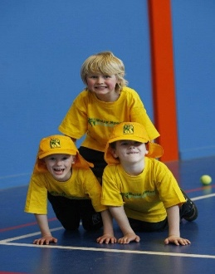

**START OF YEAR HIP HOP - MONDAYS**   
**Dates: 4th February to 1st April**  
**Time: 11am – 12pm**  
**Year Levels: Prep – 4  
Cost: $105.60 (Inc GST) (11th March – Labour Day no session)**

**SUMMER MULIT SPORTS – THURSDAYS**   
**Dates: 7th February to 4th April**  
**Time: 3:20pm – 4:20pm**  
**Year Levels: Prep – 4  
Cost: $118.80 (Inc GST)**

