

**IVANHOE PRIMARY SCHOOL**

**Stephan Achilleos**  
**M**  0413879592  
**E** stephan@kellysports.com.au



**STREET DANCE – Lunch Time Monday’s**

Street Dance takes elements of hip-hop and pop dancing styles and specifies on where it all began…the streets! Students will embark on an exciting journey learning various new moves to add to their collection. Our experience staff will work on a brand new routine throughout the term to showcase to parents and friends. Sign up fast as students will have a fantastic time learning the new moves in our high intensity, excitement-filled street dance environment.





**How To Enrol?**Please visit [www.kellysports.com.au/events](http://www.kellysports.com.au/events) and search for your school.  
Our new booking system requires upfront payments to secure your position. For more information, please call the head office.

**"The Kelly Sports Programs offer our students opportunities for physical activities; including dance & multi-sports. Conveniently located on our school grounds, they are popular with students and their families. Staff are skilled in working with young people to love active participation.”**



***Amanda Hay, Principal – Newtown Primary School***

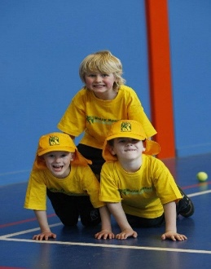

**When: Wednesday**   
**Starts: 17th July**   
**Finishes: 18th September**   
**Time: 1:50pm – 2:40pm**  
**Year Levels: Prep – 4  
Cost: $132.00 (Inc GST)   
(10 weeks)**

**CLASS INFORMATION**

Only 14 spots available so sign up fast to secure your position  
  
At the end of the term parents will be invited to an open class to watch the full dance routine.

Come and join us every Wednesday at Lunch time.

