**Stephan Achilleos**  
**M**  0413879592  
**E** stephan@kellysports.com.au

**Only $13.20 per week!**

**HEIDELBERG PRIMARY SCHOOL**

**WHEN:** Monday

**COMMENCING:** 15/07/2019

**CONCLUDING:** 16/09/2019

**TIME:** 1pm – 1.50pm

**YEAR LEVELS:** **P – 4**

**COST (GST inc):** $132.00 (10 weeks)

**STREET DANCE**



Streets Dance takes elements of hip-hop and pop dancing styles and specifies on where it all began…the streets! Students will embark on an exciting journey learning various new moves to add to their collection. Our experience staff will work on a brand new routine throughout the term to showcase to parents and friends. Sign up fast as students will have a fantastic time learning the new moves in our high intensity, excitement-filled street dance environment.



**CRAZY WINTER SOCCER**



Learn how to play like your heroes and have lots of fun learning all the skills in the game of SOCCER. Famous for being a winter sport the Kelly Sports team will teach you all the basic skills in a safe and challenging environment. If you already play soccer this is your chance to take your game to the next level and if you’re just starting out a perfect way to learn why it is “The World Game”.

**WHEN:** Monday

**COMMENCING:** 15/07/2019

**CONCLUDING:** 16/09/2019

**TIME:** 3.40pm - 4.40pm

**YEAR LEVELS:** **P – 4**

**COST (GST inc):** $132.00 (10 weeks)



**WICKED WINTER SPORTS**

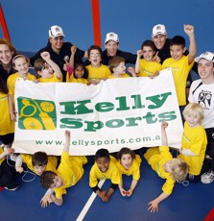

**WHEN:** Wednesday

**COMMENCING:** 17/07/2019

**CONCLUDING:** 18/09/20199Queens Bday

**TIME:** 3.40pm – 4.40pm

**YEAR LEVELS:** **P – 4**

**COST (INC GST):** $132.00 (10 weeks)

Kelly Sports is back in Term 3 for **WICKED WINTER SPORTS!!**   
Our Kelly Sports classes are all inclusive, fun & interactive with a key focus on maximum participation. Each week children will be introduced to new sports & activities in a positive environment. It’s a fantastic way to get your child active while having fun as well as building confidence and social skills!

**It’s here online enrolments !**

**To enrol**, please visit [www.kellysports.com.au](http://www.kellysports.com.au) or

fill out the enrolment form & **send** with a cheque or credit card details to:

Kelly Sports PO BOX 71, Moonee Vale, VIC, 3055.

Payment options available!

Do **not** leave enrolment forms at the school office

**­**

**It’s here online enrolments !**

**To enrol**, please visit [www.kellysports.com.au](http://www.kellysports.com.au) or

fill out the enrolment form & **send** with a cheque or credit card details to:

Kelly Sports PO BOX 71, Moonee Vale, VIC, 3055.

Payment options available!

Do **not** leave enrolment forms at the school office

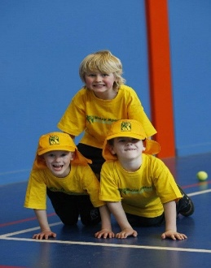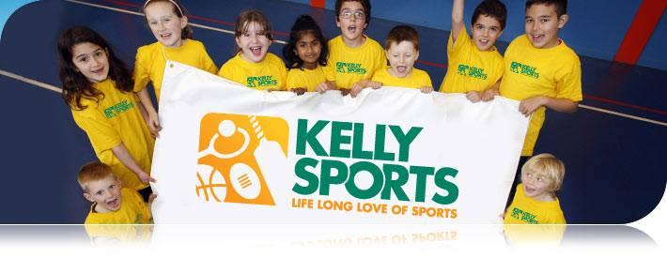

**CLASS INFORMATION**

Only 14 spots available for each session so sign up fast to secure your position

Activities include **Soccer, AFL, T-Ball, Basketball/Netball p**lus we will incorporate our Kelly Sports Modified games children love

Come and join us in Term 3.

**It’s here online enrolments !**

**To enrol**, please visit [www.kellysports.com.au](http://www.kellysports.com.au) or

fill out the enrolment form & **send** with a cheque or credit card details to:

Kelly Sports PO BOX 71, Moonee Vale, VIC, 3055.

Payment options available!

Do **not** leave enrolment forms at the school office

**It’s here online enrolments !**

**To enrol**, please visit [www.kellysports.com.au](http://www.kellysports.com.au) or

fill out the enrolment form & **send** with a cheque or credit card details to:

Kelly Sports PO BOX 71, Moonee Vale, VIC, 3055.

Payment options available!

Do **not** leave enrolment forms at the school office

**It’s here online enrolments !**

**To enrol**, please visit [www.kellysports.com.au](http://www.kellysports.com.au) or

fill out the enrolment form & **send** with a cheque or credit card details to:

Kelly Sports PO BOX 71, Moonee Vale, VIC, 3055.

Payment options available!

Do **not** leave enrolment forms at the school office