

**ST JOHNS**

**PRIMARY SCHOOL P** (03) 9384 2204

**E** [stephan@kellysports.com.au](mailto:stephan@kellysports.com.au)



**JAZZ FUNK – Lunch Time Monday’s**Jazz – Funk takes elements of both Hip Hop and Jazz, combined into one dance style that gives students a chance to release energy and dance with power and passion. Our experience staff will work on a brand new routine through out the term to showcase to parents and friends. Sign up fast as students will have a fantastic time learning the new moves in our high intensity, excitement-filled dance environment.

**AWESOME AUTUMN SPORTS – After School Thursday’s**Kelly Sports is back in Term 2 for a **AWESOME AUTUMN SPORTS!!**   
Our Kelly Sports classes are all inclusive, fun & interactive with a key focus on maximum participation. Each week children will be introduced to new sports & activities in a positive environment. It’s a fantastic way to get your child active while having fun as well as building confidence and social skills!





**"The Kelly Sports Programs offer our students opportunities for physical activities; including dance & multi-sports. Conveniently located on our school grounds, they are popular with students and their families. Staff are skilled in working with young people to love active participation.”**

**How To Enrol?**Please visit [www.kellysports.com.au/events](http://www.kellysports.com.au/events) and search for your school.  
**Our new booking system requires upfront payments to secure your position. For more information, please call the head office.**

***Amanda Hay, Principal – Newtown Primary School***



**CLASS INFORMATION**

Only 14 spots available for each program so sign up fast to secure your position

Summer Multi Sports include **Soccer, Hockey, Basketball & AFL** plus we will incorporate our Kelly Sports Modified games children love.

**Come & join us at lunch every Monday at lunch and afterschool every Thursday**

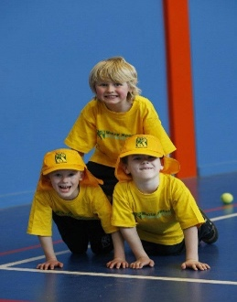

**JAZZ FUNK- MONDAYS**   
**Dates: 29th April to 24th June**  
**Time: 11am – 12pm**  
**Year Levels: Prep – 4  
Cost: $105.60 (Inc GST) (10th June due to Queen’s Birthday No Session)**

**AWESOME AUTUMN SPORTS – THURSDAYS**   
**Dates: 2nd May to 27th June**  
**Time: 3:20pm – 4:20pm**  
**Year Levels: Prep – 4  
Cost: $118.80 (Inc GST)**

