 P.O. Box 492,Essendon Nth 3041

**M 0410 588 800**

**Hurry**

**Places  
Limited**

**E** jordan@kellysports.com.au

**ST BERNADETTES P.S**

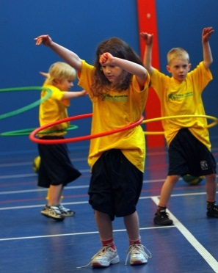

**DANCE DANCE DANCE**

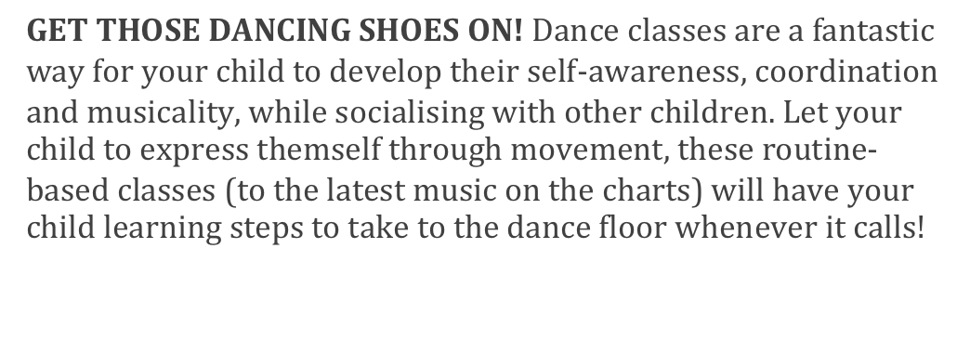

**WHEN:** Tuesday

**COMMENCING:** 29/07/14

**CONCLUDING:** 16/09/14

**TIME:** Lunchtime

**YEAR LEVELS: P - 6**

**WILD WINTER SPORTS**

SIGN UP FOR WILD WINTER OF SPORTS THIS TERM! Our sports program will ensure your child will develop new skills, build coordination and awareness and increase their confidence. This 8 week program will allow your child to play a range of different sports; these include: Crazy Games, Soccer, Football, and Hockey. Your child will learn how to play fairly and have fun all in an enjoyable environment.

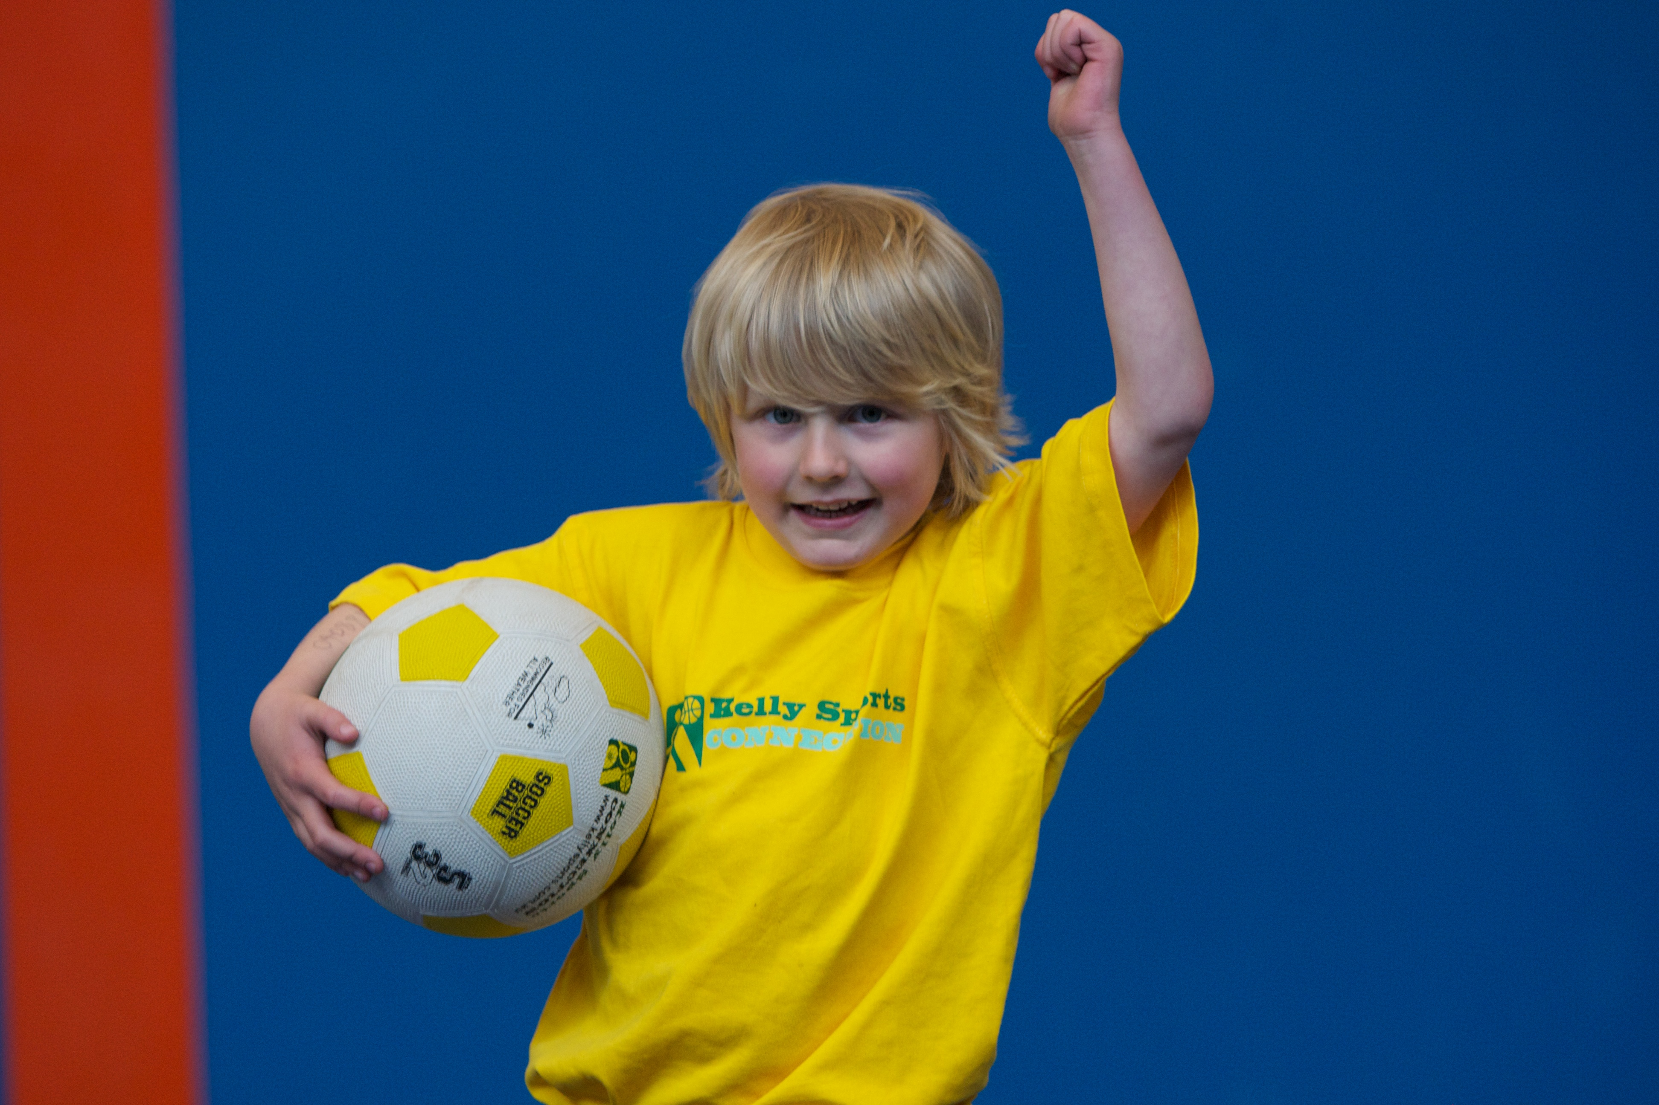

**WHEN:** Tuesday

**COMMENCING:** 29/07/14

**CONCLUDING:** 16/09/14

**TIME:** 3:40 – 5:00

**YEAR LEVELS:** P – 6



**COST: $80 (enrol at www.kellysports.com.au/zone/Ivanhoe& search your school)**

**VENUE: ST BERNADETTE’S PRIMARY SCHOOL – Cunningham Centre if cold/wet weather**



To enrol, please visit **w**ww.kellysports.com.au/zone/Ivanhoe

or fill out the below enrolment form & sendwith a cheque or credit

card details to: **PO BOX 492, Essendon Nth VIC 3041**. **Do not** leave enrolment forms at the school office.

**ONLINE ENROLMENT**

**www.kellysports.com.au/zone/ivanhoe**

**ENROLMENT FORM**

□ **AWESOME AUTUMN SPORTS** (After School) □ **DANCE DANCE DANCE** (Lunch)

School: Year Level:

Name: Room No:

Address: Post Code:

Phone: Mobile/Work:

Email: Medical Conditions:

At the completion of after school clinics, does your child? □ Go to after care □ Get collected

**Parents’ consent: I hereby authorise Kelly Sports to act on my behalf should my child require medical attention, and release   
Kelly Sports Ivanhoe from any liability for injury incurred by my child at Kelly Sports programmes.**

Parent/Caregiver name: Signature:

Amount Paid: $ Credit card payment: □ **Visa** □ **Master card**  CCV□□□

Card Number: □□□□ □□□□ □□□□ □□□□ Expiry Date: □□/□□

**­**

**It’s here online enrolments !**

**To enrol**, please visit [www.kellysports.com.au](http://www.kellysports.com.au) or

fill out the enrolment form & **send** with a cheque or credit card details to:

Kelly Sports PO BOX 71, Moonee Vale, VIC, 3055.

Payment options available!

Do **not** leave enrolment forms at the school office

**It’s here online enrolments !**

**To enrol**, please visit [www.kellysports.com.au](http://www.kellysports.com.au) or

fill out the enrolment form & **send** with a cheque or credit card details to:

Kelly Sports PO BOX 71, Moonee Vale, VIC, 3055.

Payment options available!

Do **not** leave enrolment forms at the school office

**It’s here online enrolments !**

**To enrol**, please visit [www.kellysports.com.au](http://www.kellysports.com.au) or

fill out the enrolment form & **send** with a cheque or credit card details to:

Kelly Sports PO BOX 71, Moonee Vale, VIC, 3055.

Payment options available!

Do **not** leave enrolment forms at the school office

**It’s here online enrolments !**

**To enrol**, please visit [www.kellysports.com.au](http://www.kellysports.com.au) or

fill out the enrolment form & **send** with a cheque or credit card details to:

Kelly Sports PO BOX 71, Moonee Vale, VIC, 3055.

Payment options available!

Do **not** leave enrolment forms at the school office