
P P.O. Box 492 Essendon North 3041
M Jordan Doering 0410 588 800

E Jordan@kellysports.com.au
Special O


GOODSTART ROSANNA
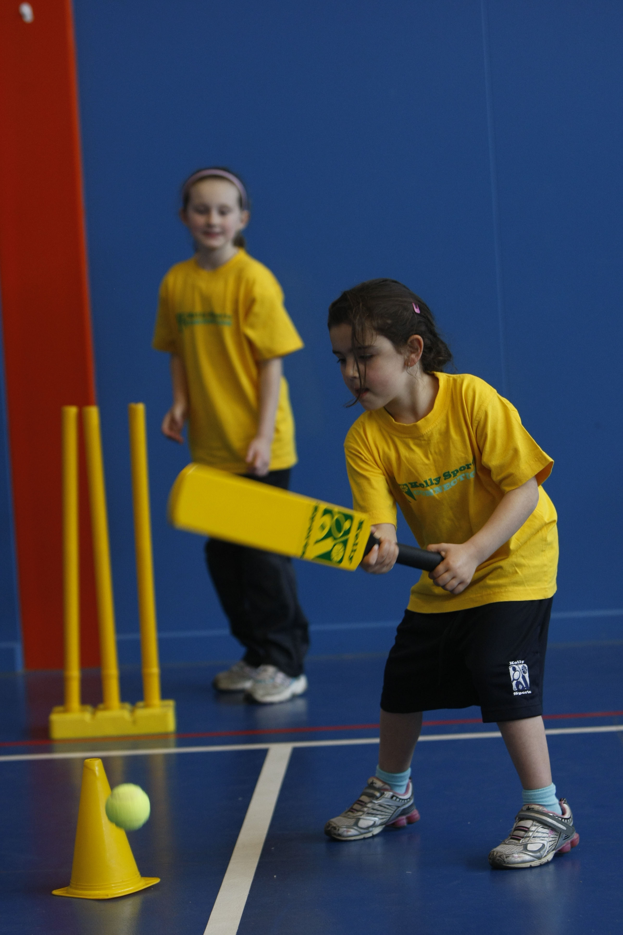
FUNDAMENTAL SKILLS PROGRAM

Kelly Sports runs programmes to teach children the fundamentals of sport. This 8 WEEK program is all inclusive with high participation. Our key aims are to develop and enhance the following skills – running, jumping, catching, throwing, passing, kicking and striking:
The Fundamental Skills Program includes:
- Motor Skill Development
- Balance and Hand- Eye Coordination
- Introduction to a variety of sports -Soccer, Basketball, Cricket, Football, and more.

WHEN: Monday
COMMENCING: 28/7/14
CONCLUDING: 15/09/14
TIME: 10:30am – 12:30pm

COST: $64 (enrol online go to www.kellysports.com.au/zone/ivanhoe and search for your centre)
It’s here online enrolments !
To enrol, please visit www.kellysports.com.au or
fill out the enrolment form & send with a cheque or credit card details to:
Kelly Sports PO BOX 71, Moonee Vale, VIC, 3055.
Payment options available!
Do not leave enrolment forms at the school office

VENUE: Goodstart Rosanna
It’s here online enrolments !
To enrol, please visit www.kellysports.com.au or
fill out the enrolment form & send with a cheque or credit card details to:
Kelly Sports PO BOX 71, Moonee Vale, VIC, 3055.
Payment options available!
Do not leave enrolment forms at the school office

NOTE: Kelly Sports Ivanhoe is a Registered Child Care: Rebates are available for families.
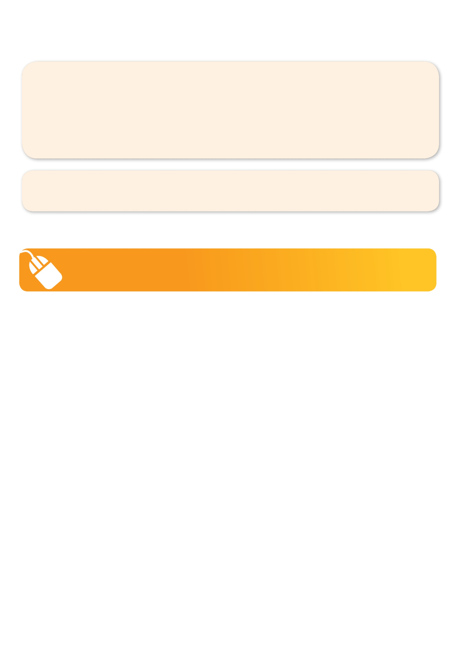
It’s here online enrolments !
To enrol, please visit www.kellysports.com.au or
fill out the enrolment form & send with a cheque or credit card details to:
Kelly Sports PO BOX 71, Moonee Vale, VIC, 3055.
Payment options available!
Do not leave enrolment forms at the school office

It’s here online enrolments !
To enrol, please visit www.kellysports.com.au or
fill out the enrolment form & send with a cheque or credit card details to:
Kelly Sports PO BOX 71, Moonee Vale, VIC, 3055.
Payment options available!
Do not leave enrolment forms at the school office

It’s here online enrolments !
To enrol, please visit www.kellysports.com.au or
fill out the enrolment form & send with a cheque or credit card details to:
Kelly Sports PO BOX 71, Moonee Vale, VIC, 3055.
Payment options available!
Do not leave enrolment forms at the school office

To enrol, please visit www.kellysports.com.au/zone/ivanhoe or fill out the below enrolment form & send with a cheque or credit card details to: PO BOX 492, Essendon North 3041 Payment options available!
Do not leave enrolment forms at the school office.

ONLINE ENROLMENT
www.kellysports.com.au/zone/Ivanhoe

ENROLMENT FORM
□ Pre kinder □ Kinder
School: Year Level:
Name: Room No:
Address: Post Code:
Phone: Mobile/Work:
Email: Medical Conditions:

Parents’ consent: I hereby authorise Kelly Sports to act on my behalf should my child require medical attention, and release
Kelly Sports from any liability for injury incurred by my child at Kelly Sports programmes.
Parent/Caregiver name: Signature:
Amount Paid: $ Credit card payment:  Visa  MasterCard CCV
Card Number:     Expiry Date: /

