

**ROSANNA GOLF**

**PRIMARY SCHOOL P** (03) 9384 2204

**M** 0403 149 391

** E chrishoegel@kellysports.com.au**

**SPRING INTO SPORT**

Come and experience all the fun in our 9 week Kelly Sports

Mighty Multi Sport program.

Start the new School term by enrolling in this fantastic Kelly sports program. Join up with your friends and develop your skills in a fun, safe and exciting sporting environment. With a new sport every 2 weeks the kids will love the variety and will be able to work on a range wide of sporting skills.

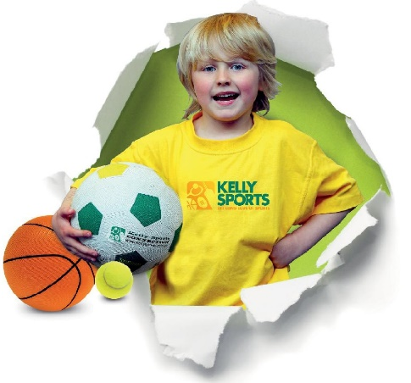



**How To Enrol?**Please visit [www.kellysports.com.au/events](http://www.kellysports.com.au/events) and search for your school.  
Our new booking system requires upfront payments to secure your position. For more information, please call the head office.



**"The Kelly Sports Programs offer our students opportunities for physical activities; including dance & multi-sports. Conveniently located on our school grounds, they are popular with students and their families. Staff are skilled in working with young people to love active participation.”**



***Amanda Hay, Principal – Newtown Primary School***

**CLASS INFORMATION**

Activities include **AFL, Soccer, Hockey, Basketball, p**lus we will incorporate our Kelly Sports Modified games children love

Come & join us every Tuesday straight after school.

No Programs Melbourne cup weekend (Tues 6th Nov)

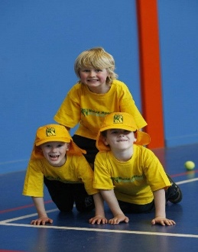

**When: Tuesday**  
**Starts: 9th October**  
**Finishes: 11th December**  
**Time: 3:40pm – 4:40pm**  
**Year Levels: Prep – 4  
Cost: $118.80 (Inc GST)**

