

**ST JOHNS**

**PRIMARY SCHOOL Stephan Achilleos**  
 **M**  0413879592  
 **E** stephan@kellysports.com.au





**STREETS DANCE – Lunch Time Monday’s**Streets Dance takes elements of hip-hop and pop dancing styles and specifies on where it all began…the streets! Students will embark on an exciting journey learning various new moves to add to their collection. Our experience staff will work on a brand new routine throughout the term to showcase to parents and friends. Sign up fast as students will have a fantastic time learning the new moves in our high intensity, excitement-filled street dance environment.

**WICKED WINTER SPORTS – After School Thursday’s**Kelly Sports is back in Term 3 for **WICKED WINTER SPORTS!!**   
Our Kelly Sports classes are all inclusive, fun & interactive with a key focus on maximum participation. Each week children will be introduced to new sports & activities in a positive environment. It’s a fantastic way to get your child active while having fun as well as building confidence and social skills!



**How To Enrol?**Please visit [www.kellysports.com.au/events](http://www.kellysports.com.au/events) and search for your school.  
**Our new booking system requires upfront payments to secure your position. For more information, please call the head office.**

**"The Kelly Sports Programs offer our students opportunities for physical activities; including dance & multi-sports. Conveniently located on our school grounds, they are popular with students and their families. Staff are skilled in working with young people to love active participation.”**

***Amanda Hay, Principal – Newtown Primary School***



**CLASS INFORMATION**

Only 14 spots available for each program so sign up fast to secure your position

Summer Multi Sports include **Soccer, AFL, Basketball/Netball & T-Ball** plus we will incorporate our Kelly Sports Modified games children love.

**Come & join us at lunch every Monday at lunch and afterschool every Thursday**

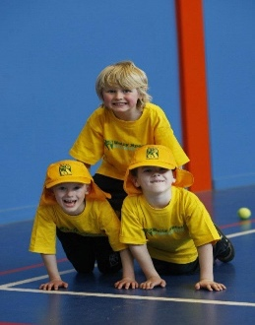

**STREET DANCE - MONDAYS**   
**Dates: 15th July – 16th September**  
**Time: 11am – 12pm**  
**Year Levels: Prep – 4  
Cost: $132.00 (Inc GST) (10 weeks)**

**WICKED WINTER SPORTS – THURSDAYS**   
**Dates: 18th July – 19th September**  
**Time: 3:20pm – 4:20pm**  
**Year Levels: Prep – 4  
Cost: $132.00 (Inc GST) (10 weeks)**

