 P.O. Box 71, Moonee Vale 3055

**Only $12 per week!**

**T** (03) 9384 2204

**E** jeff@kellysports.com.au

**HEIDELBERG PRIMARY SCHOOL**

**WHEN:** Monday

**COMMENCING:** 15/10/18

**CONCLUDING:** 10/12/18

**TIME:** 1pm – 1.50pm

**YEAR LEVELS:** **P – 4**

**COST (GST inc):** $118.80

**END OF YEAR CHEER**



**IT’S THE END OF THE YEAR AND IT’S TIME TO CHEER!**

Join us in Term 4 for our Cheerleading program for boys and girls. This program will combine both Hip Hop and Cheerleading to create a new and fresh routine. You will have a fantastic time learning the new moves in our high intensity, excitement-filled dance environment. Book early for this incredibly fun program



**SUPER SOCCER**



Our Kelly Sports classes are all inclusive, fun and interactive with a key focus on maximum participation. Each week children will be introduced to new sports and activities in a positive environment. It’s a fantastic way to get your child active while having fun as well as building confidence and social skills!

**WHEN:** Monday

**COMMENCING:** 15/10/18

**CONCLUDING:** 10/12/18

**TIME:** 3.40pm – 4.40pm

**YEAR LEVELS:** **P – 4**

**COST (INC GST):** $118.80



**SPRING MULTI SPORTS**



**WHEN:** Wednesday

**COMMENCING:** 17/10/18

**CONCLUDING:** 12/12/18

**TIME:** 3.40pm – 4.40pm

**YEAR LEVELS:** **P – 4**

**COST (INC GST):** $118.80

Learn how to play like your heroes and have lots of fun learning all the skills in the game of SOCCER. The Kelly Sports team will teach you all the basic skills in a safe and challenging environment. If you already play soccer this is your chance to take your game to the next level!

**It’s here online enrolments !**

**To enrol**, please visit [www.kellysports.com.au](http://www.kellysports.com.au) or

fill out the enrolment form & **send** with a cheque or credit card details to:

Kelly Sports PO BOX 71, Moonee Vale, VIC, 3055.

Payment options available!

Do **not** leave enrolment forms at the school office

**­**

**It’s here online enrolments !**

**To enrol**, please visit [www.kellysports.com.au](http://www.kellysports.com.au) or

fill out the enrolment form & **send** with a cheque or credit card details to:

Kelly Sports PO BOX 71, Moonee Vale, VIC, 3055.

Payment options available!

Do **not** leave enrolment forms at the school office

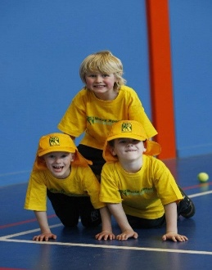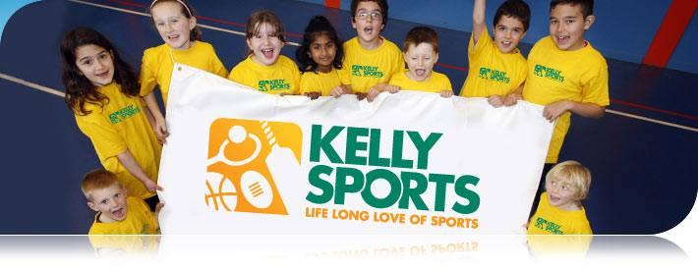

**CLASS INFORMATION**

Only 15 spots available for each session so sign up fast to secure your position

Activities include **Soccer, Hockey, Basketball, Cricket & Crazy games, p**lus we will incorporate our Kelly Sports Modified games children love

Come and join us in Term 4.

**It’s here online enrolments !**

**To enrol**, please visit [www.kellysports.com.au](http://www.kellysports.com.au) or

fill out the enrolment form & **send** with a cheque or credit card details to:

Kelly Sports PO BOX 71, Moonee Vale, VIC, 3055.

Payment options available!

Do **not** leave enrolment forms at the school office

**It’s here online enrolments !**

**To enrol**, please visit [www.kellysports.com.au](http://www.kellysports.com.au) or

fill out the enrolment form & **send** with a cheque or credit card details to:

Kelly Sports PO BOX 71, Moonee Vale, VIC, 3055.

Payment options available!

Do **not** leave enrolment forms at the school office

**It’s here online enrolments !**

**To enrol**, please visit [www.kellysports.com.au](http://www.kellysports.com.au) or

fill out the enrolment form & **send** with a cheque or credit card details to:

Kelly Sports PO BOX 71, Moonee Vale, VIC, 3055.

Payment options available!

Do **not** leave enrolment forms at the school office