

**ST JOHNS LUTHERAN**

**PRIMARY SCHOOL M** 0428 055 677

** E** [geelong@kellysports.com.au](mailto:geelong@kellysports.com.au)

**MULTI SPORTS MANIA!**

Come and experience all the fun our 9 week Kelly Sports

Multi Sports Mania program has to offer.

Conveniently located after school each Tuesday in a fun & positive environment, join us for  
**Footy, Soccer, Basketball, Cricket and much more!!**



**COST: $80 WEEKS for 9 weeks** (To enrol, please visit [**www.kellysports.com.au**](http://www.kellysports.com.au/)**/events** or call **0428 055 677**) **Students are offered one free trial session before signing up**

**VENUE: ST JOHNS LUTHERAN PRIMARY SCHOOL**



**"The Kelly Sports Programs offer our students opportunities for physical activities; including dance & multi-sports. Conveniently located on our school grounds, they are popular with students and their families. Staff are skilled in working with young people to love active participation.”**

***Amanda Hay, Principal – Newtown Primary School***



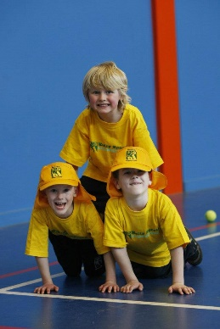

**When: Thursdays**

**Starts: 4th May**

**Finishes: 29th June**

**Time: 3:30pm – 4:40pm**

**Year Levels: Prep - 4**

**CLASS INFORMATION**

Our Kelly Sports program allows your child to play a range of dynamic & active sports over a 9 week program.   
  
Activities include **Footy, Soccer, Athletics, Basketball and much more!**

Come & join us every Tuesday straight after school.

