How to change your Electronic Sign in/out Pin

1. **Log in to your profile on our Kelly Sports Website:** [**kellysports.com.au**](http://kellysports.com.au)
2. **Click on my Details**



1. **Click Change My Pin:**

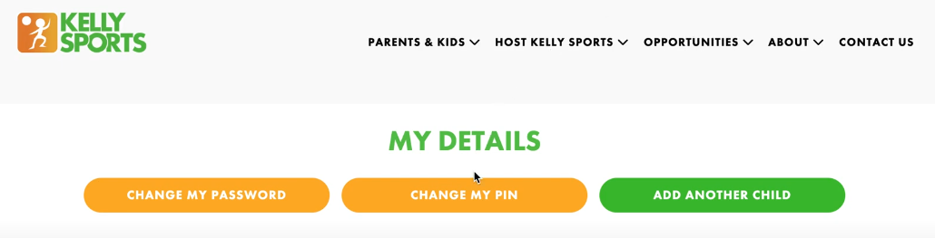

1. **Choose a 4 digit pin, confirm 4 digit pin and click save:**

