

**ST ROBERTS NEWTOWN  
 PRIMARY SCHOOL M** 0423 280 873

** E** [geelong@kellysports.com.au](mailto:geelong@kellysports.com.au)

**KELLY SPORTS DANCE**

**HIP HOP!**

**Do you love to DANCE?**

Our Kelly Sports 8 week Hip Hop classes are all inclusive, fun and interactive with a key focus on maximum participation!

This lunchtime program is not only a fantastic way for your child to get their groove on, but also great for their confidence and social skills! Don’t be afraid to bust a move!

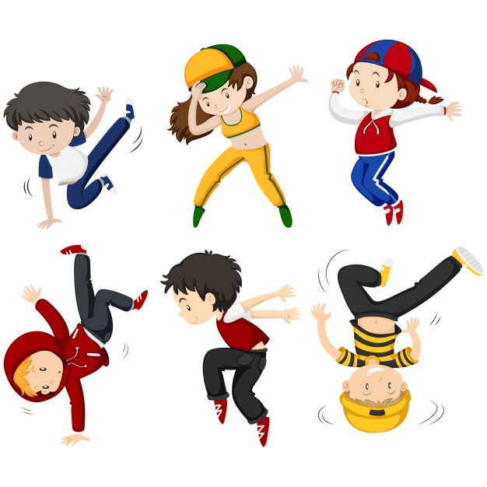

**When: Tuesdays**

**Starts: 6th February 2018**

**Finishes: 27th March 2018**

**Time: 1:15pm – 2:15pm**

**Year Levels: Prep - 4**



**COST: $80 – 8 weeks** (To enrol, please visit [**www.kellysports.com.au**](http://www.kellysports.com.au/)**/events** or call **0423 280 873**)

**VENUE: ST ROBERTS NEWTOWN PRIMARY SCHOOL**



**"The Kelly Sports Programs offer our students opportunities for physical activities; including dance & multi-sports. Conveniently located on our school grounds, they are popular with students and their families. Staff are skilled in working with young people to love active participation.”**

***Amanda Hay, Principal – Newtown Primary School***



**MULTI SPORT MAYHEM!**

Come and experience all the fun our 7 week Kelly Sports ‘Multi Sport Mayhem’ Program has to offer.

Conveniently located after school each Friday in a fun and positive environment! Join us for  
**Basketball, Soccer, Cricket, Tennis and much more!**



**When: Fridays**

**Starts: 9th February**

**Finishes: 23rd March 2018**

**Time: 3:30pm – 4:40pm**

**Year Levels: Prep - 4**



**COST: $60 for 7 WEEKS** (To enrol, please visit [**www.kellysports.com.au**](http://www.kellysports.com.au/)**/events** or call **0428 055 677**)

**Students are offered one free trial session before signing up!**

**VENUE: ST ROBERTS NEWTOWN PRIMARY SCHOOL**

