

**ASCOT VALE**

**PRIMARY SCHOOL M** 0403 149 391

 **E** [mitch@kellysports.com.au](mailto:mitch@kellysports.com.au)

**AWSOME AUTUUM SPORTS PROGRAM**

Come and experience all the fun our 9 week Kelly Sports

Awsome Autuum Sports program has to offer.

Our Kelly Sports classes are all inclusive, fun & interactive with a key focus on maximum participation. Each week children will be introduced to new sports & activities in a positive environment. It’s a fantastic way to get your child active while having fun as well as building confidence and social skills!

Conveniently located after school each Wednesday in a fun & positive environment!

**AFL, Basketball, Soccer & Hockey!!!**



**COST: $108 – 9 WEEKS** (To enrol, please visit [**www.kellysports.com.au**](http://www.kellysports.com.au/)**/events** or call **0403 149 391**)

**VENUE: ASCOT VALE PRIMARY SCHOOL**

**MEETING PLACE: ON THE OVAL NEXT TO KELLY SPORTS BANNER**

**"The Kelly Sports Programs offer our students opportunities for physical activities; including dance & multi-sports. Conveniently located on our school grounds, they are popular with students and their families. Staff are skilled in working with young people to love active participation.”**



***Amanda Hay, Principal – Newtown Primary School***



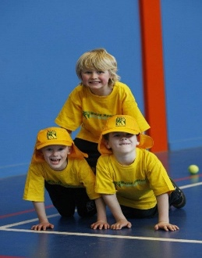

**CLASS INFORMATION**

Our Kelly Sports program allows your child to play a range of dynamic & active sports over a 9-week program.  
  
Activities include **BASKETBALL, AFL, SOCCER  
& HOCKEY!**

Come & join us every Wednesday straight after school.

**When: Wednesdays**

**Starts: 2nd May**

**Finishes: 27th June**

**Time: 3:40pm – 4:40pm**

**Year Levels: Prep - 4**

