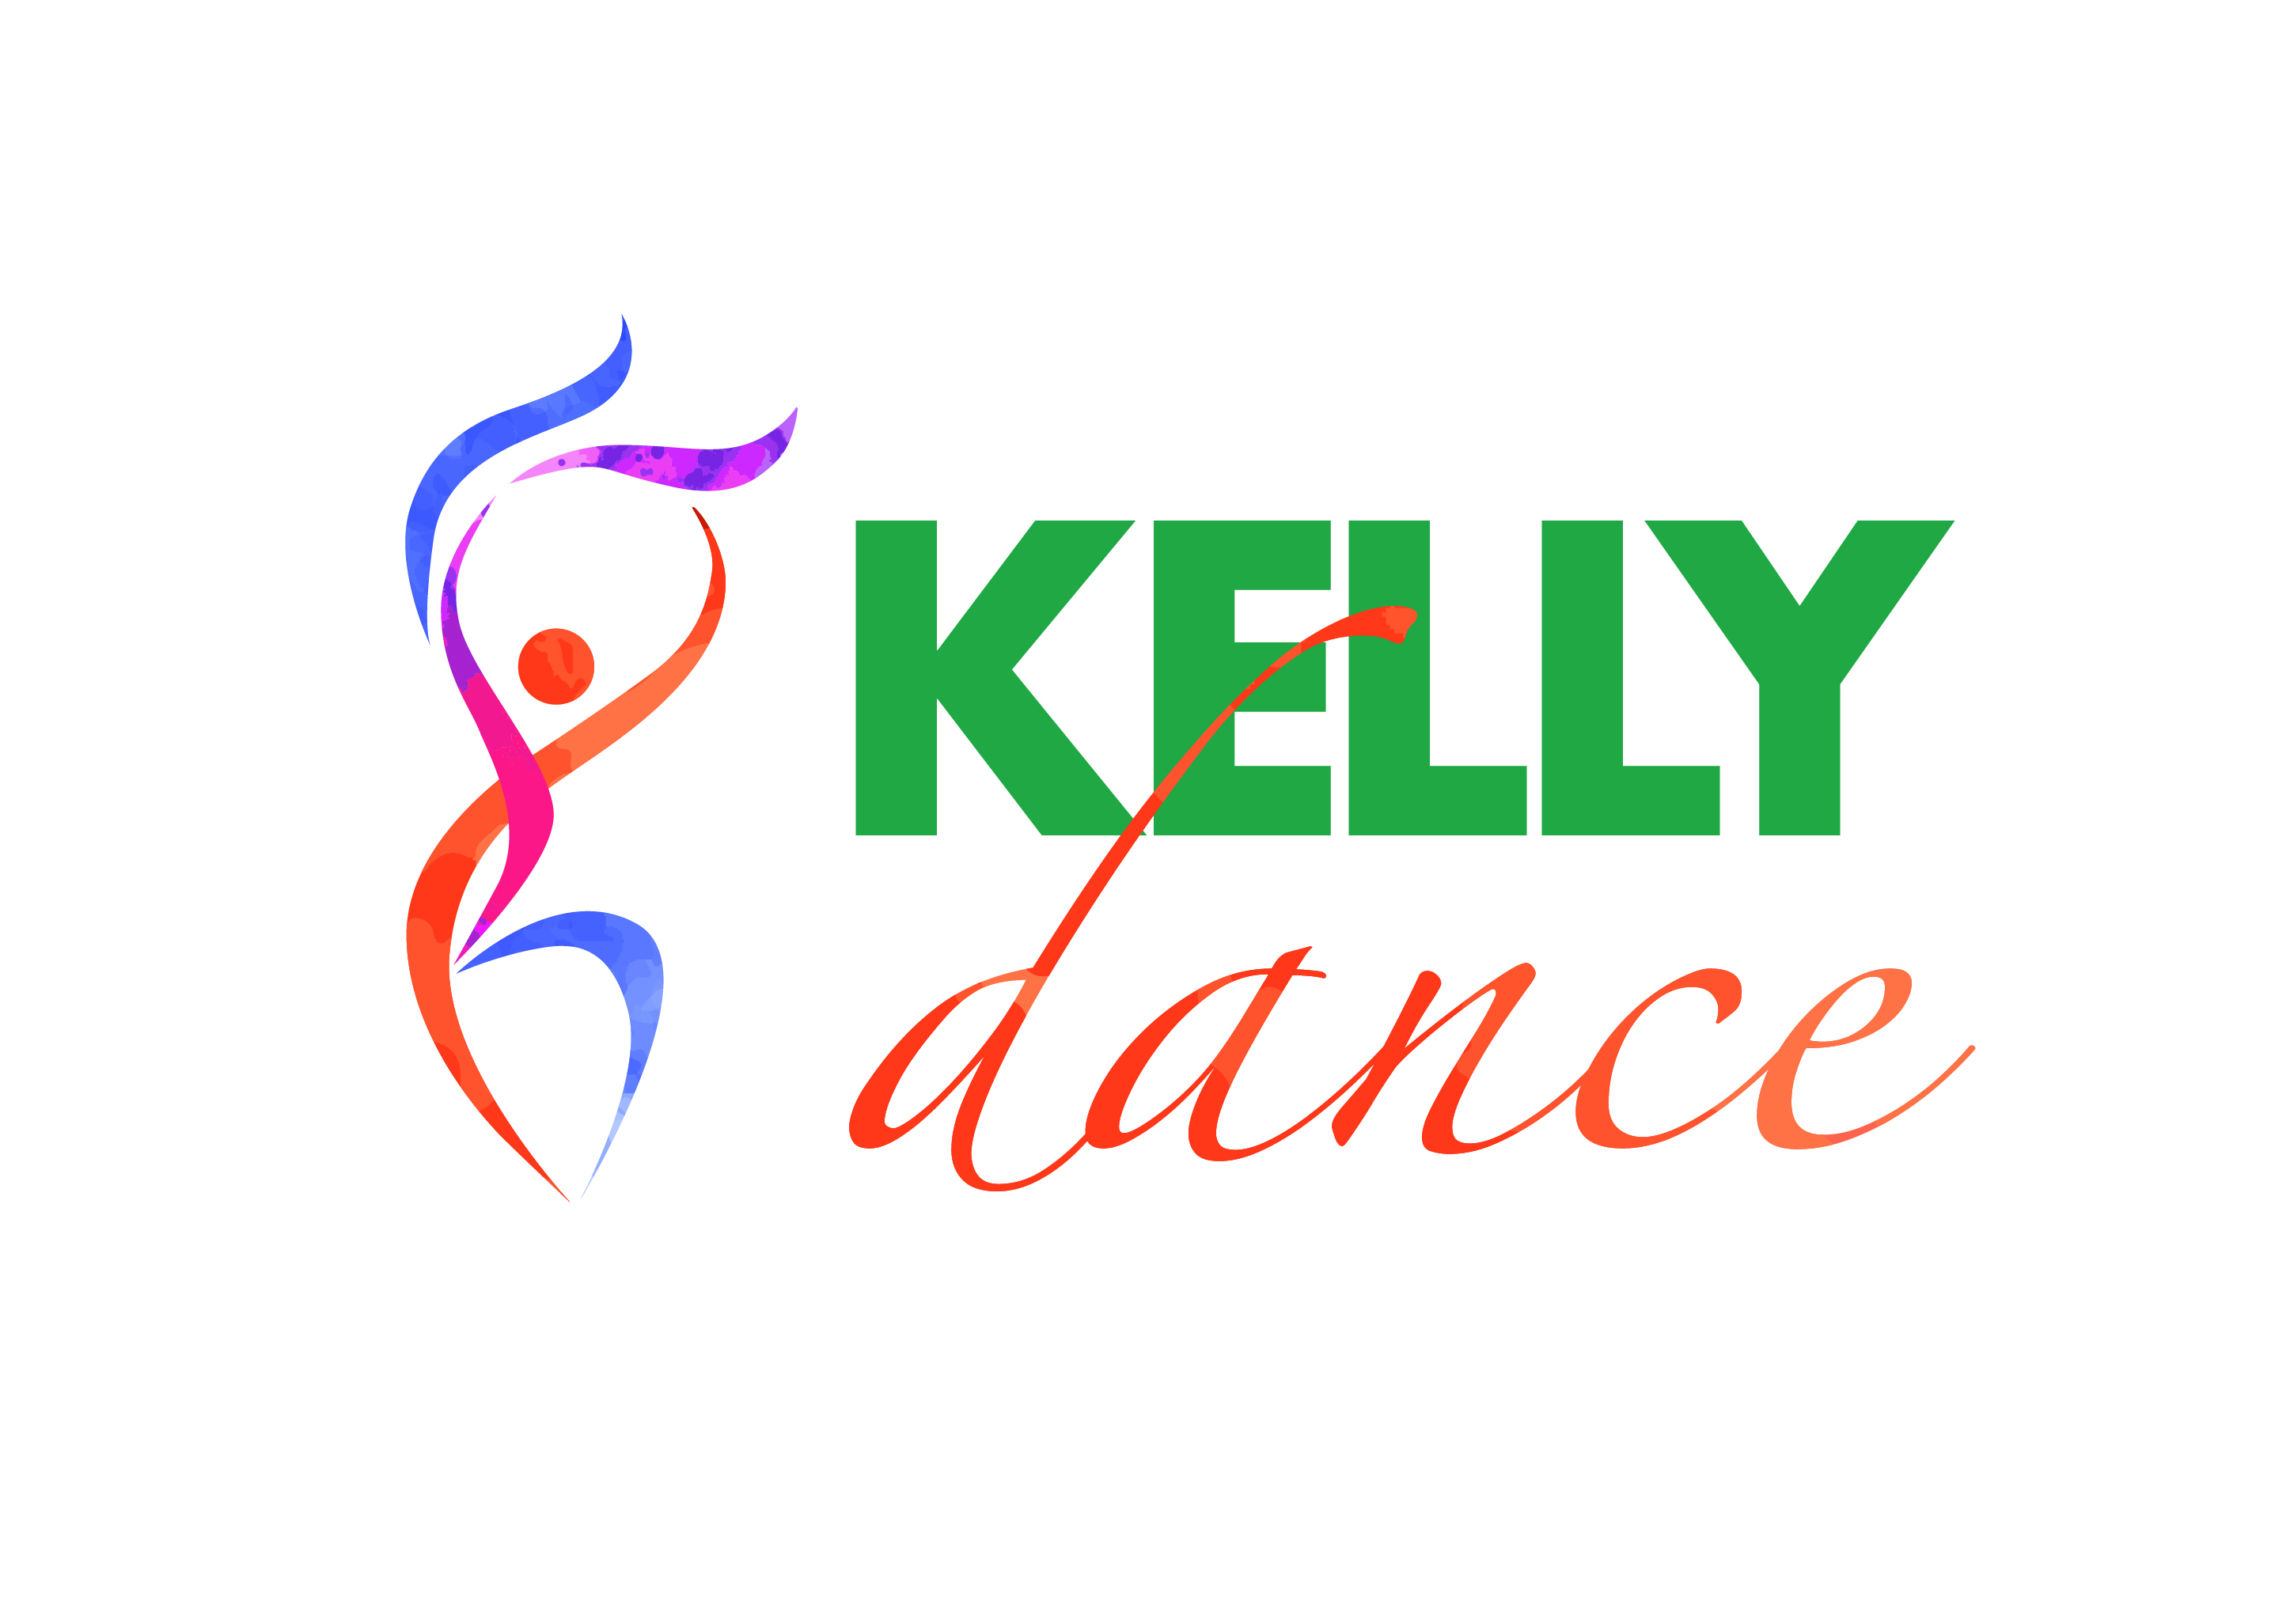

***Kelly School of Dance***

***presents***

***A Showcase of Dance***

Yes it’s here!!!! It’s time for our hard working little and Big!! cherubs to show off their new dances

We are very excited to be holding our concert .

A reminder that this is still in keeping with our philosophy that dance should be fun and non threatening. So with this in mind, this concert will be a very low key event aimed at allowing the students to share their talents with their friends and family.

Costumes will be kept to a minimum and most of it will be sourced by the Kelly School of Dance. We may ask parents to provide the odd item which you will probably already have.

**Where:** Flemington Primary School, Performing Arts Centre

Cnr Mount Alexander Rd and Padman Lane

**When:** Sunday 4th of December, 2016

**Time:**  6:30pm

**Ticket Prices:** $15:00 per ticket per adult

$7:00 per Child

(No ticket required for students performing)

Tickets will be available for pre purchase from Monday 21st Via Miss Sarah.

(Please ensure you have the correct money) or on the night.

On Concert day we ask that the students are dropped off to Flemington Primary School, Performing Arts Centre by 5:45pm so they have time to dress and prepare. They should bring everything that they will need for their performance for the Dress rehearsal and leave for the production

**FULL DRESS Rehearsal will commence at 12 - 2pm, 4th December at Flemington Primary School.**

We hope you will enjoy this special day for your child and we look forward to seeing their excited faces!