

**WILLIAMSTOWN**

**PRIMARY SCHOOL P** (03) 9384 2204

**M** 0403 149 391

** E** [mitch@kellysports.com.au](mailto:mitch@kellysports.com.au)

**END OF YEAR CHEER – After school Mondays  
IT’S THE END OF THE YEAR AND IT’S TIME TO CHEER!**   
Join us in Term 4 for our Cheerleading program for boys and girls. This program will combine both Hip Hop and Cheerleading to create a new and fresh routine. You will have a fantastic time learning the new moves in our high intensity, excitement-filled dance environment. Book early for this incredibly fun program!

**SPRING MULTI SPORTS – After School Wednesday**Come and experience all the fun in our 9 week Kelly Sports

Mighty Multi Sport program.

Our Kelly Sports classes are all inclusive, fun & interactive with a key focus on maximum participation. Each week children will be introduced to new sports & activities in a positive environment. It’s a fantastic way to get your child active while having fun as well as building confidence and social skills!





**How To Enrol?**Please visit [www.kellysports.com.au/events](http://www.kellysports.com.au/events) and search for your school.  
**Our new booking system requires upfront payments to secure your position. For more information, please call the head office.**



**"The Kelly Sports Programs offer our students opportunities for physical activities; including dance & multi-sports. Conveniently located on our school grounds, they are popular with students and their families. Staff are skilled in working with young people to love active participation.”**



***Amanda Hay, Principal – Newtown Primary School***

**CLASS INFORMATION**

Only 14 spots available for each program so sign up fast to secure your position

Mighty Multi Sports include **Soccer, Hockey, Basketball, Cricket & Crazy games**, plus we will incorporate our Kelly Sports Modified games children love.

Come and join us every Monday and Tuesday straight after school

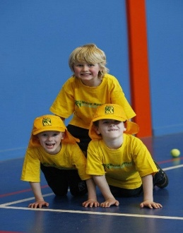

**When: Mondays & Wednesdays**   
**Starts: 15th Oct & 17th Oct**   
**Finishes: 10th Dec & 12th Dec**  
**Dance: 3:40pm – 4:40pm  
Sports: 3:40pm – 4:40pm**  
**Year Levels: Prep – 4  
Cost: $118.80 (Inc GST)**

