

**ST MARYS (ASCOT VALE)**

**PRIMARY SCHOOL P** (03) 9384 2204

**M** 0403 149 391

** E** [mitch@kellysports.com.au](mailto:mitch@kellysports.com.au)

**HIP HOP – Lunch time Mondays**Kelly Sports welcomes HIP HOP back in Term 1! In this program Students will have the opportunity to move, groove, spin and bop to the sound of hip hop beats alongside our very experienced dance instructor. You will have a fantastic time learning the new moves in our high intensity, excitement-filled dance environment.

**SIZZLING SUMMER SPORTS – After School Tuesdays**Kelly Sports is back in Term 1 for a **SIZZLING SUMMER OF SPORTS!!**   
Our Kelly Sports classes are all inclusive, fun & interactive with a key focus on maximum participation. Each week children will be introduced to new sports & activities in a positive environment. It’s a fantastic way to get your child active while having fun as well as building confidence and social skills!





**How To Enrol?**Please visit [www.kellysports.com.au/events](http://www.kellysports.com.au/events) and search for your school.  
**Our new booking system requires upfront payments to secure your position. For more information, please call the head office.**



**"The Kelly Sports Programs offer our students opportunities for physical activities; including dance & multi-sports. Conveniently located on our school grounds, they are popular with students and their families. Staff are skilled in working with young people to love active participation.”**



***Amanda Hay, Principal – Newtown Primary School***

**CLASS INFORMATION**

Only 14 spots available for each program so sign up fast to secure your position

Multi Sports includes **Soccer, Basketball, Cricket & Tennis,** plus we will incorporate our Kelly Sports Modified games children love.

**Come and join us at lunchtime every Monday and afterschool every Tuesday**

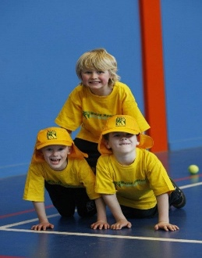

**When: Mondays & Tuesdays**   
**Starts: 4th Feb & 5th Feb**   
**Finishes: 1st April & 2nd April**  
**Dance: 1:00pm – 2:00pm  
Sports: 3:40pm – 4:40pm**  
**Year Levels: Prep – 4  
Sport Cost: $118.80 (Inc GST)  
Dance Cost: $105.60 (Inc GST)  
No session 11th of March due to Labour day**

