

**ASCOT VALE**

**PRIMARY SCHOOL P** (03) 9384 2204

**M** 0403 149 391

** E** [mitch@kellysports.com.au](mailto:mitch@kellysports.com.au)



**WILD WINTER SPORTS**Have a sensational time with Kelly Sports in term 3. Kelly Sports dynamic and active programs run weekly throughout the term. Your child will love the variety of sports and activities, with a new sport every 2 weeks. This program will not only provide an essential base for your child's motor skills but help build awareness, co-ordination and friendship all in an enjoyable environment.



**ONLINE ENROLMENT www.kellysports.com.au**

To enrol, please visit [**www.kellysports.com.au**](http://www.kellysports.com.au)**, and search for your  
school.** Our booking system requires credit card upfront payments to   
secure your position. For more information, please call the head office**.**



**CLASS INFORMATION**

Only 14 spots available for each program so sign up fast to secure your position  
  
 Multi Sports include **Soccer, Basketball, AFL, European Handball & Athletics,** plus we will incorporate our Kelly Sports Modified games children love.

Sign up anytime and only pay for the remaining weeks in the term - $13.20 per week

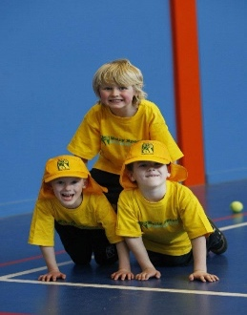

**When: Wednesday’s**  
**Starts: 24th July**  
**Finishes: 18th September**   
**Time: 3:40pm – 4:40pm**  
**Year Levels: Prep – 4  
Cost: $118.80 Inc GST**



**"The Kelly Sports Programs offer our students opportunities for physical activities; including dance & multi-sports. Conveniently located on our school grounds, they are popular with students and their families. Staff are skilled in working with young people to love active participation.”**

***Amanda Hay, Principal – Newtown Primary School***

