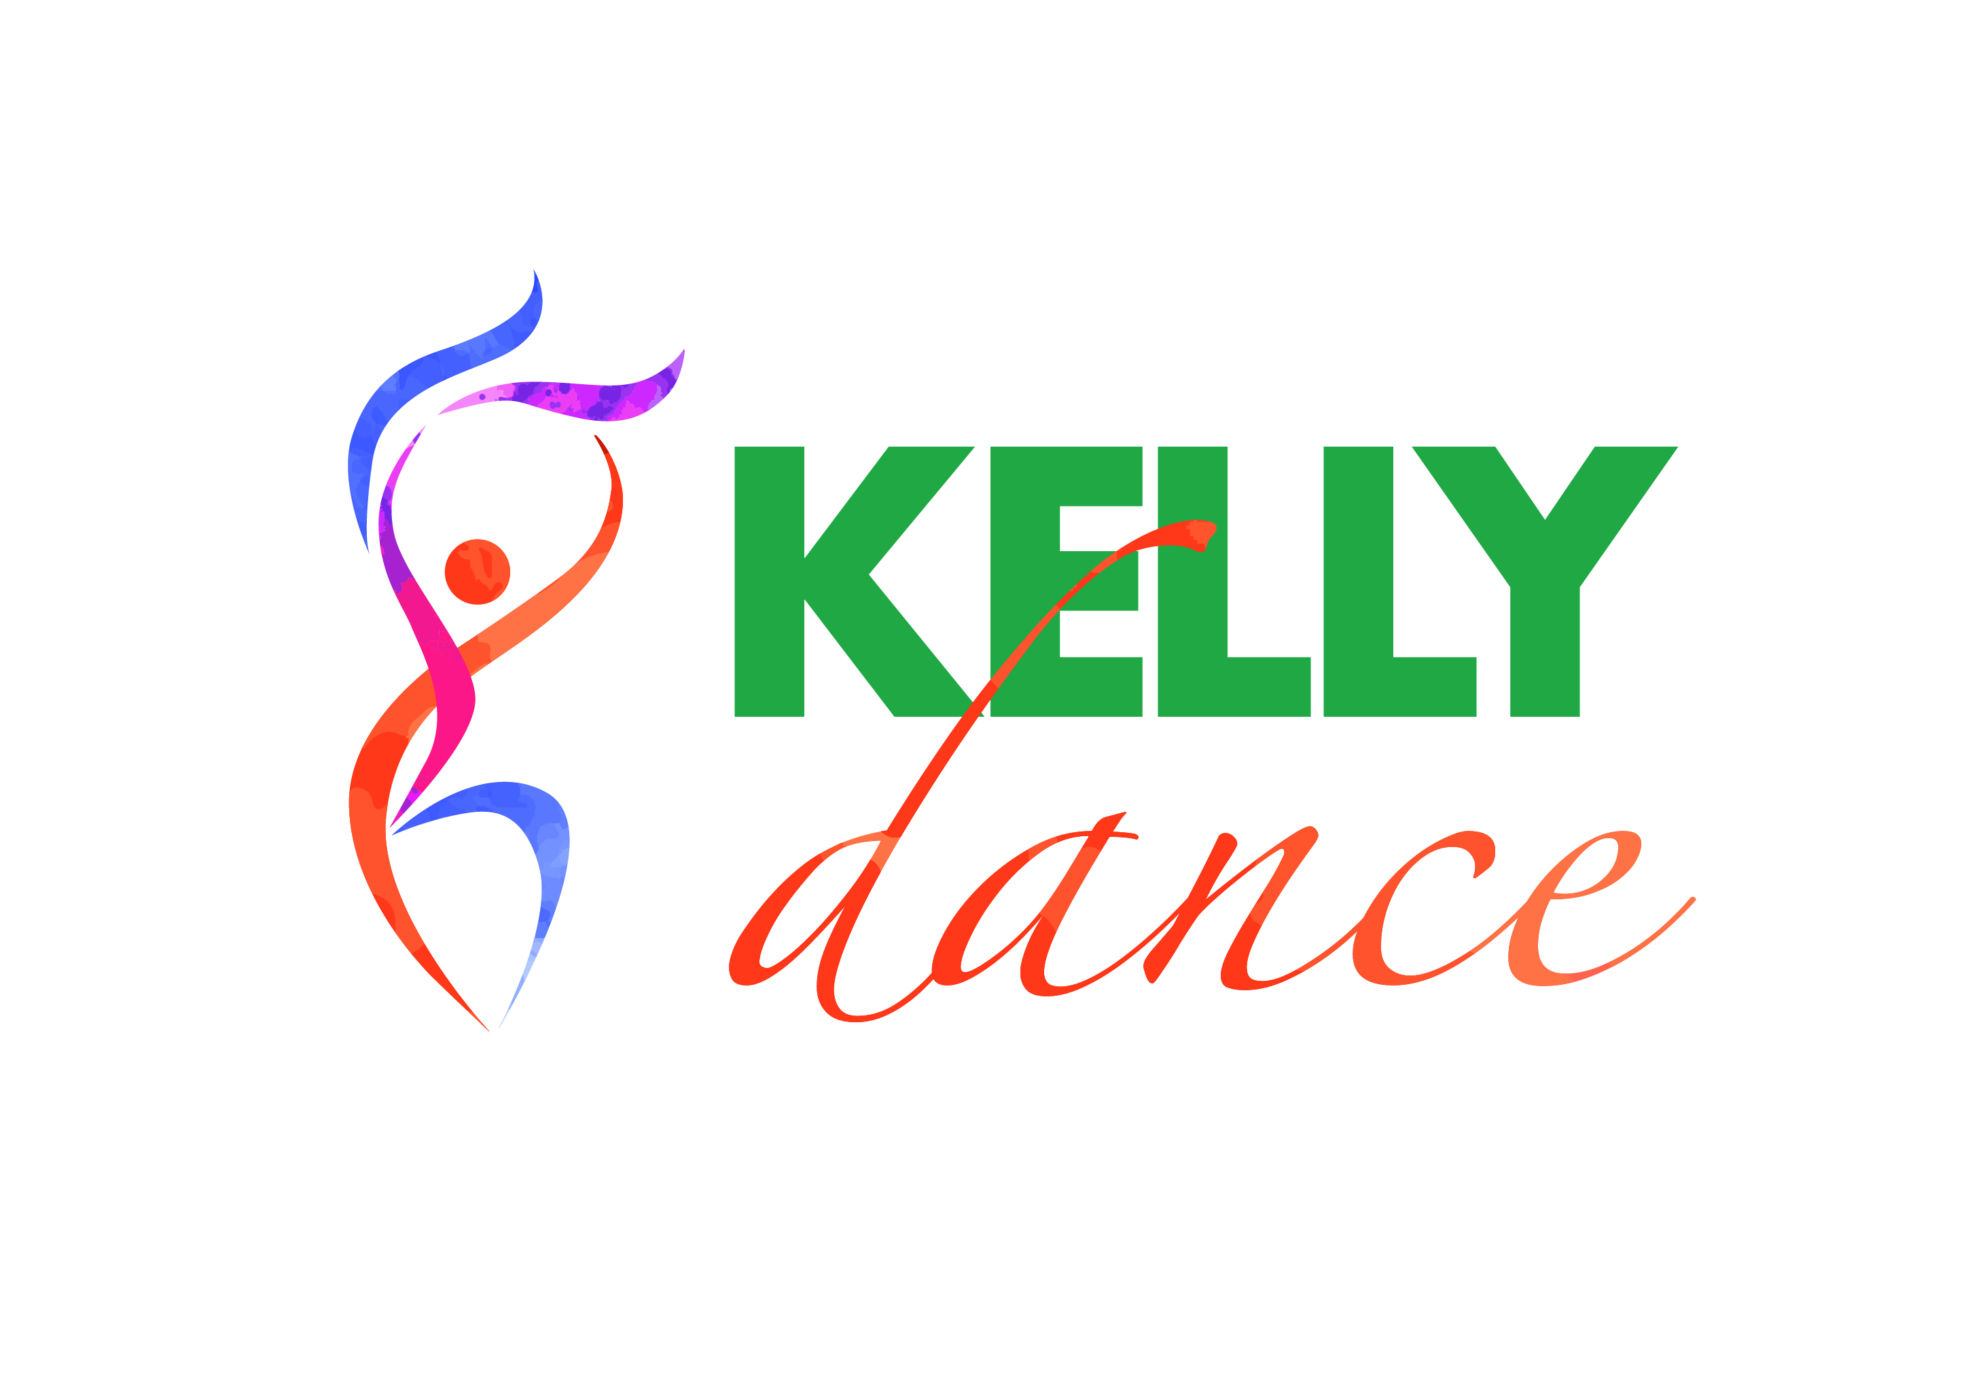

***Kelly School of Dance***

***Presents our***

***End of Year Concert***

Yes it’s here!!!! It’s time for our hard working little and Big cherubs to show off their new dances

We are very excited to be holding our concert .

A reminder that this is still in keeping with our philosophy that dance should be fun and non threatening. So with this in mind, this concert will be a low key event aimed at allowing the students to share their talents with their friends and family.

Costumes will be kept to a minimum and most of it will be sourced by the Kelly School of Dance. We may ask parents to provide the odd item which you will probably already have. If you have any time to help with costumes can you please see Deb or email me at [sonya@kellysports.com.au](mailto:sonya@kellysports.com.au) As we have nearly doubled our performers this year we have quite a few costumes to complete!

**Where:** St Bernards College, College Auditorium

41 Rosehill Rd, Essendon

Parking and Auditorium entrance is via Hampton Rd, Use top carpark

**When:** Friday 1st of December, 2017

**Time:**  7 pm Sharp concert will last approx. 2.5 hours

**Ticket Prices:** $15:00 per ticket per adult

$7:00 per Child (5-16 yrs) children under 5 free

(No ticket required for students performing)

Tickets will be available for pre purchase at Dress Rehearsal

(Please ensure you have the correct money) or on the night.

On Concert day we ask that the students are at the Auditorium by 5pm, so they have time to dress and prepare. They should bring everything that they will need for their performance. Please ensure all clothes have a name and a labelled bag

Miss Deb will provide a list for each class for what children will need in addition to their costumes.

**FULL DRESS Rehearsal will be at Kensington Primary School Saturday 25th November 11am – 2:30pm. Classes scheduled prior to 11 am will still run.**

We hope you will enjoy this special day for your child and we look forward to seeing their excited faces!