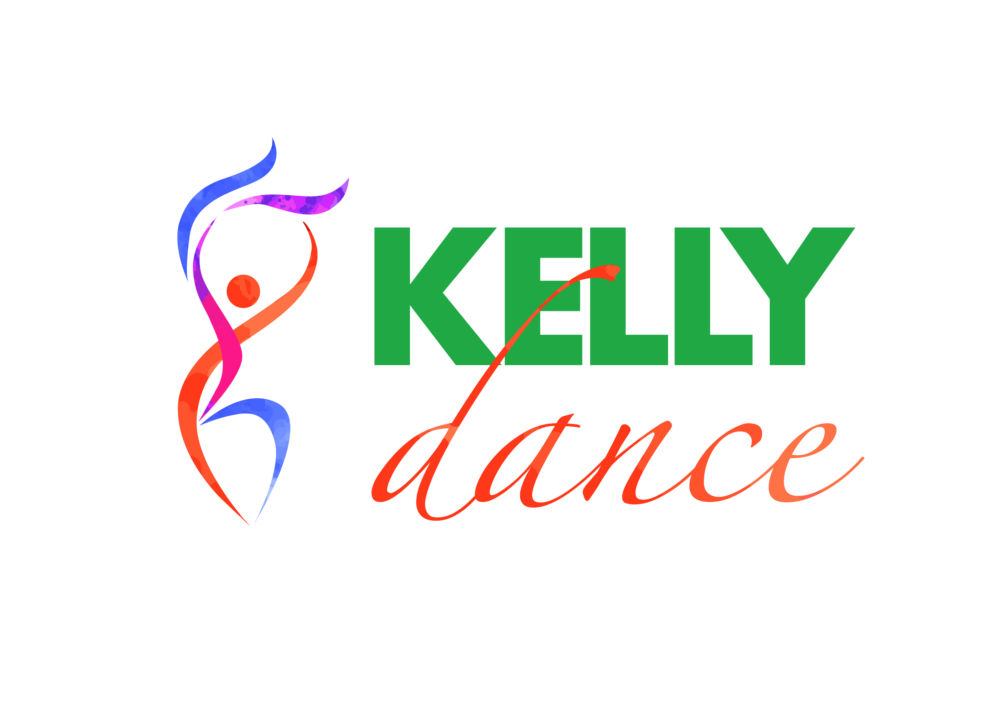

***Kelly School of Dance Presents***

***A Showcase of Dance***

Yes it’s here!!!! It’s time for our hard working little cherubs to show off their new dances

We are very excited to be holding our concert .

A reminder that this is still in keeping with our philosophy that dance should be fun and non threatening. So with this in mind, this concert will be a very low key event aimed at allowing the students to share their talents with their friends and family.

Costumes will be kept to a minimum and most of it will be sourced by the Kelly School of Dance. We may ask parents to provide the odd item which you will probably already have.

**Where:** Kensington Community Recreation Centre YMCA

Cnr Kensington Rd and Altona Street

**When:** Saturday 5th of December, 2015

**Time:**  6:30pm

**Ticket Prices:** $10:00 per ticket per adult

$5:00 per Child

(No ticket required for students performing)

Tickets can be purchased at the door on the day

On Concert day we ask that the students are dropped off to the Kensington Community Centre by 5:45pm so they have time to dress and prepare. They should bring everything that they will need for their performance for the Dress rehearsal and leave for the production

Snacks will be provided for the students performing, so please advise of any allergies/dietary restrictions

**FULL DRESS Rehearsal will commence at 2:45 - 4:45pm, 5th December at the Kensington Community Centre.**

We hope you will enjoy this special day for your child and we look forward to seeing their excited faces!