 P.O. Box 71, Moonee Vale 3055

**T** (03) 9384 2204

**F** (03) 9384 2205

**Super Special price for Preps 50% off our program!**

**Call to book in!**

**E** [sonya@kellysports.com.au](mailto:sonya@kellysports.com.au)

**ST Mary’s Primary School** (Ascot Vale)



**DANCE FUN**

Shake, move and let the beat enter your feet with Kelly Sports. Our trained dance coaches can get your child’s **hips swinging, heads bumping, feet rocking and bodies shaking** to all of modern contemporary music’s classics. Sign up fast as places are limited and let our coaches beat ignite your child’s dancing feet.

**WHEN:** Monday

**COMMENCING:** 11/4/2016

**CONCLUDING:** 20/6/2016

**TIME:** 1:10 – 2:00pm

**YEAR LEVELS:** P – 4



**SOCCER**

Speed, Precision, Athleticism and Fun! Our Soccer program is aimed at introducing your child to the skills and game play of this popular sport. It is designed to build and develop the motor skills balance and co – ordination used in these fast paced games. It all takes place in a fun energetic environment.

**WHEN:** Thursday

**COMMENCING:** 14/4/2016

**CONCLUDING:** 14/6/2016

**TIME:** 3:35 – 4:35pm

**YEAR LEVELS:** P - 4



**AWESOME AUTUMN SPORTS**

Don’t miss out on this brilliant Autumn action, with our Awesome Autumn Sports. This program allows your child to experience a fun, energetic and highly active multi-sport program over **10 lively weeks**! These include: **Basketball, Ball Skills, Soccer, AFL and Hockey.** This program will not only provide an essential base for your child’s motor skills but help build awareness and co-ordination all in an enjoyable environment.

**WHEN:** Tuesday

**COMMENCING:** 12/4/2016

**CONCLUDING:** 14/6/2016

**TIME:** 3.35pm – 4.35pm

**YEAR LEVELS:** P – 4



**COST: $ 120 ($108 for Mondays, 9 weeks)**

**It’s here online enrolments !**

**To enrol**, please visit [www.kellysports.com.au](http://www.kellysports.com.au) or

fill out the enrolment form & **send** with a cheque or credit card details to:

Kelly Sports PO BOX 71, Moonee Vale, VIC, 3055.

Payment options available!

Do **not** leave enrolment forms at the school office

**VENUE: St Mary’s Primary School**

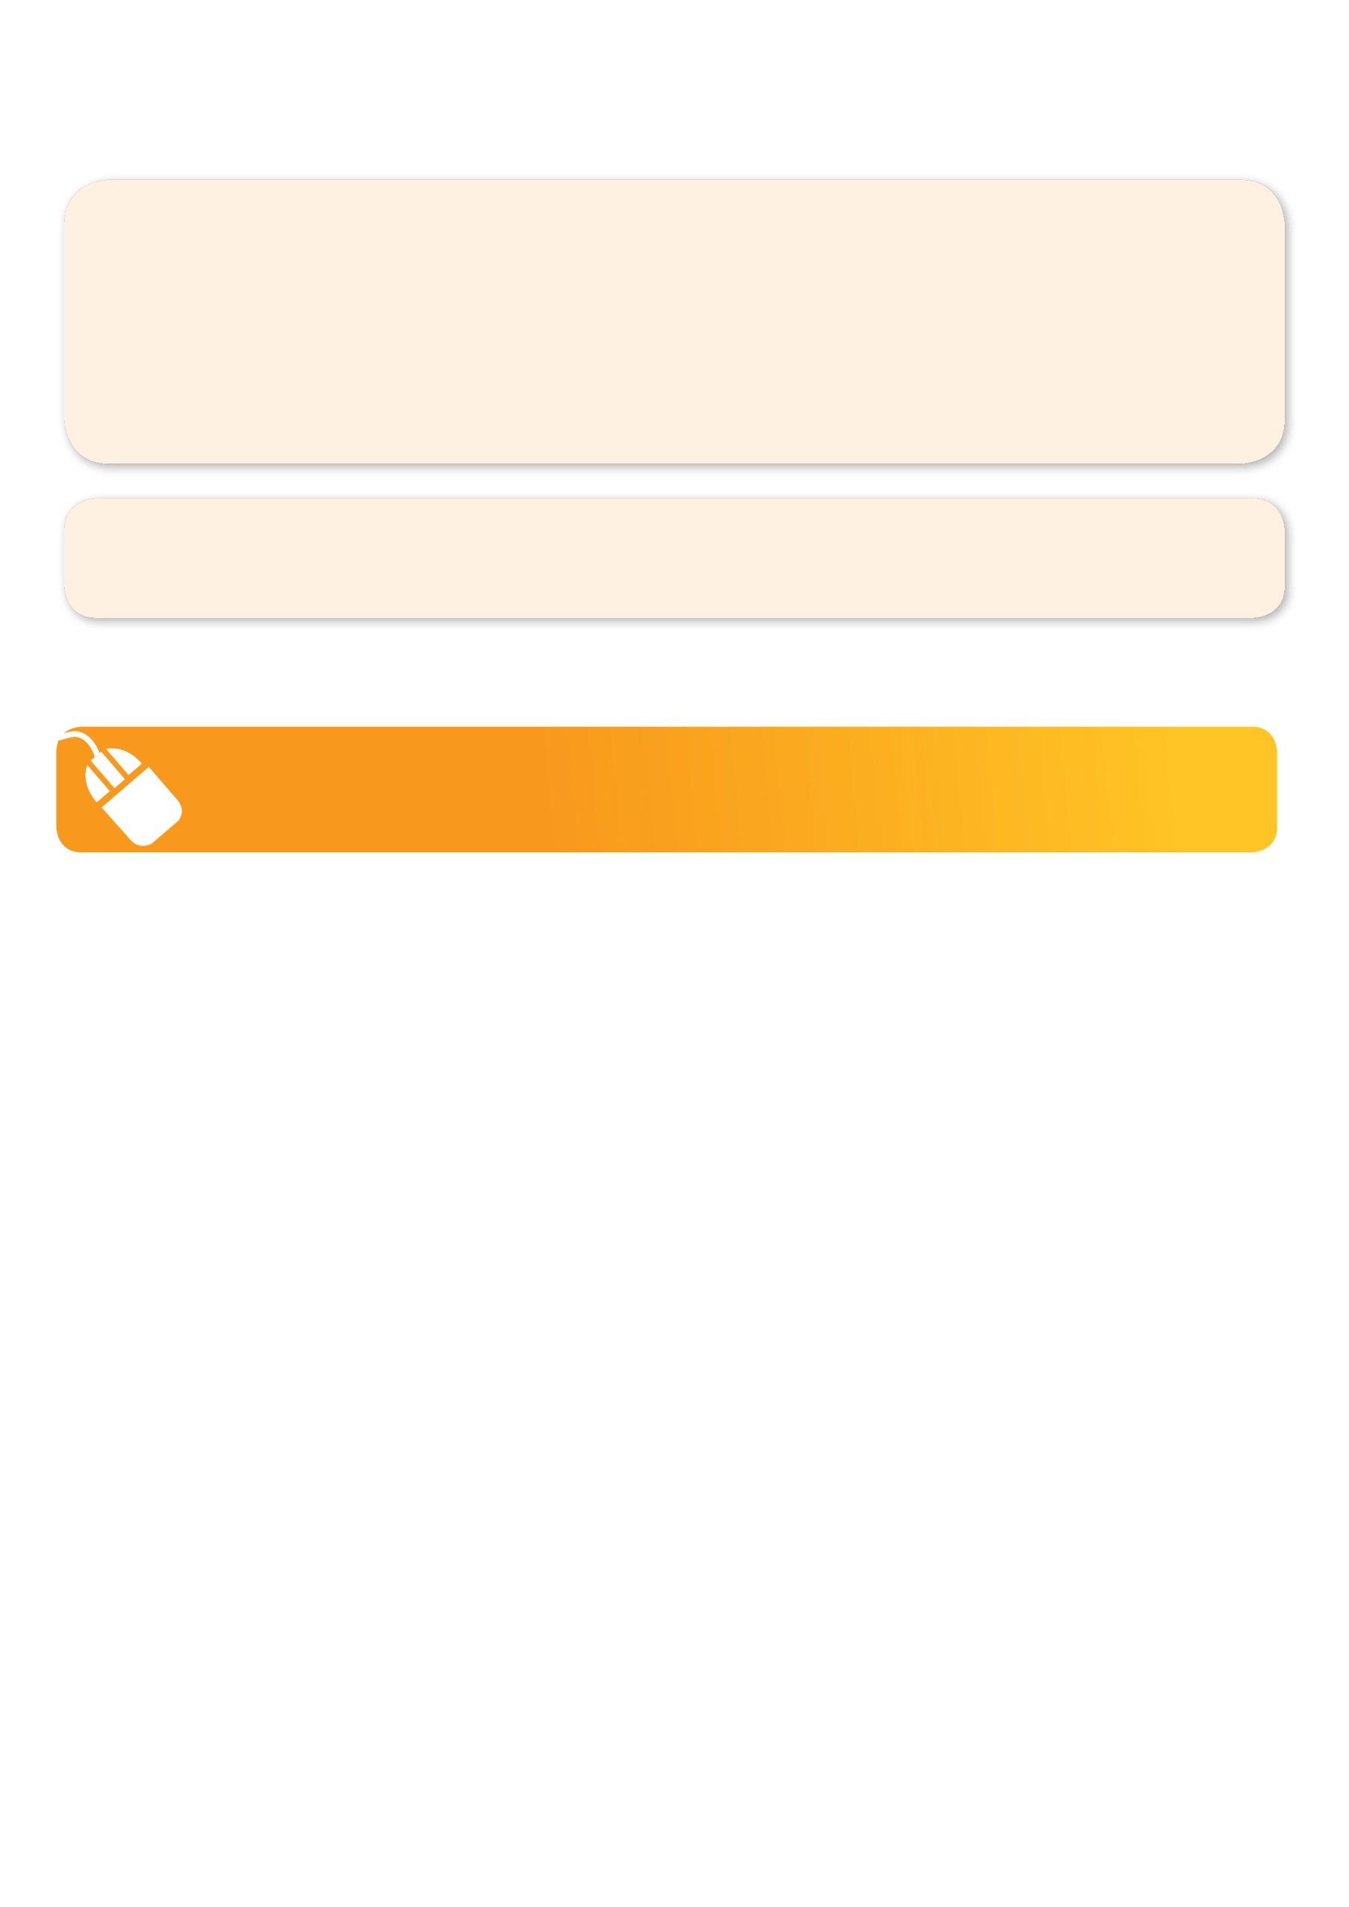**­**

**It’s here online enrolments !**

**To enrol**, please visit [www.kellysports.com.au](http://www.kellysports.com.au) or

fill out the enrolment form & **send** with a cheque or credit card details to:

Kelly Sports PO BOX 71, Moonee Vale, VIC, 3055.

Payment options available!

Do **not** leave enrolment forms at the school office

**ENROLMENT FORM**

□ **Dance Fun** □**Soccer**  □ **Awesome Autumn Sports**

School: Year Level:

Name: Room No:

Address: Post Code:

Phone: Mobile/Work:

Email: Medical Conditions:

At the completion of after school clinics, does your child? □ Go to after care □ Get collected

**Parents’ consent: I hereby authorise Kelly Sports to act on my behalf should my child require medical attention, and release   
Kelly Sports Essendon from any liability for injury incurred by my child at Kelly Sports programmes.**

Parent/Caregiver name: Signature:

Amount Paid: $ ____________ **Direct deposit**: Bsb: 633 000 Acct: 142172618 Please quote child's surname as reference

Credit card payment: □ **Visa** □ **Mastercard**

Card Number: □□□□ □□□□ □□□□ □□□□ Expiry Date: □□/□□

To enrol, please visit http://www.kellysports.com.au

or fill out the below enrolment form & sendwith a cheque or credit

card details to:   
**PO BOX 71, Moonee Vale VIC 3055**.   
**Do not** leave enrolment forms at the school office.

**ONLINE ENROLMENT**

**www.kellysports.com.au**

**It’s here online enrolments !**

**To enrol**, please visit [www.kellysports.com.au](http://www.kellysports.com.au) or

fill out the enrolment form & **send** with a cheque or credit card details to:

Kelly Sports PO BOX 71, Moonee Vale, VIC, 3055.

Payment options available!

Do **not** leave enrolment forms at the school office

**It’s here online enrolments !**

**To enrol**, please visit [www.kellysports.com.au](http://www.kellysports.com.au) or

fill out the enrolment form & **send** with a cheque or credit card details to:

Kelly Sports PO BOX 71, Moonee Vale, VIC, 3055.

Payment options available!

Do **not** leave enrolment forms at the school office

**It’s here online enrolments !**

**To enrol**, please visit [www.kellysports.com.au](http://www.kellysports.com.au) or

fill out the enrolment form & **send** with a cheque or credit card details to:

Kelly Sports PO BOX 71, Moonee Vale, VIC, 3055.

Payment options available!

Do **not** leave enrolment forms at the school office