

**SACRED HEART PS**

**P** (03) 9384 2204  
**M** 0403 149 391  
**E** [mitch@kellysports.com.au](mailto:mitch@kellysports.com.au)



**END OF YEAR CHEER**

**IT’S THE END OF THE YEAR AND IT’S TIME TO CHEER!**

Join us in Term 4 for our Cheerleading program for boys and girls. This program will combine both Hip Hop and Cheerleading to create a new and fresh routine. You will have a fantastic time learning the new moves in our high intensity, excitement-filled dance environment. Book early for this incredibly fun program!





**How To Enrol?**Please visit [www.kellysports.com.au/events](http://www.kellysports.com.au/events) and search for your school.  
Our new booking system requires upfront payments to secure your position. For more information, please call the head office.



**"The Kelly Sports Programs offer our students opportunities for physical activities; including dance & multi-sports. Conveniently located on our school grounds, they are popular with students and their families. Staff are skilled in working with young people to love active participation.”**

***Amanda Hay, Principal – Newtown Primary School***



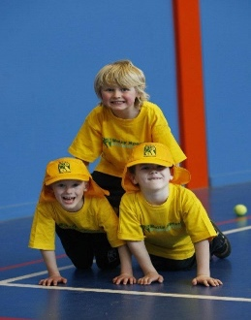

**CLASS INFORMATION**

Only 14 spots available so sign up fast to secure your position  
  
At the end of the term parents will be invited to an open class to watch the full dance routine.

Come & join us every Thursday at Lunch time.

**When: Thursdays**  
**Starts: 18TH October**  
**Finishes: 13th December**  
**Time: 1:00pm – 1:45pm**  
**Year Levels: Prep – 4  
Cost: $118.20 (Inc GST)**

