 3/294 Police Road, Noble Park North

**SIGN UP ….Now!**

**T** 0418 585 227

**E** angela@kellysports.com.au

**KINGSWOOD PRIMARY SCHOOL**

**AWESOME AUTUMN SPORTS**

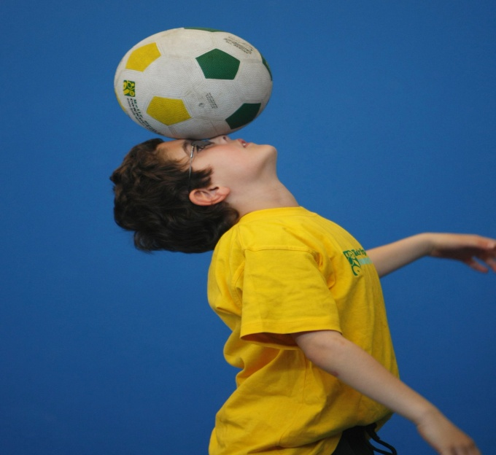

**SOCCER – BASKETBALL/NETBALL- FOOTY-HOCKEY– TEAM GAMES** This program is a fantastic way to challenge and improve your child’s motor and coordination skills. Our experienced coaches aim to develop and enhance the wide range of sporting skills of your child, including catching, kicking & throwing. While also improving strength, flexibility, hand-eye co-ordination, spatial awareness, co-operative skills and teamwork, all within a FUN and very SAFE environment.

**WHEN:** TUESDAY

**COMMENCING:** 30/04/19

**CONCLUDING:** 25/06/19

**TIME:** 3.35pm – 4.35pm

**YEAR LEVELS:** P – 6

**COST:** $118.80(Inc GST)



**NETBALL FUN**



Kelly Sports is giving children the opportunity to learn the game of netball and the fundamental skills used in netball. We have a qualified foundation coach taking each session who is looking forward to sharing her knowledge with the girls and boys in Prep to grade 3.

**WHEN:** Monday

**COMMENCING:** 29/04/19

**CONCLUDING:** 24/06/19(No session June 10 Queens birthday)

**TIME:** 3.35PM – 4.35pm

**YEAR LEVELS:** P – Grade 3

**COST:** $105.60(Inc GST)



**GET IN QUICK FOR TERM 2 AS PLACES FILLING FAST**

**It’s here online enrolments !**

**To enrol**, please visit [www.kellysports.com.au](http://www.kellysports.com.au) or

fill out the enrolment form & **send** with a cheque or credit card details to:

Kelly Sports PO BOX 71, Moonee Vale, VIC, 3055.

Payment options available!

Do **not** leave enrolment forms at the school office

**$118.80 FOR 9 WEEK PROGRAM, or $105.60 for 8 weeks of netball**

**­**

NEW IMPROVED ONLINE BOOKING SYSTEM!!!

SIMPLY GO TO [WWW.KELLYSPORTS.COM.AU](http://WWW.KELLYSPORTS.COM.AU) ENTER YOUR POST CODE AND ENROL FROM THERE. OR

FILL OUT THE BELOW ENROLMENT FORM & SEND WITH A CHEQUE OR CREDIT CARDS DETAILS TO:

**3/294 POLICE ROAD, NOBLE PARK NORTH. 3174**

PAYMENT OPTIONS AVAILABLE!

**It’s here online enrolments !**

**To enrol**, please visit [www.kellysports.com.au](http://www.kellysports.com.au) or

fill out the enrolment form & **send** with a cheque or credit card details to:

Kelly Sports PO BOX 71, Moonee Vale, VIC, 3055.

Payment options available!

Do **not** leave enrolment forms at the school office

**ENROLMENT FORM**

□ **Awesome Autumn Sports** □ **Netball Fun**

School: Year Level:

Name: Room No:

Address: Post Code:

Phone: Mobile/Work:

Email: Medical Conditions:

At the completion of after school clinics, does your child? □ Go to after care □ Get collected

**Parents’ consent: I hereby authorise Kelly Sports to act on my behalf should my child require medical attention, and release   
Kelly Sports Western Region from any liability for injury incurred by my child at Kelly Sports programs.**

Parent/Caregiver name: Signature:

Amount Paid: $ Credit card payment: □ **Visa** □ **Master card**

Card Number: □□□□ □□□□ □□□□ □□□□Expiry Date: □□/□□CVV:□□□

**THINGS TO KNOW**

Kelly Sports is a Registered Child Care provider

Don’t leave forms at the School Office

Spaces are limited so please make sure you enrol online or return form to Kelly Sports.

**It’s here online enrolments !**

**To enrol**, please visit [www.kellysports.com.au](http://www.kellysports.com.au) or

fill out the enrolment form & **send** with a cheque or credit card details to:

Kelly Sports PO BOX 71, Moonee Vale, VIC, 3055.

Payment options available!

Do **not** leave enrolment forms at the school office

**It’s here online enrolments !**

**To enrol**, please visit [www.kellysports.com.au](http://www.kellysports.com.au) or

fill out the enrolment form & **send** with a cheque or credit card details to:

Kelly Sports PO BOX 71, Moonee Vale, VIC, 3055.

Payment options available!

Do **not** leave enrolment forms at the school office

**It’s here online enrolments !**

**To enrol**, please visit [www.kellysports.com.au](http://www.kellysports.com.au) or

fill out the enrolment form & **send** with a cheque or credit card details to:

Kelly Sports PO BOX 71, Moonee Vale, VIC, 3055.

Payment options available!

Do **not** leave enrolment forms at the school office