

P.O. Box 71, Moonee Vale 3055
T (03) 9384 2204
FOLLOW US
ONLINE

F (03) 9384 2205

E mitch@kellysports.com.au





ST MARKS PRIMARY SCHOOL
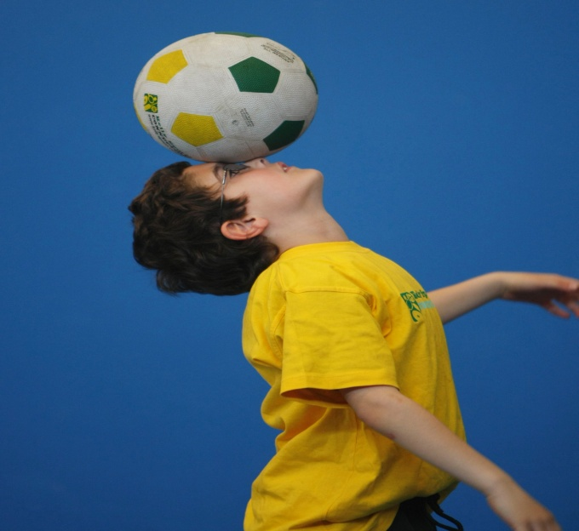
CRICKET & SOCCER

WHEN: Friday
COMMENCING: 16/10/15
CONCLUDING: 11/12/15
TIME: 3.30pm – 4.30pm
YEAR LEVELS: P – 4
COST: $90

Have fun in the sun this term! Cricket & Soccer is a dynamic and active program run over 9 weeks. Our experienced coaches will teach your child all the fundamental skills needed to become the next sporting superstar. This Program will not only provide an essential base for your child's motor skills but help build awareness, co-ordination and friendship all in an enjoyable environment.


CALISTHENICS


Experience this unique blend of sport and artistry at your own school.
Calisthenics combines the elements of dance and movement including gymnastics, ballet, modern dance, apparatus (rods and flags). Learn routines choreographed to music, so that you can present these routines in front of an audience. Calisthenics encourages physical development, coordination, self-discipline and team spirit
WHEN: Wednesday
COMMENCING: 14/10/15
CONCLUDING: 16/12/15
TIME: 1.30pm – 2.10pm
YEAR LEVELS: P – 4
COST: $100

GET IN QUICK FOR TERM 4 AS PLACES FILLING FAST
It’s here online enrolments !
To enrol, please visit www.kellysports.com.au or
fill out the enrolment form & send with a cheque or credit card details to:
Kelly Sports PO BOX 71, Moonee Vale, VIC, 3055.
Payment options available!
Do not leave enrolment forms at the school office

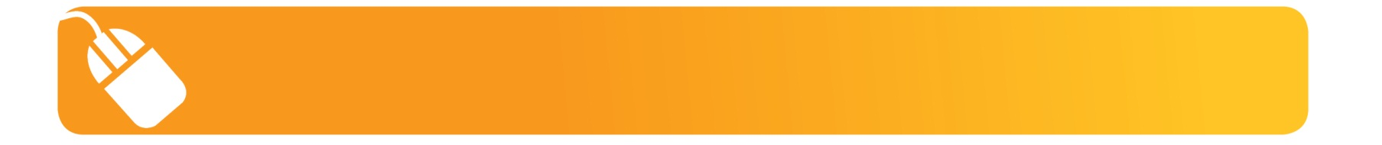
It’s here online enrolments !
To enrol, please visit www.kellysports.com.au or
fill out the enrolment form & send with a cheque or credit card details to:
Kelly Sports PO BOX 71, Moonee Vale, VIC, 3055.
Payment options available!
Do not leave enrolment forms at the school office

NEW IMPROVED ONLINE BOOKING SYSTEM!!!
SIMPLY GO TO WWW.KELLYSPORTS.COM.AU ENTER YOUR POST CODE AND ENROL FROM THERE. OR
FILL OUT THE BELOW ENROLMENT FOR & SEND WITH A CHEQUE OR CREDIT CARDS DETAILS TO:
PO BOX 71, MOONEE VALE, 3055
PAYMENT OPTIONS AVALIABLE!

It’s here online enrolments !
To enrol, please visit www.kellysports.com.au or
fill out the enrolment form & send with a cheque or credit card details to:
Kelly Sports PO BOX 71, Moonee Vale, VIC, 3055.
Payment options available!
Do not leave enrolment forms at the school office

It’s here online enrolments !
To enrol, please visit www.kellysports.com.au or
fill out the enrolment form & send with a cheque or credit card details to:
Kelly Sports PO BOX 71, Moonee Vale, VIC, 3055.
Payment options available!
Do not leave enrolment forms at the school office

It’s here online enrolments !
To enrol, please visit www.kellysports.com.au or
fill out the enrolment form & send with a cheque or credit card details to:
Kelly Sports PO BOX 71, Moonee Vale, VIC, 3055.
Payment options available!
Do not leave enrolment forms at the school office

ENROLMENT FORM
 Cricket & Soccer  Calisthenics
School: Year Level:
Name: Room No:
Address: Post Code:
Phone: Mobile/Work:
Email: Medical Conditions:

At the completion of after school clinics, does your child?  Go to after care  Get collected
Parents’ consent: I hereby authorise Kelly Sports to act on my behalf should my child require medical attention, and release
Kelly Sports Knox-Waverley from any liability for injury incurred by my child at Kelly Sports programs.
Parent/Caregiver name: Signature:
Amount Paid: $ Credit card payment:  Visa  Master card
Card Number:    Expiry Date: /CVV:
THINGS TO KNOW
Kelly Sports is a Registered Child Care provider
Don’t leave forms at the School Office
Spaces are limited so please make sure you enrol online or return form to Kelly Sports.

