

P.O. BOX 71, MOONEE VALE, VIC, 3055

**T** (03) 9384 2204 **F** (03) 9384 2205

**E** info@kellysports.com.au



**HURRY**

**UP AND**

**ENROL!**

**BURWOOD**

ABN 16 057 507 337

***Please do not leave Enrolment forms at the school office.***

**ST MARK’S PS, Dingley**

***Amended pro-rata program/s commence this week***

**CALISTHENICS !**



**Experience this unique blend of sport and artistry at your own school.**

**We offer Calisthenics as a sporting option in partnership with Calisthenics Victoria, providing their qualified coaches to deliver high quality programs. Calisthenics combines the elements of dance and movement including gymnastics, ballet, modern dance, apparatus (rods and flags). Learn routines choreographed to music, so that you can present these routines in front of an audience. Calisthenics encourages physical development, coordination, self-discipline and team spirit.**

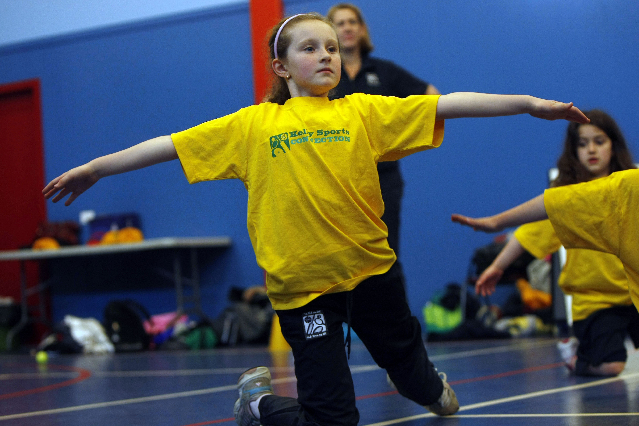

**WHEN: Thursday**

**COMMENCING:**  **14 Aug ‘14**

**CONCLUDING:** **18 Sept ‘14**

**TIME:** **1.20pm – 2pm**

**YEAR LEVELS:** **P – 6**



**WHEN: Friday**

**COMMENCING:** **15 Aug ‘14**

**CONCLUDING:** **19 Sept ‘14**

**TIME:** **3.30pm – 4.30pm**

**YEAR LEVELS:** **P – 4**

**WORLD CUP SOCCER**

**LOVE THE WORLD CUP LOOK NO FURTHER The journey to stardom begins here at the Kelly Sports 6 week World Cup Soccer. Our talented qualified and enthusiastic coaches will have your children kicking goals in no time, developing skills in passing, dribbling, heading and of course** **kicking their team to glory.**



**COST: $65 each. Enrol online for $60** – go to [**www.kellysports.com.au**](http://www.kellysports.com.au) **to register, enrol and pay via credit card.**

**It’s here online enrolments !**

**To enrol**, please visit [www.kellysports.com.au](http://www.kellysports.com.au) or

fill out the enrolment form & **send** with a cheque or credit card details to:

Kelly Sports PO BOX 71, Moonee Vale, VIC, 3055.

Payment options available!

Do **not** leave enrolment forms at the school office

**VENUE: At School. Calisthenics:** *Hall* **Soccer:** *Meet next to the Prep area.*

**ONLINE ENROLMENT**

**www.kellysports.com.au**

To enrol, please visit [**www.kellysports.com.au**](http://www.kellysports.com.au)or fill out the enrolment form below & sendwith a cheque or credit card details or pay by internet banking:

**ANZ Bsb 013 030 A/c 4936 95452** (use child’s first, last name as reference)

Mail to: **PO BOX 71, Moonee Vale, VIC 3055**. Email **info@kellysports.com.au**

**Do not** leave enrolment forms at the school office.



**ENROLMENT FORM**

□ **Calisthenics** (Lunch time) □ **World Cup Soccer** (After School)

School: **St Mark’s PS** Year Level:

Name: Room No:

Address: Post Code:

Phone: Mobile/Work:

Email: Medical Conditions / Special Needs:

At the completion of after school clinics, does your child? □ Go to after care □ Get collected

**Parents’ consent**

**I hereby authorise Kelly Sports to act on my behalf should my child require medical attention, and release Kelly Sports Dingley from   
any liability for injury incurred by my child at Kelly Sports programmes.**

□ **I authorise the use by Kelly Sports of any photographs or video image of my child or legal charge for any reasonable purpose.**

Parent/Caregiver name: Signature:

Amount Paid: $ Credit card payment: □ **Visa** □ **Mastercard**

Card Number: □□□□ □□□□ □□□□ □□□□ Expiry Date: □□/□□