  P.O. Box 71, Moonee Vale 305

**T** (03) 9384 2204

**FOLLOW US**

**ONLINE**

**F** (03) 9384 2205

**E** mitch@kellysports.com.au



**MURRUMBEENA PRIMARY SCHOOL**

**SPRING INTO SPORTS**

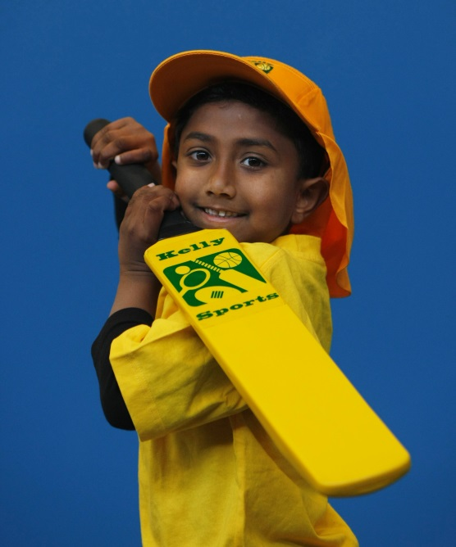

**WHEN:** Monday

**COMMENCING:** 12/10/15

**CONCLUDING:** 14/12/15

**TIME:** 3.40pm – 4.40pm

**YEAR LEVELS:** P – 4

**COST:** $90

Note : No session Melbourne Cup

week

**Soccer – Cricket – Hockey – Basketball – Team Games** Have fun in the sun this term! Spring into Sports dynamic and active programs run over 10 weeks; these include: Soccer, Hockey, Basketball, Cricket and team games. This Program will not only provide an essential base for your child's motor skills but help build awareness, co-ordination and friendship all in an enjoyable environment.

**GET IN QUICK FOR TERM 4 AS PLACES FILLING FAST**

**$90 FOR 9 WEEK PROGRAM**

**­**

NEW IMPROVED ONLINE BOOKING SYSTEM!!!

SIMPLY GO TO [WWW.KELLYSPORTS.COM.AU](http://WWW.KELLYSPORTS.COM.AU) ENTER YOUR POST CODE AND ENROL FROM THERE. OR

FILL OUT THE BELOW ENROLMENT FOR & SEND WITH A CHEQUE OR CREDIT CARDS DETAILS TO:

**PO BOX 71, MOONEE VALE, 3055**

PAYMENT OPTIONS AVALIABLE!

**It’s here online enrolments !**

**To enrol**, please visit [www.kellysports.com.au](http://www.kellysports.com.au) or

fill out the enrolment form & **send** with a cheque or credit card details to:

Kelly Sports PO BOX 71, Moonee Vale, VIC, 3055.

Payment options available!

Do **not** leave enrolment forms at the school office

**ENROLMENT FORM**

□ **SPRING INTO SPORTS**

School: Year Level:

Name: Room No:

Address: Post Code:

Phone: Mobile/Work:

Email: Medical Conditions:

At the completion of after school clinics, does your child? □ Go to after care □ Get collected

**Parents’ consent: I hereby authorise Kelly Sports to act on my behalf should my child require medical attention, and release   
Kelly Sports North West from any liability for injury incurred by my child at Kelly Sports programs.**

Parent/Caregiver name: Signature:

Amount Paid: $ Credit card payment: □ **Visa** □ **Master card**

Card Number: □□□□ □□□□ □□□□ □□□□Expiry Date: □□/□□CVV:□□□

**THINGS TO KNOW**

Kelly Sports is a Registered Child Care provider

Don’t leave forms at the School Office

Spaces are limited so please make sure you enrol online or return form to Kelly Sports.

**It’s here online enrolments !**

**To enrol**, please visit [www.kellysports.com.au](http://www.kellysports.com.au) or

fill out the enrolment form & **send** with a cheque or credit card details to:

Kelly Sports PO BOX 71, Moonee Vale, VIC, 3055.

Payment options available!

Do **not** leave enrolment forms at the school office

**It’s here online enrolments !**

**To enrol**, please visit [www.kellysports.com.au](http://www.kellysports.com.au) or

fill out the enrolment form & **send** with a cheque or credit card details to:

Kelly Sports PO BOX 71, Moonee Vale, VIC, 3055.

Payment options available!

Do **not** leave enrolment forms at the school office

**It’s here online enrolments !**

**To enrol**, please visit [www.kellysports.com.au](http://www.kellysports.com.au) or

fill out the enrolment form & **send** with a cheque or credit card details to:

Kelly Sports PO BOX 71, Moonee Vale, VIC, 3055.

Payment options available!

Do **not** leave enrolment forms at the school office