 P.O. Box 71, Moonee Vale 3055

**Only $19.50 per week!**

**T** (03) 9384 2204

**E** steve@kellysports.com.au

**St KILDA PARK PRIMARY SCHOOL**



**SUPER SOCCER**



Learn how to play like your heroes and have lots of fun learning all the skills in the game of SOCCER. The Kelly Sports team will teach you all the basic skills in a safe and challenging environment. If you already play soccer this is your chance to take your game to the next level!

**WHEN:** Monday

**COMMENCING:** 11/02/19

**CONCLUDING:** 1/04/19 (6 sessions)

**TIME:** 3.30pm – 5.00pm

**YEAR LEVELS:** **P – 4**

**COST (GST inc):** $117.00

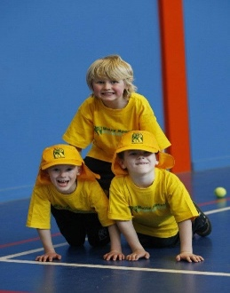

**It’s here online enrolments !**

**To enrol**, please visit [www.kellysports.com.au](http://www.kellysports.com.au) or

fill out the enrolment form & **send** with a cheque or credit card details to:

Kelly Sports PO BOX 71, Moonee Vale, VIC, 3055.

Payment options available!

Do **not** leave enrolment forms at the school office

**It’s here online enrolments !**

**To enrol**, please visit [www.kellysports.com.au](http://www.kellysports.com.au) or

fill out the enrolment form & **send** with a cheque or credit card details to:

Kelly Sports PO BOX 71, Moonee Vale, VIC, 3055.

Payment options available!

Do **not** leave enrolment forms at the school office

**CLASS INFORMATION**

Only 14 spots available for each session so sign up fast to secure your position

Activities will be fun, inclusive and exciting! **P**lus we will incorporate our Kelly Sports Modified games children love.

Come and join us in Term 1.

**It’s here online enrolments !**

**To enrol**, please visit [www.kellysports.com.au](http://www.kellysports.com.au) or

fill out the enrolment form & **send** with a cheque or credit card details to:

Kelly Sports PO BOX 71, Moonee Vale, VIC, 3055.

Payment options available!

Do **not** leave enrolment forms at the school office

**It’s here online enrolments !**

**To enrol**, please visit [www.kellysports.com.au](http://www.kellysports.com.au) or

fill out the enrolment form & **send** with a cheque or credit card details to:

Kelly Sports PO BOX 71, Moonee Vale, VIC, 3055.

Payment options available!

Do **not** leave enrolment forms at the school office

**It’s here online enrolments !**

**To enrol**, please visit [www.kellysports.com.au](http://www.kellysports.com.au) or

fill out the enrolment form & **send** with a cheque or credit card details to:

Kelly Sports PO BOX 71, Moonee Vale, VIC, 3055.

Payment options available!

Do **not** leave enrolment forms at the school office