

P.O. Box 183, Black Rock 3193

**T** 9502 0611

**M** 0432 832 466

**E** pierre@kellysports.com.au

[www.facebook.com/KellySportsBayside](https://www.facebook.com/KellySportsBayside)

**BRIGHTON PS**

**SUPER SOCCER**

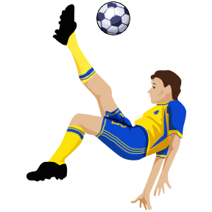

Play Soccer with your friends in the Kelly Sports Soccer Clinic. Now with 3 levels of coaching. Beginners (prep), Intermediate (1s) and Soccer Squad (y 2+) We recommend that children bring a snack for after school.

**WHEN:** Wednesday

**COMMENCING:** 16/7/14

**CONCLUDING:** 17/9/14

**TIME:** 3.30pm – 5.00pm

**YEAR LEVELS:** P – 4

 

**WHEN:** Wednesday

**COMMENCING:** 16/7/14

**CONCLUDING:** 17/9/14

**TIME:** 3.35pm – 4.35pm

**YEAR LEVELS:** P – 4

Have fun learning and playing Basketball with your friends. Great for all levels.

**BASKETBALL**

**COST: Soccer $150 Basketball $115** (early bird rate $145 & $110 if paid before 11/7/14)

**ONLINE ENROLMENT**

**www.kellysports.com.au/zone/brighton**

enrol online go to [www.kellysports.com.au](http://www.kellysports.com.au) and search for **Brighton PS**

**VENUE: Brighton Primary School on oval and basketball court**

**TRY A CLASS AT NO COST. EMAIL** [pierre@kellysports.com.au](mailto:pierre@kellysports.com.au)

**FOR A FREE TRIAL CLASS. GREAT FOR BOYS AND GIRLS**

Why not have a Footy, Cricket, Soccer, Dance, Gymnastics, Hockey, Netball or any other Sporting Party. Have a coach from Kelly Sports come out and run your birthday party.





We supply all equipment, come to a venue of your choice, and the Birthday Boy or Girl chooses which games or sports they want to play. For more information call Pierre Sutcliffe at Kelly Sports Bayside on

9502 0611 or [pierre@kellysports.com.au](mailto:pierre@kellysports.com.au)