

**RIPPONLEA**

**PRIMARY SCHOOL P (**03) 9384 2204

** E** [mitch@kellysports.com.au](mailto:mitch@kellysports.com.au)

**MIGHTY MULTI SPORTS – After School Monday**Come and experience all the fun in our 9-week Kelly Sports

Mighty Multi Sport program.

Our Kelly Sports classes are all inclusive, fun & interactive with a key focus on maximum participation. Each week children will be introduced to new sports & activities in a positive environment. It’s a fantastic way to get your child active while having fun as well as building confidence and social skills!





**How To Enrol?**Please visit [www.kellysports.com.au/events](http://www.kellysports.com.au/events) and search for your school.  
**Our new booking system requires upfront payments to secure your position. For more information, please call the head office.**



**"The Kelly Sports Programs offer our students opportunities for physical activities; including dance & multi-sports. Conveniently located on our school grounds, they are popular with students and their families. Staff are skilled in working with young people to love active participation.”**



***Amanda Hay, Principal – Newtown Primary School***

**CLASS INFORMATION**

Limited spots for each program so sign up fast to secure your position

Mighty Multi Sports include **AFL, Soccer, Basketball & Hockey** plus we will incorporate our Kelly Sports Modified games children love.

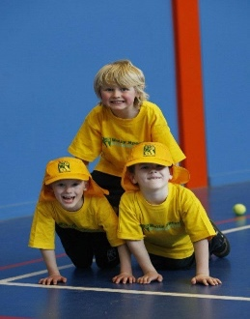

**Sports – 9 week program  
Starts: 29th of April**  
**Finishes: 24th of June  
Time: 3:30pm – 5:00pm  
Cost : $175 (Inc GST)**

