

**Kelly Sports - Berwick & Pakenham**

$45

per day!

P.O. Box 2055, Fountain Gate VIC 3805

**T** Darren Michelle 0402 224 116

**F** (03) 8692 6539

**W** www.kellysports.com.au

**E** [darren@kellysports.com.au](mailto:darren@kellysports.com.au)

AUTUMN **HOLIDAY PROGRAM**

**OUR HOLIDAY PROGRAM IS NOW OFFERING EARLY CARE FROM 7:30AM ACTIVITIES START AT 9:00AM!**

**Sports orientated holiday program designed to emphasise fun, enjoyment, confidence and skills with maximum participation. Children require a packed lunch, drink bottle & hat. Craft table and restful activities also provided.**

Suitable for both GIRLS and BOYS. Kelly Sports is a registered childcare provider

**VENUE: Berwick Chase Primary School Hall, 72 Viewgrand Dr Berwick**

**WHEN:** Term 1 Holidays

**COMMENCING:** Tuesday 3rd April

**CONCLUDING:** Friday 11th April

**TIME:** 7:30am – 4:30pm

**YEAR LEVELS:** All ages



|  |  |  |  |  |  |
| --- | --- | --- | --- | --- | --- |
| Tue 3rd  7.30am-4.30pm | Basketball | Soccer | Hockey | **Football** | Touch Rugby |
| Wed 4th  7.30am-4.30pm | TENNIS | GYMC:\Users\Evange.Evange-PC\AppData\Local\Microsoft\Windows\Temporary Internet Files\Content.IE5\QUELLS1W\MC900285850[1].wmf | Soccer | tBall | CRICKET |
| Thu 5th  7.30am-4.30pm | Soccer | Dance | Volleyball | **Athletics** | Basketball |
| Fri 6th  7.30am-4.30pm | Basketball | *Netball* | **Football** | TENNIS | CRICKET |

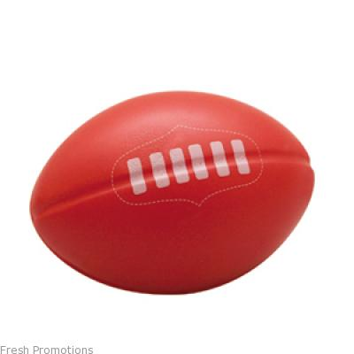

**WEEK 1**

|  |  |  |  |  |  |
| --- | --- | --- | --- | --- | --- |
| Mon 9th  7.30am-4.30pm | Soccer | Basketball | **Football** | Hockey | TENNIS |
| Tue 10th  7.30am-4.30pm | Basketball | CRICKET | Hockey | **Football** | Dance |
| Wed 11th  7.30am-4.30pm | Volleyball | Touch Rugby | Soccer | *Netball* | **Tennis** |
| Thu 12th  7.30am-4.30pm | Soccer | **Athletics** | Dance | **Football** | Basketball |
| Fri 13th  7.30am-4.30pm | tBall | CRICKET | **Football** | C:\Users\Evange.Evange-PC\AppData\Local\Microsoft\Windows\Temporary Internet Files\Content.IE5\QUELLS1W\MC900285850[1].wmfGYM | Soccer |

**­**

**WEEK 2**

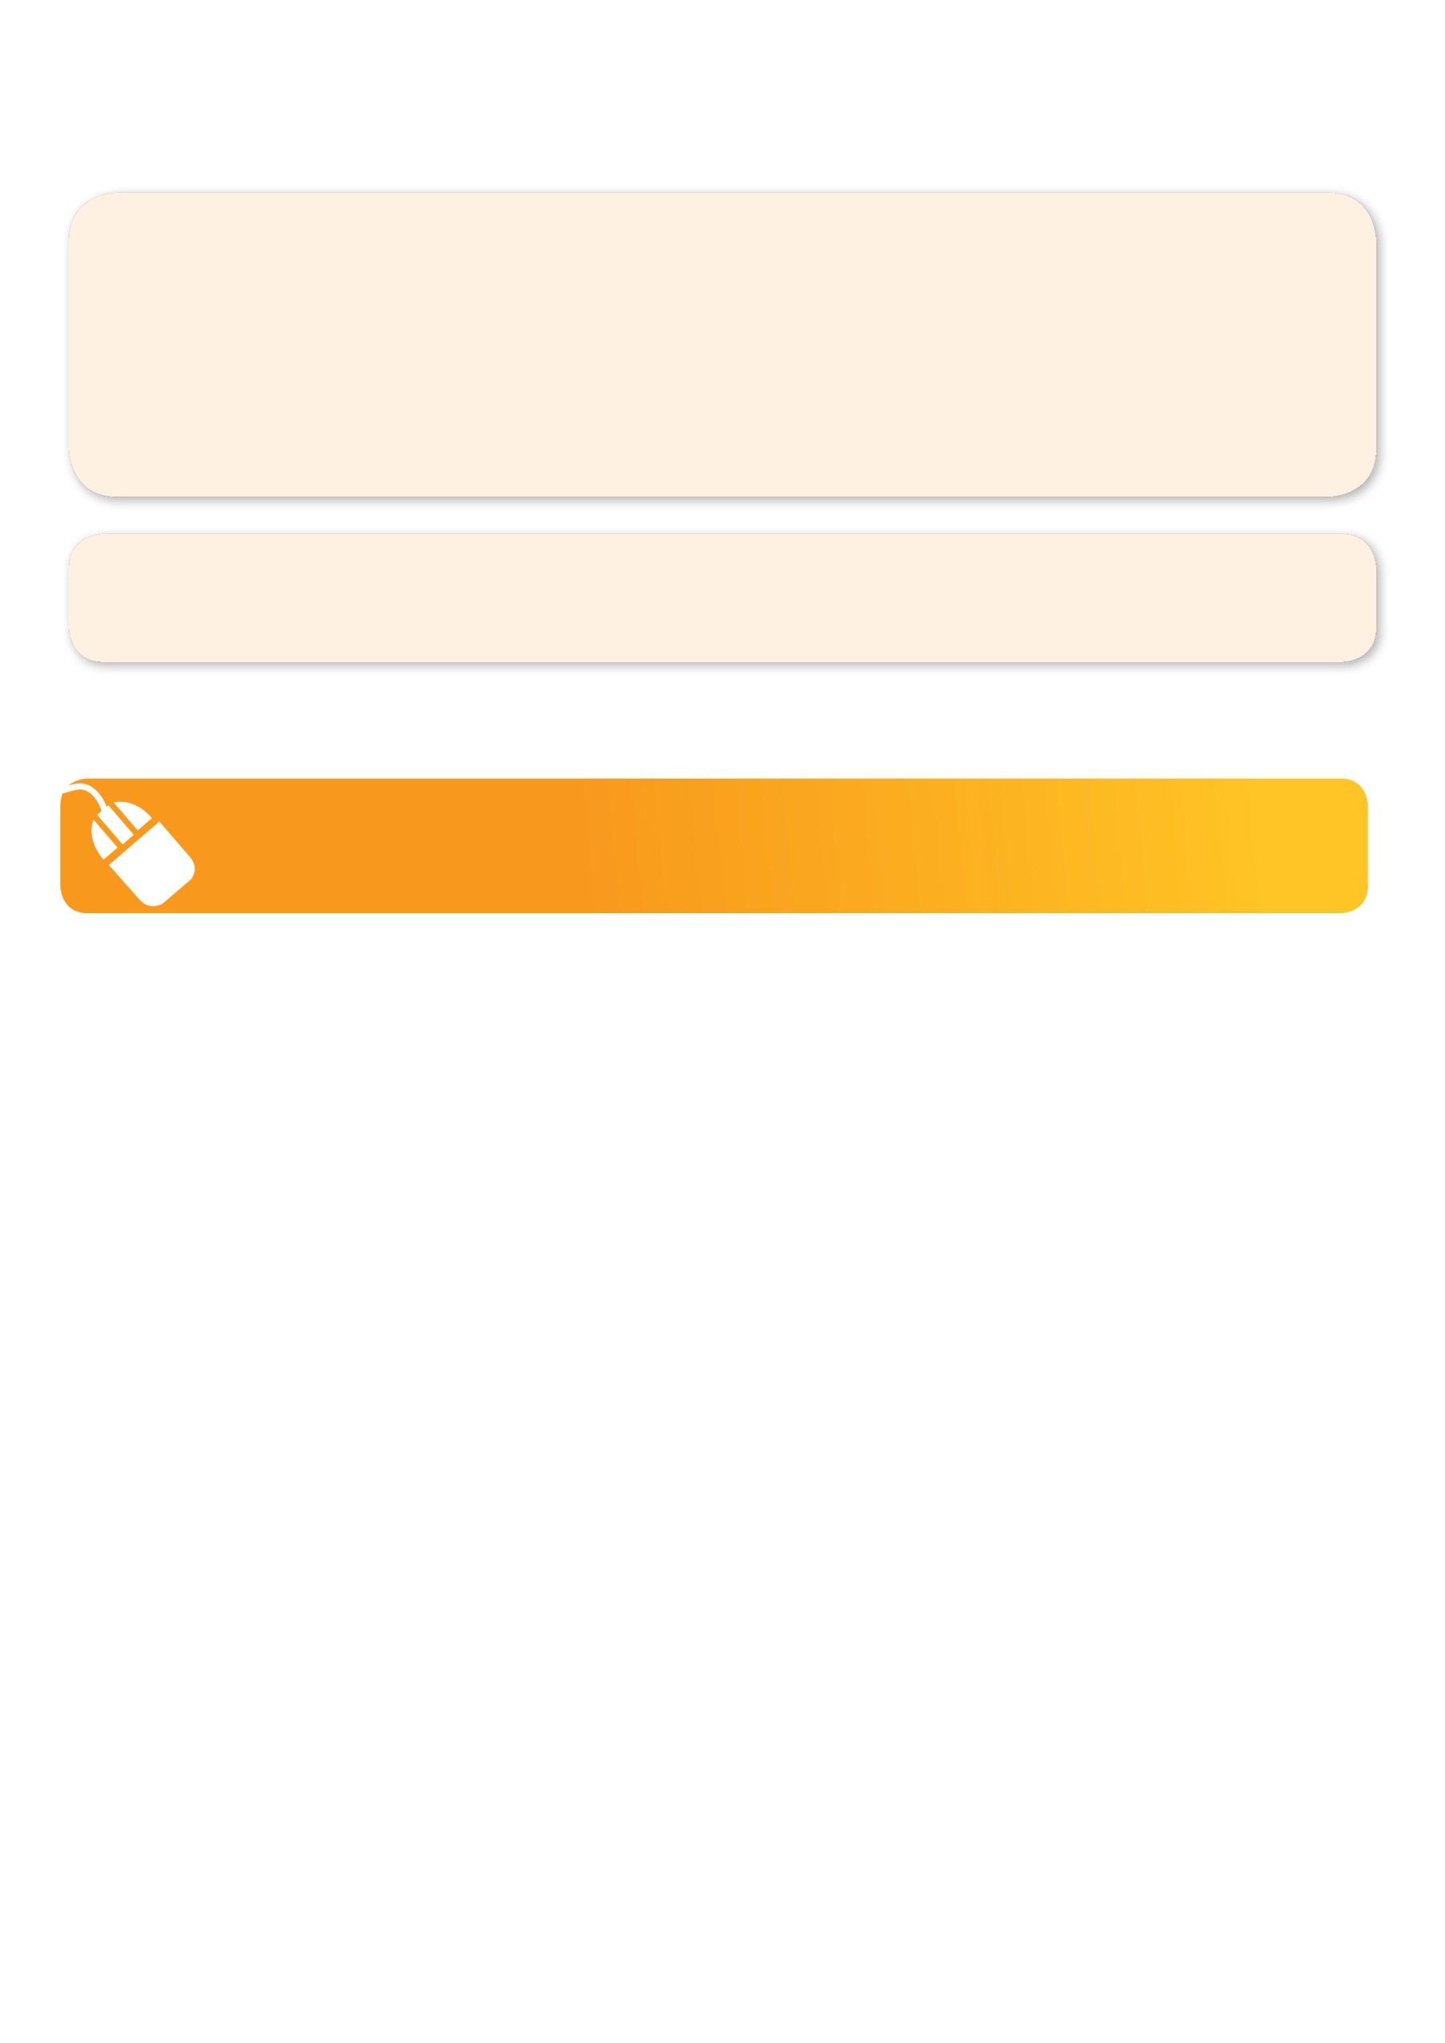

**ONLINE ENROLMENT**

**www.kellysports.com.au/events**

2013 Winner: Cardinia Business Awards **'Franchisee'**

2015 Winner: City of Casey Home Based Business! ::::::private:var:folders:kh:khsNorPdHv0D4qiVYklUJ++++TM:-Tmp-:com.apple.mail.drag-T0x100520d50.tmp.ZGYIab:image001.jpg

**ENROLMENT FORM**

**W1: Tue 3rd □ Wed 4th □ Thu 5th □ Fri 6th □ W2: Mon 9th □ Tue 10th □ Wed 11th □ Thu 12th □ Fri 13th □**

Name: DOB: Grade:

Address: Post Code:

Phone: Mobile/Work:

Email: Medical Conditions:

**Parents’ consent I hereby authorise Kelly Sports to act on my behalf should my child require medical attention,**

**and release Kelly Sports Berwick from any liability for injury incurred by my child at Kelly Sports programmes.**

Parent/Caregiver name: Signature: Amount Paid: $

Card: □□□□ □□□□ □□□□ □□□□Exp□□/□□(online surcharge applies) Internet Transfer: **□** Cash: **□** Cheque: **□**



**ONLINE ENROLMENT**

**www.kellysports.com.au/events**

***search holiday program postcode 3806***