

**Kelly Sports - Berwick & Pakenham**

$40

per day

P.O. Box 2055, Fountain Gate VIC 3805

**T** Darren Michelle 0402 224 116

**F** (03) 8692 6539

**W** www.kellysports.com.au

**E** [darren@kellysports.com.au](mailto:darren@kellysports.com.au)



SUMMER **HOLIDAY PROGRAM**

Sports orientated holiday program designed to emphasise fun, enjoyment, confidence and skills with maximum participation. Children require a packed lunch, drink bottle & hat. Quiet, restful activities also provided.

Suitable for both GIRLS and BOYS Kelly Sports is a registered childcare provider.

**VENUE: Berwick Chase Primary School GYM, 51 Bridgewater Blvd Berwick, enter via Viewgrand Dr.**

**WHEN:** JANUARY 2015

**COMMENCING:** Monday 12th Jan

**CONCLUDING:** Friday 23rd Jan

**TIME:** 8:30am – 4:30pm

**YEAR LEVELS:** All ages

|  |  |  |  |  |  |
| --- | --- | --- | --- | --- | --- |
| Mon 12th  8.30am-4.30pm | CRICKET | Soccer | **Football** | *Netball* | Dance |
| Tue 13th  8.30am-4.30pm | Basketball | C:\Users\Evange.Evange-PC\AppData\Local\Microsoft\Windows\Temporary Internet Files\Content.IE5\QUELLS1W\MC900285850[1].wmf GYM | Hockey | **Football** | Touch Rugby |
| Wed 14th  8.30am-4.30pm | TENNIS | Hip Hop | Soccer | Basketball | CRICKET |
| Thu 15th  8.30am-4.30pm | Soccer | **Tennis** | Volleyball | Dance | Basketball |
| Fri 16th  8.30am-4.30pm | Basketball | tBall | **Football** | TENNIS | CRICKET |

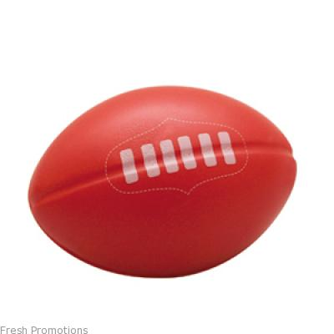

**WEEK 2**

**WEEK 1**

|  |  |  |  |  |  |
| --- | --- | --- | --- | --- | --- |
| Mon 19th  8.30am-4.30pm | Soccer | Basketball | Hip Hop | Hockey | TENNIS |
| Tue 20th  8.30am-4.30pm | Basketball | CRICKET | Hockey | **Football** | Touch Rugby |
| Wed 21st  8.30am-4.30pm | Volleyball | Hip Hop | Soccer | *Netball* | **Tennis** |
| Thu 22nd  8.30am-4.30pm | Soccer | **Athletics** | C:\Users\Evange.Evange-PC\AppData\Local\Microsoft\Windows\Temporary Internet Files\Content.IE5\QUELLS1W\MC900285850[1].wmfGYM | **Football** | Basketball |
| Fri 23rd  8.30am-4.30pm | tBall | CRICKET | **Football** | C:\Users\Evange.Evange-PC\AppData\Local\Microsoft\Windows\Temporary Internet Files\Content.IE5\QUELLS1W\MC900285850[1].wmfGYM | Soccer |

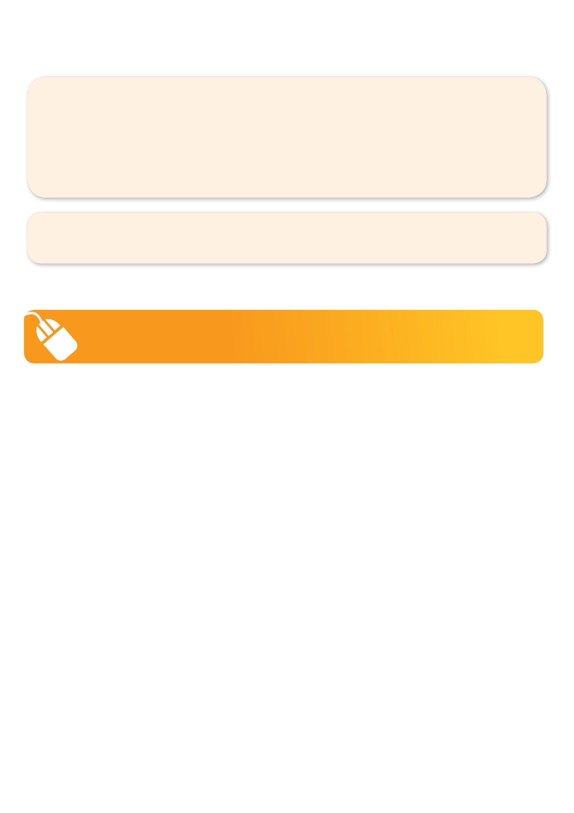**­**

To **enrol**, please visit www.kellysports.com.au or fill out the below enrolment form & **send** with a cheque or credit card details to: PO BOX 2055, Fountain Gate VIC 3805, or **scan to: darren@kellysports.com.au** or **fax** to 03 8692 6539. **Internet Direct credit available** BSB: 083-214 Acct No: 15-985-2563 Acct Name: Kelly Sports Berwick

**It’s here online enrolments !**

**To enrol**, please visit [www.kellysports.com.au](http://www.kellysports.com.au) or

fill out the enrolment form & **send** with a cheque or credit card details to:

Kelly Sports PO BOX 71, Moonee Vale, VIC, 3055.

Payment options available!

Do **not** leave enrolment forms at the school office

:::::::::private:var:folders:kh:khsNorPdHv0D4qiVYklUJ++++TM:-Tmp-:com.apple.mail.drag-T0x100520d40.tmp.qgfw8R:image003.jpg**Winner: 2013 Cardinia Franchisee of the year!**::::::private:var:folders:kh:khsNorPdHv0D4qiVYklUJ++++TM:-Tmp-:com.apple.mail.drag-T0x100520d50.tmp.ZGYIab:image001.jpg**Winner: 2013 Casey Home Based Business Awards!**

**ENROLMENT FORM**

**W1: Mon 12th□ Tue 13th□ Wed 14th□ Thu 15th□ Fri 16th□ W2: Mon 19th□ Tue 20th □ Wed 21st□ Thu 22nd□ Fri 23rd □**

Name: DOB:

Address: Post Code:

Phone: Mobile/Work:

Email: Medical Conditions:

**Parents’ consent I hereby authorise Kelly Sports to act on my behalf should my child require medical attention,**

**and release Kelly Sports Berwick from any liability for injury incurred by my child at Kelly Sports programmes.**

Parent/Caregiver name: Signature: Amount Paid: $

Card: □□□□ □□□□ □□□□ □□□□Exp□□/□□(online surcharge applies) Internet Transfer: **□** Cash: **□** Cheque: **□**

**ONLINE ENROLMENT**

**www.kellysports.com.au**

**It’s here online enrolments !**

**To enrol**, please visit [www.kellysports.com.au](http://www.kellysports.com.au) or

fill out the enrolment form & **send** with a cheque or credit card details to:

Kelly Sports PO BOX 71, Moonee Vale, VIC, 3055.

Payment options available!

Do **not** leave enrolment forms at the school office

**It’s here online enrolments !**

**To enrol**, please visit [www.kellysports.com.au](http://www.kellysports.com.au) or

fill out the enrolment form & **send** with a cheque or credit card details to:

Kelly Sports PO BOX 71, Moonee Vale, VIC, 3055.

Payment options available!

Do **not** leave enrolment forms at the school office

**It’s here online enrolments !**

**To enrol**, please visit [www.kellysports.com.au](http://www.kellysports.com.au) or

fill out the enrolment form & **send** with a cheque or credit card details to:

Kelly Sports PO BOX 71, Moonee Vale, VIC, 3055.

Payment options available!

Do **not** leave enrolment forms at the school office