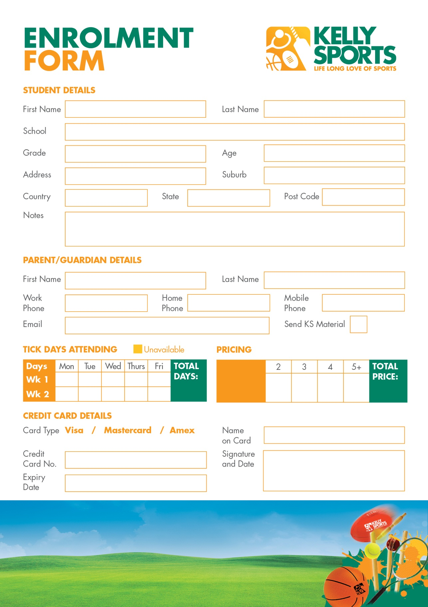

*School Programs *Kinder Programs *School Sports Days *Corporate Events

*Leadership/Teambuilding Events *Specialised Coaching

Would you like Kelly Sports at your school or kindergarten?

Enquire about our introductory FREE session today!

**Price   
per day: $40**

**$80**

**$120**

**$160**

**$175**

**($35 daily)**

**DID YOU KNOW KELLY SPORTS ALSO OFFERS?**

**___ days**

**$_______**

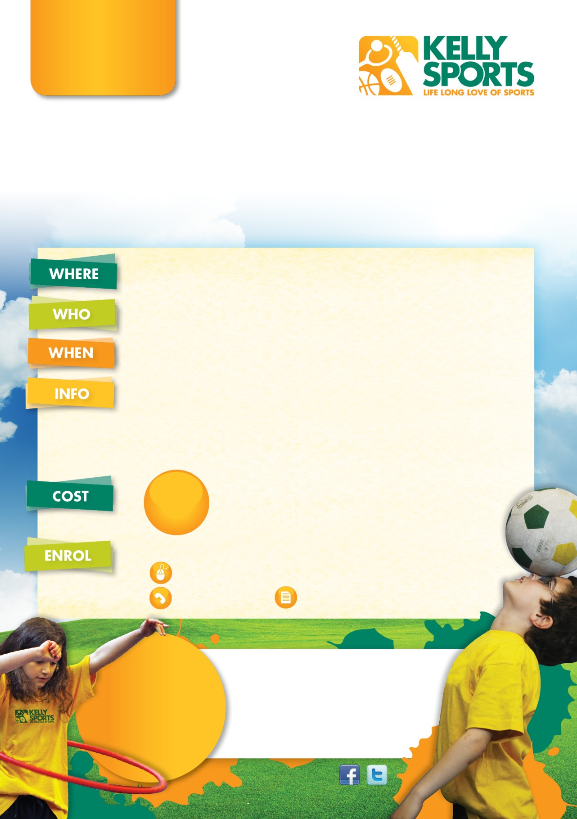

**Brett Harris**

**M**  0438 198 031

**E**  [brett@kellysports.com.au](mailto:brett@kellysports.com.au)

**A** 12 Metropolitan Drive,

Eaglehawk VIC 3556

**HOLIDAY  
 PROGRAM**

**WINTER SCHOOL**

**HOLIDAY PROGRAM**

Sports orientated holiday program designed for children   
to emphasise fun, enjoyment and maximum participation.

**QUARRY HILL COMMUNITY HALL**

Hamlet St, Quarry Hill VIC 3550

**Kinder-Grade 6 (Boys & Girls)**

**Monday 3rd to Friday 14th July 2017**   
**8:00am-5:00pm**(excluding Weekends & Public Holidays)

***Kelly Sports are offering an exciting holiday sports program for kids this***

***Winter break!***

• Friendly and experienced coaches teaching a variety of skills

throughout the whole day & providing an exciting and safe

environment.

•Sports & activities that all kids can enjoy such as: Basketball, Netball, Cricket, T-Ball, Soccer, Footy,

Dancing, Gymnastics, Circus activities, Parachute

& crazy games and much more.

**Children need to bring along a drink bottle,

lunch & plenty of healthy snacks.

***Enrol for 5 days or more for only $35 per day!

**$40**

**FROM**

**PER DAY**

**THREE WAYS TO ENROL**

Online: [www.kellysports.com.au](http://www.kellysports.com.au)**,** click on events & enter postcode 3550

Call /text Brett

**LOOK OUT!**

**SEE WHAT’S**

**COMING UP**

**KELLY SPORTS   
DOES BIRTHDAY PARTIES!**

For more info, go to

**www.kellysports.com.au**

**\*EARLY BIRD SPECIAL\***

**ENROL BEFORE FRIDAY 23rd JUNE & GET $5**

**OFF PER DAY!**

**\*EARLY BIRD SPECIAL\***

**ENROL BEFORE FRIDAY 23rd JUNE & GET $5**

**OFF PER DAY!**

Photo consent 

Return the form (reverse side) in person or to the above address