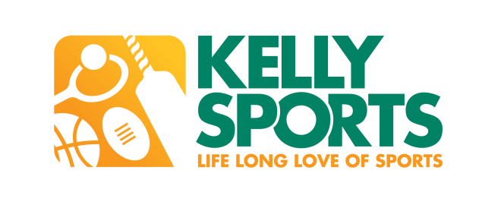

**Kelly Sports Program at Spring Gully Primary School**

Kelly Sports is looking forward to conducting clinics again at Spring Gully Primary School. We will be running an 8 week Mega Multi Sports program that includes 4 different sports including:

Footy, Volleyball, Touch Rugby & Crazy Games & a brand new 8 week Circus & Gymnastics program that includes awesome circus & gymnastics tricks using apparatus such as colourful ribbons, hula hoops, spinning plates, juggling scarves & diablos just to name a few.

Below are some details about our program and how your child could benefit.

For all enquiries about programs, please contact Brett Harris on 0438 198 031.

* Kelly Sports’ motto is Safe, Skill & Smile.
* Our programs cater for boys and girls from Prep – Grade 6.
* Kelly Sports provide highly trained coaches that cater to individuals’ needs.
* Children can be enrolled in After School Care, as coaches walk child to after school care once session has concluded to sign them in.
* Maximum ratio of 1 coach to 30 children (Circus & Gymnastics) & 1 coach to 14 children (Mega Multi Sports) to ensure maximum participation rate.
* Activities begin 10 minutes after the bell and go for 45 minutes (Circus & Gymnastics-lunchtime) 1 hour (Mega Multi Sports-afterschool).
* Children meet at a designated area where a roll is taken to ensure every child is accounted for before session is conducted.
* Clinics will be conducted on school grounds.
* $96 for 8 Fun and Challenging 1 hour sessions (Mega Multi Sports).
* $80 for 8 Exciting & Energetic 45 minute session (Circus & Gymnastics).
* Starts Wednesdays 26th July & concludes 13th September 01:10pm-01:55pm (lunch times).
* Starts Fridays 28th July & concludes 15th September 03:25 pm-04:25 pm (after school).
* To enrol, just check out [www.kellysports.com.au](http://www.kellysports.com.au), enter your school name, click GO and select Book Now from the program that you’d like to enrol your child in.
* ***\*\*EARLY BIRD SPECIAL OFFER** If you enrol your child in any program before Sunday 16th July you’ll receive 1 session FREE!!***

**www.kellysports.com.au**