 **P.O. Box 91, Brighton SA 5048**

**$100 Sports Voucher discount available!**

**MULTI -SPORTS**

**PROGRAM**

**TERM 1 2019**

**T 0439 0639 16**

**E** **ianbarnes@kellysports.com.au**

**Special O**

**SIZZLING SUMMER SPORTS**

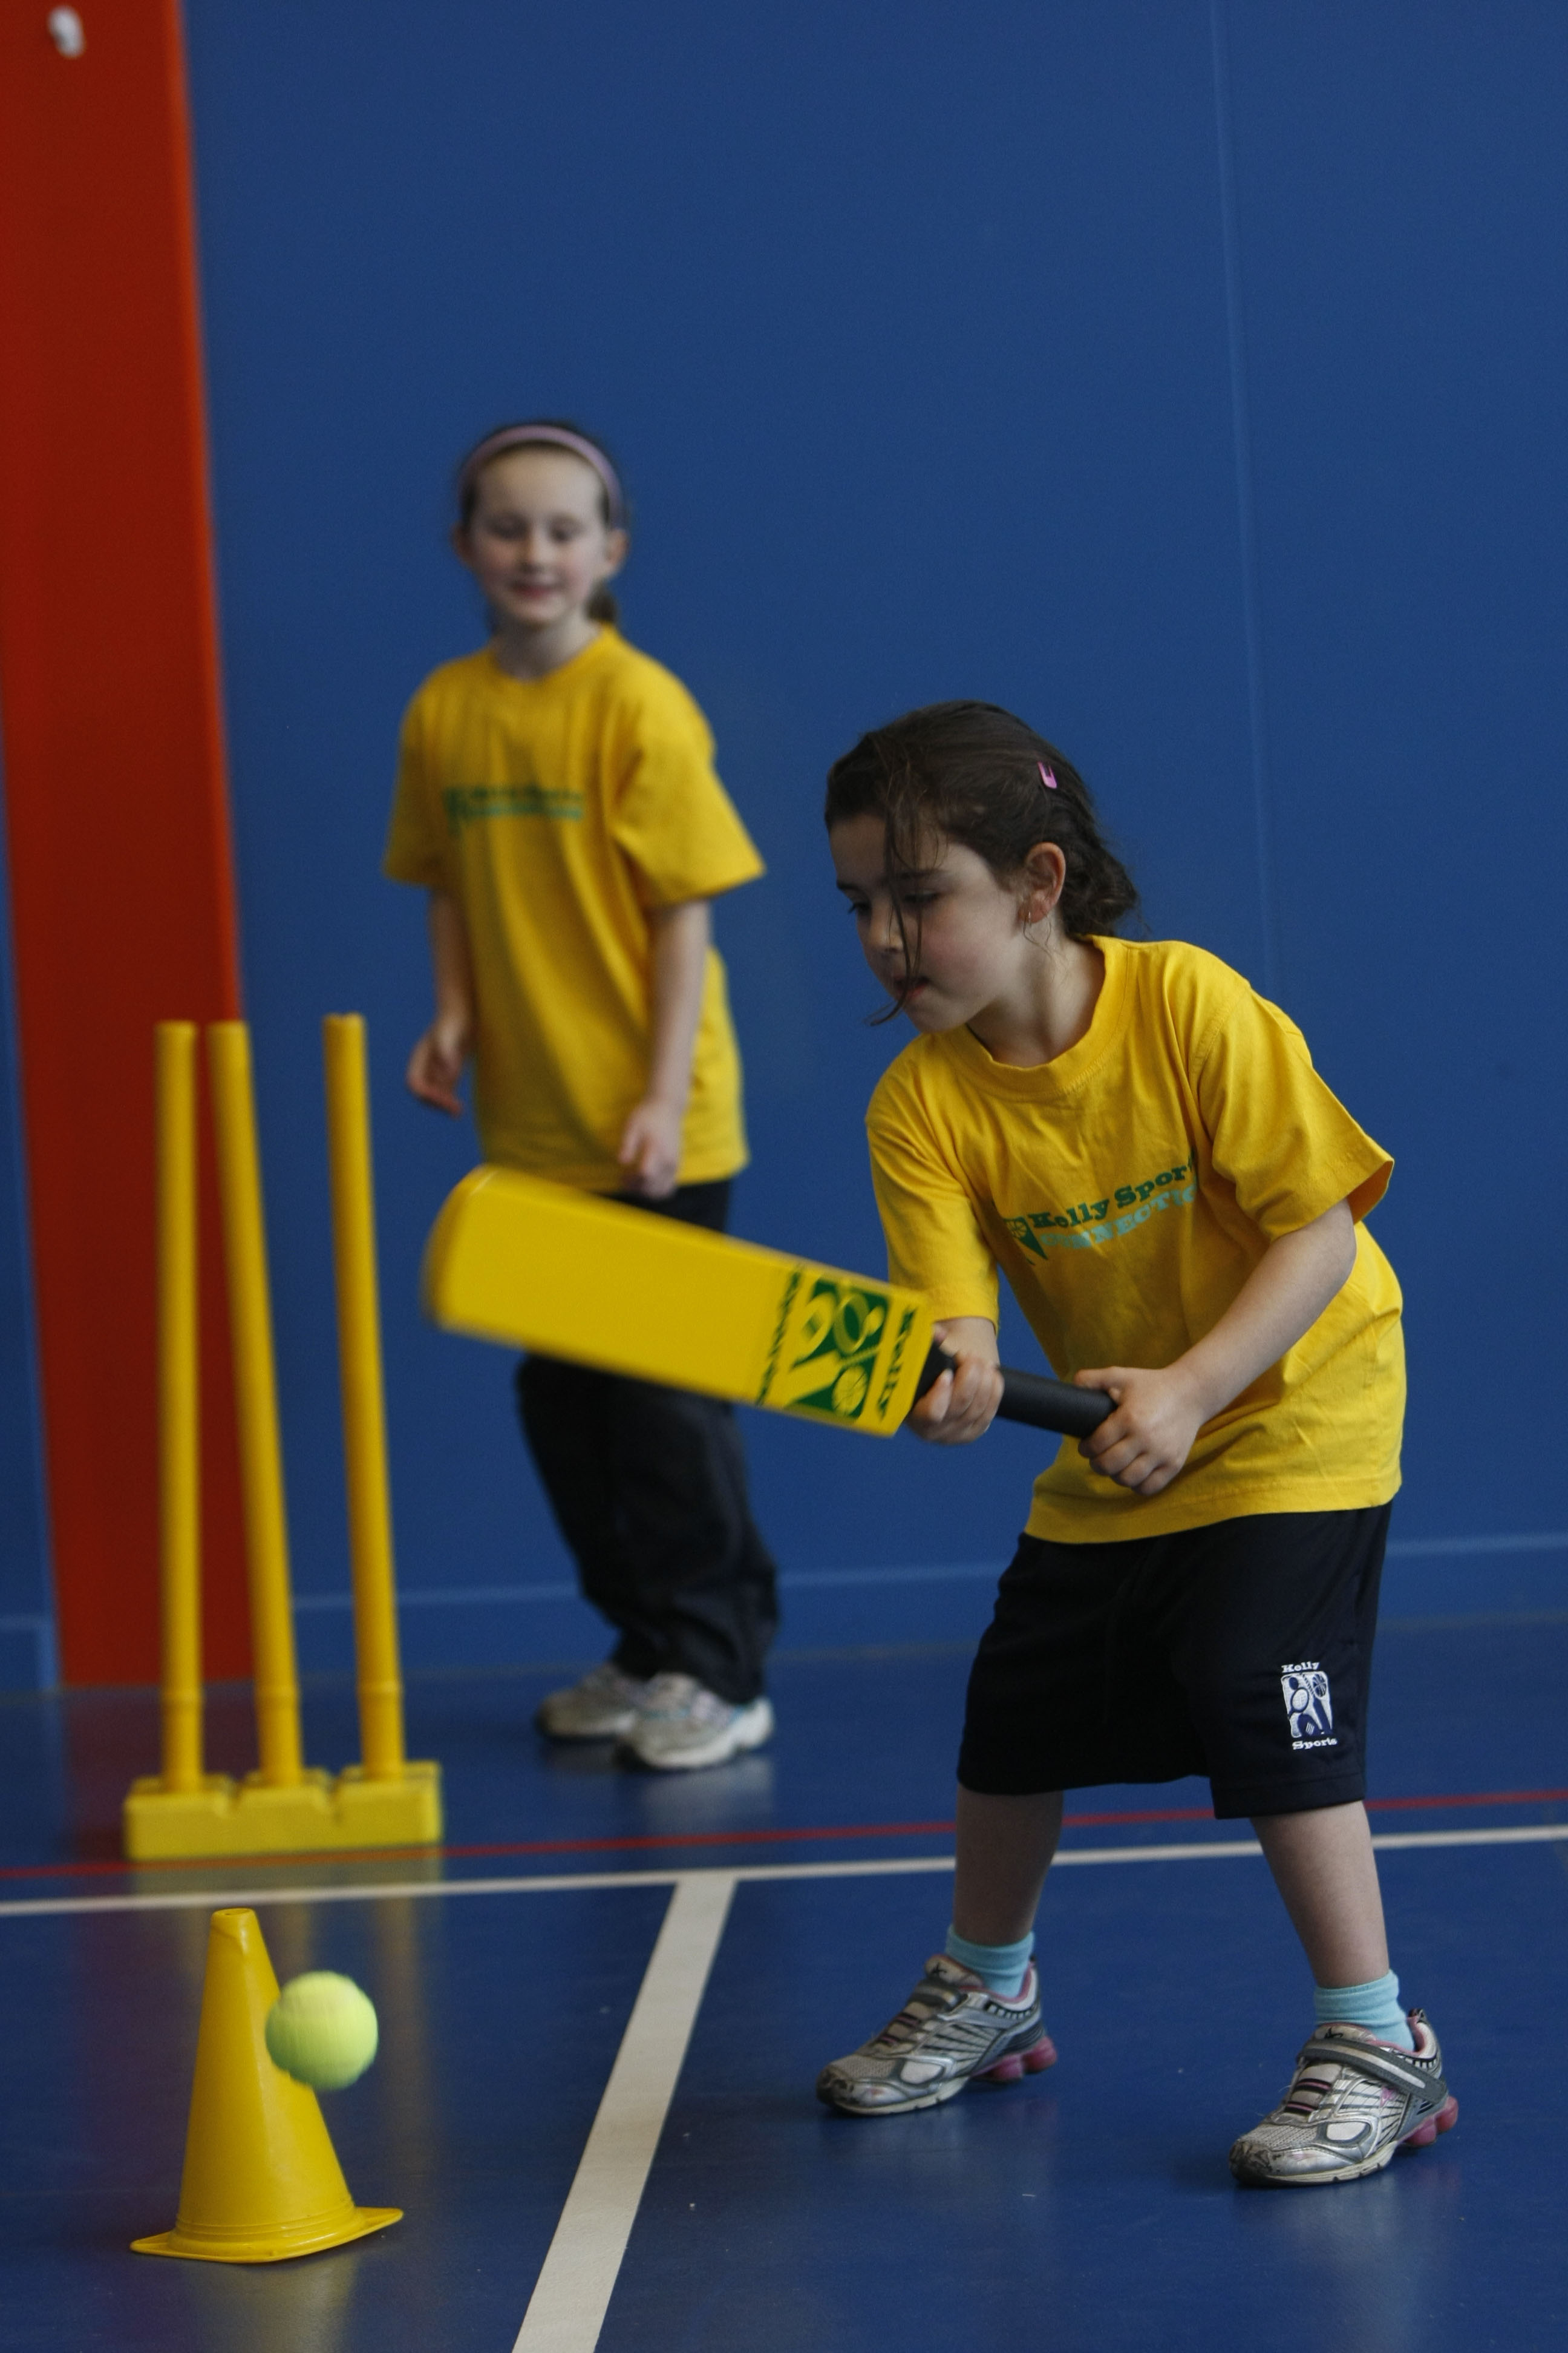**ST TERESA PRIMARY SCHOOL**



The **Sizzling Summer Sports** programme allows your child to experience energetic and highly active multi-sport sessions which will challenge and improve your child’s motor and co-ordination skills.

The **Sizzling Summer Sports** programme includes

**CRICKET, TOUCH FOOTBALL, ATHLETICS, TEEBALL**

Our experienced coaches aim to develop and enhance the wide range of sporting skills of your child including kicking, catching & throwing while also improving strength, flexibility, hand-eye co-ordination, spatial awareness, co-operative skills and teamwork.

A Kelly Sports coach will be responsible for your child during this activity and a registration form and payment is required before your child participates in activities with us.

**WHEN: TUESDAY**

**COMMENCING: 5/2/19**

**CONCLUDING:** **19/3/19**

**TIME: 3:15pm - 4:15pm**

**YEAR LEVELS: R - 2**

**COST: $99 *+GST (Total cost $108.90)***

***Kelly Sports is a Sports***

***Voucher provider.***



**VENUE: St Theresa Primary School Meeting Place : School Courtyard**

**It’s here online enrolments !**

**To enrol**, please visit [www.kellysports.com.au](http://www.kellysports.com.au) or

fill out the enrolment form & **send** with a cheque or credit card details to:

Kelly Sports PO BOX 71, Moonee Vale, VIC, 3055.

Payment options available!

Do **not** leave enrolment forms at the school office

**It’s here online enrolments !**

**To enrol**, please visit [www.kellysports.com.au](http://www.kellysports.com.au) or

fill out the enrolment form & **send** with a cheque or credit card details to:

Kelly Sports PO BOX 71, Moonee Vale, VIC, 3055.

Payment options available!

Do **not** leave enrolment forms at the school office



To enrol and/or redeem your sports voucher discount, register online at [**www.kellysports.com.au**](http://www.kellysports.com.au)OR fill out the enrolment form below and send it to **PO BOX 91** **Brighton SA 5048.** Payments can be made online at [www.kellysports.com.au](http://www.kellysports.com.au) or by EFT to **Kelly Sports Adelaide Metro BSB 035 045 A/C No 342581**. For further information about your Sports Voucher eligibility please visit [www.sportsvouchers.sa.gov.au](http://www.sportsvouchers.sa.gov.au).

*Kelly Sports is a learning destination for the Children’s University*

**ENROLMENT FORM**

School: Year Level:

Name: D.O.B: _____________________________

Address: Post Code:

Phone: Mobile/Work:

Email: _______________________________________________________________________

Medical Conditions: _______

At the completion of the Kelly Sports clinics, does your child? GO TO AFTER CARE □ GET COLLECTED □

**Parents’ consent: I hereby authorise Kelly Sports to act on my behalf should my child require medical attention, and release   
Kelly Sports Adelaide Metro from any liability for injury incurred by my child at Kelly Sports programmes.**

**I consent to my child’s photo being taken for use in promotional material by Kelly Sports.**

Parent/Caregiver name: Signature: ___________________________________

Amount Paid: $ _________ by Cash / Cheque / Internet transfer (date)____________________________________

**ONLINE ENROLMENT**

**www.kellysports.com.au**

**ENQUIRE NOW ABOUT A KELLY SPORTS BIRTHDAY PARTY FOR YOUR CHILD**

*Statement of commitment to child safety*

*All children who come to Kelly Sports have a right to feel and be safe. The welfare of the children in our care will always be our first priority and we have a zero tolerance to child abuse. We aim to create a child safe and child friendly environment where children feel safe and have fun. This policy was developed in collaboration with all our staff, volunteers and the children who use our services and their parents. It applies to all staff, volunteers, children and individuals involved in our organisation.*

**It’s here online enrolments !**

**To enrol**, please visit [www.kellysports.com.au](http://www.kellysports.com.au) or

fill out the enrolment form & **send** with a cheque or credit card details to:

Kelly Sports PO BOX 71, Moonee Vale, VIC, 3055.

Payment options available!

Do **not** leave enrolment forms at the school office

**It’s here online enrolments !**

**To enrol**, please visit [www.kellysports.com.au](http://www.kellysports.com.au) or

fill out the enrolment form & **send** with a cheque or credit card details to:

Kelly Sports PO BOX 71, Moonee Vale, VIC, 3055.

Payment options available!

Do **not** leave enrolment forms at the school office

**It’s here online enrolments !**

**To enrol**, please visit [www.kellysports.com.au](http://www.kellysports.com.au) or

fill out the enrolment form & **send** with a cheque or credit card details to:

Kelly Sports PO BOX 71, Moonee Vale, VIC, 3055.

Payment options available!

Do **not** leave enrolment forms at the school office