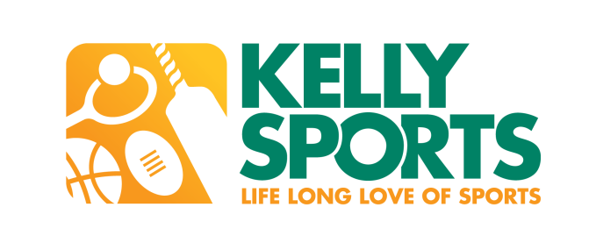

Kelly Sports Adelaide Metro
PO BOX 91 BRIGHTON SA 5048
Tel: 0439 063 916 Email: IANBARNES@kellysports.com.au

Come n Try
SUMMER HOLIDAY SPORTS PROGRAM

Join up with your friends and come n try the
City of Marion Summer Holiday Sports Program

Lots of modified games and different sports throughout the day to keep the children active and entertained

The multi-sports program is designed to provide fun, enjoyment and maximum participation includes:

Hockey Soccer Lacrosse

Basketball Ball Games Cricket

AFL Mini-Olympics Badminton

VENUE: Clovelly Park Primary School
All Kelly Sports coaches have mandatory child related employment screencing clearances.

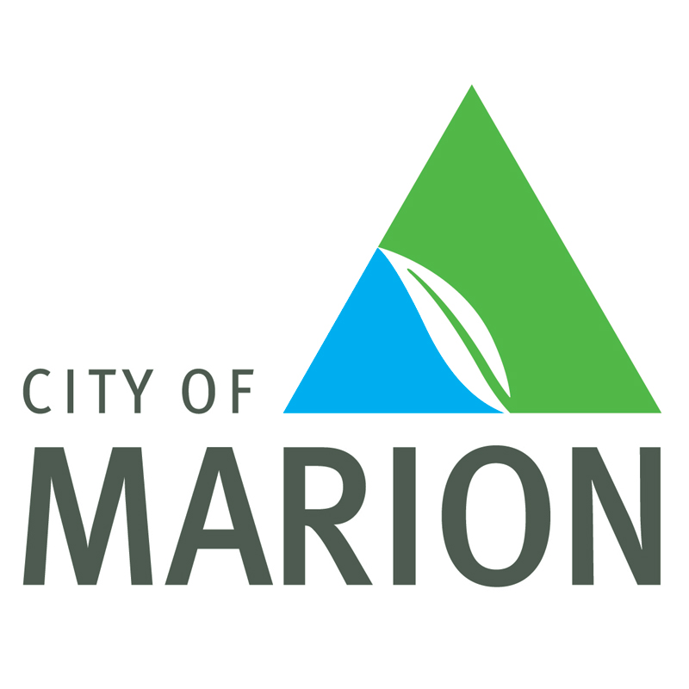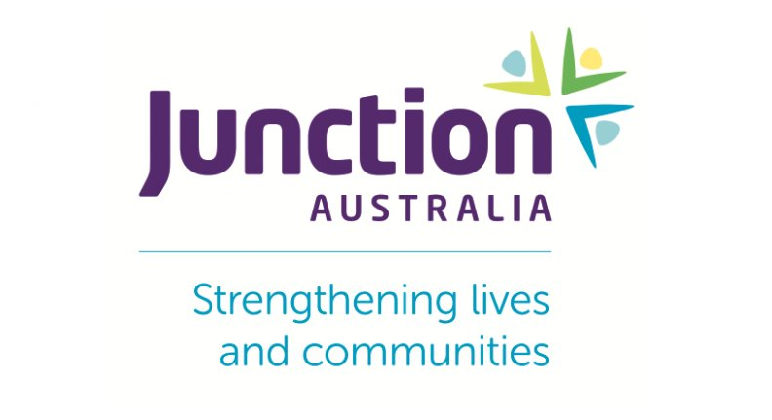

WHEN: TBA

TIME: TBA

YEAR LEVELS: 3 to 7



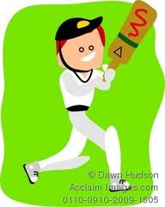
THE FREE SUMMER HOLIDAY SPORTS PROGRAM WILL BE HELD AT
THE MITCHELL PARK SPORTS & COMMUNITY CLUB MORELAND AVENUE MITCHELL PARK
WEDNESDAY 21ST DECEMBER 2016 AND TUESDAY 17TH JANUARY 2017
9.00AM – 1.00PM

To register for the City of Marion Summer Holiday Sports program at Mitchell Park during the school holidays
Contact Ian Barnes at Kelly Sports Adelaide Metro on:
Phone : 0439 063 916
or
Email : ianbarnes@kellysports.com.au

