

**BAYSWATER SOUTH PS**

**P** (03) 9384 2204  
**M** 0403 149 391  
**E** [mitch@kellysports.com.au](mailto:mitch@kellysports.com.au)



**SIZZLING SUMMER SPORTS**

Kelly Sports is back in Term 1 for a **SIZZLING SUMMER OF SPORTS!!**   
Our Kelly Sports classes are all inclusive, fun & interactive with a key focus on maximum participation. Each week children will be introduced to new sports & activities in a positive environment. It’s a fantastic way to get your child active while having fun as well as building confidence and social skills!





**How To Enrol?**Please visit [www.kellysports.com.au/events](http://www.kellysports.com.au/events) and search for your school.  
Our new booking system requires upfront payments to secure your position. For more information, please call the head office.

**"The Kelly Sports Programs offer our students opportunities for physical activities; including dance & multi-sports. Conveniently located on our school grounds, they are popular with students and their families. Staff are skilled in working with young people to love active participation.”**



***Amanda Hay, Principal – Newtown Primary School***

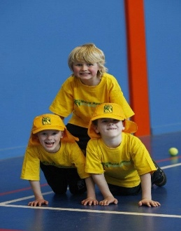

**CLASS INFORMATION**

Only 14 spots available so sign up fast to secure your position  
  
Multi Sports includes **Soccer, Basketball, Cricket & Tennis,** plus we will incorporate our Kelly Sports Modified games children love.

Come and join us every Wednesday straight after school.

**When: Wednesdays**  
**Starts: 6th Feb**  
**Finishes: 3rd April**  
**Time: 3:40pm – 4:40pm**  
**Year Levels: Prep – 4  
Cost: $118.80 (Inc GST)**

