

**SYNDAL SOUTH**

**PRIMARY SCHOOL P** (03) 9384 2204

**M** 0403 149 391

** E** [mitch@kellysports.com.au](mailto:mitch@kellysports.com.au)

**JAZZ FUNK – Lunch time Fridays**Jazz – Funk takes elements of both Hip Hop and Jazz, combined into one dance style that gives students a chance to release energy and dance with power and passion. Our experience staff will work on a brand new routine through out the term to showcase to parents and friends. Sign up fast as students will have a fantastic time learning the new moves in our high intensity, excitement-filled dance environment.

**AWESOME AUTUMN SPORTS – After School Fridays**Kelly Sports is back in Term 2 for a **AWESOME AUTUMN OF SPORTS!!**   
Our Kelly Sports classes are all inclusive, fun & interactive with a key focus on maximum participation. Each week children will be introduced to new sports & activities in a positive environment. It’s a fantastic way to get your child active while having fun as well as building confidence and social skills!





**How To Enrol?**Please visit [www.kellysports.com.au/events](http://www.kellysports.com.au/events) and search for your school.  
**Our new booking system requires upfront payments to secure your position. For more information, please call the head office.**



**"The Kelly Sports Programs offer our students opportunities for physical activities; including dance & multi-sports. Conveniently located on our school grounds, they are popular with students and their families. Staff are skilled in working with young people to love active participation.”**



***Amanda Hay, Principal – Newtown Primary School***

**CLASS INFORMATION**

Only 14 spots available for each program so sign up fast to secure your position

Multi Sports includes **Soccer, Basketball, AFL & Hockey,** plus we will incorporate our Kelly Sports Modified games children love.

**Come and join us every Friday at Lunch or After School**

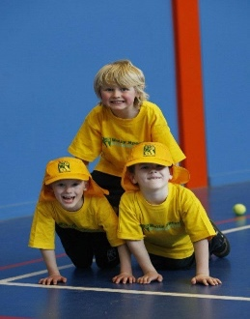

**When: Fridays**   
**Starts: 3nd May**   
**Finishes: 21st June**   
**Dance: 1:40pm – 2:30pm  
Sports: 3:40pm – 4:40pm**  
**Year Levels: Prep – 4  
Cost: $105.60 per program(Inc GST)**

