

**OLMC**

**PRIMARY SCHOOL P** (03) 9384 2204

**M** 0403 149 391

** E** [mitch@kellysports.com.au](mailto:mitch@kellysports.com.au)

**JAZZ FUNK**

Jazz – Funk takes elements of both Hip Hop and Jazz, combined into one dance style that gives students a chance to release energy and dance with power and passion. Our experience staff will work on a brand new routine through out the term to showcase to parents and friends. Sign up fast as students will have a fantastic time learning the new moves in our high intensity, excitement-filled dance environment.

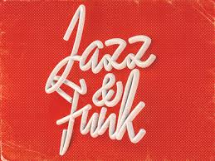



**How To Enrol?**Please visit [www.kellysports.com.au/events](http://www.kellysports.com.au/events) and search for your school.  
Our new booking system requires upfront payments to secure your position. For more information, please call the head office.



**"The Kelly Sports Programs offer our students opportunities for physical activities; including dance & multi-sports. Conveniently located on our school grounds, they are popular with students and their families. Staff are skilled in working with young people to love active participation.”**



***Amanda Hay, Principal – Newtown Primary School***

**CLASS INFORMATION**

Only 14 spots available so sign up fast to secure your position  
  
At the end of the term parents will be invited to an open class to watch the full dance routine.

Come & join us every Tuesday at Lunch time.

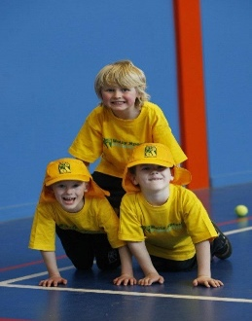

**When: Tuesday**  
**Starts: 30th April**  
**Finishes: 25th June**  
**Time: 1:25pm – 2:05pm**  
**Year Levels: Prep – 4  
Cost: $118.80 (Inc GST)**

